United States Coast Guard Auxiliary

Federal Short Range Aids to Navigation

Study Guide

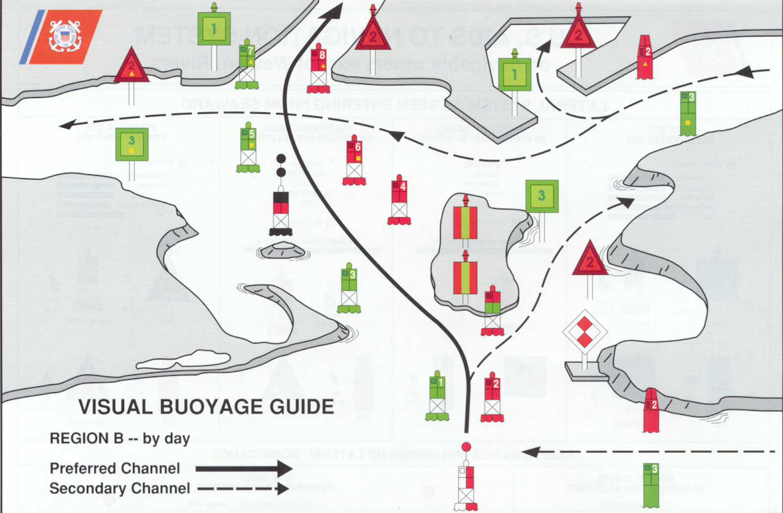

“We verify the ATONs and PATONs, check the Bridges, and update the Charts and Small Craft Facilities along the waterways of the United States”

Table of Contents

Introduction - 3
Objectives – 3
Annual Aids to Navigation Awards - 3
Tools needed for checking Federal Aids - 4
Binoculars – 4
Time Piece – 4
GPS - 4
Light List - 4
LNM – Local Notice to Mariners - 4
Coast Pilot - 5
Chart No. 1 – 5
NOAA Nautical Charts - 5
ANSC-7054 Aid to Navigation Report – 5, 38
Pencil - 5
Plotter - 5
Digital Camera - 5
Calculator - 6
Reference Documents – 6
Conventional Direction of Buoyage - 7
The IALA-B System of Aids to Navigation - 8
Lateral System - 8
Lateral System as seen when entering from seaward – 8
Lateral Marks - 8
Port Hand Marks – 8
Preferred Channel Marks - 9
Starboard Hand Marks - 10
Junction – 10
Bifurcation – 10
Crossing - 10
Beacons – 11
Buoyant Beacons – 11
Buoys - 11
Aids to Navigation having no lateral significance – 12
Safe Water Marks - 12
Isolated Danger Marks - 12
Special Marks – 13-14
Information and Regulatory Marks – 13, 14
Mooring Buoys - 14
Major Lights - 15
Coast and Seacoast Lights - 14
Inland Major Lights - 14
Discrepancies on a major light - 15
Directional or Sector Lights – 15
Fog Detector - 15
Discrepancies on a Fog Detector - 15
RACON - 16
Discrepancies on a RACON - 16
Sound Signal - 16
Discrepancies on a Sound Signal - 16
The Western River System – 17, 18, 19
The Intracoastal Waterway System – ICW - 20
ICW Markings - 20
Dual Purpose Aids - 20
Marking of Coaxial Waterways - 21
Variations on the Direction of Buoyage - 22
The Uniform State Waterway Marking System - 23
Inland Waters Obstruction Mark - 23
Cardinal Marks - 23
Lanterns - 23
Solar LED Lanterns - 24
Light Characteristics - 24
Discrepancies on Lights - 25
Ranges - 25
Discrepancies on Ranges –25
Extra Pre-underway equipment checks for AN Patrols - 26
Guidelines for checking a Federal Aid. - 28
Guidelines for taking a Fix. - 29
Guidelines for taking a Depth reading. – 29, 30
Suggested Boat Crew Assignments - 30
Federal Aid Discrepancies. - 31
Critical - 31
Urgent - 32
Routine – 32
Important Points to Remember - 33
Reporting ATON Activity to AUXDATA. - 34
AN Patrols - 35
Individual Aid to Navigation Missions - 35
Individual AN Activity Reports – 35, 36
INDEX – 37
List of Acronyms and Terms – 38 - 39
LAT/LON Conversion Table - 40

Figures
- Three-line GPS Screen – 4
- Conventional Direction of Buoyage. - 7
- Port Side Odd Numbered Aids – 8
- Preferred Channel Aids – 9
- Starboard Side Even Numbered Aids – 10
- Junction, Bifurcation, and Crossing Patterns – 11
- Safe Water Marks – 12
- Isolated Danger Marks – 12
- Special Marks – 13
- Information and Regulatory Marks – 14
- Western Rivers – Port Side/Right Desd. Bank – 18
- Western Rivers – Preferred Channel Marks – 18
- Western Rivers – Starboard Side /Left Desd Bank – 19
- Samples of ICW marked Aids – 20
- Coaxial Waterway – 21
- Var. on the direction of Conventional Buoyage – 22
- Inland (State) Waters Obstruction Mark – 23
- Cardinal Mark System – 23
- The Elements of a Navigational Lantern – 23
- Solar LED Lanterns – 24
- Ranges – 25
- Pre-Underway Check List for AN Patrols. - 27

Introduction to Federal Aids - ATONs

One of the primary responsibilities of the Auxiliary Aid to Navigation Program is the reporting of discrepancies observed on Federal Short Range Aids to Navigation (ATONs). The Auxiliary works with the U.S. Coast Guard to accomplish this important mission. This is a partnership focused on assisting the Coast Guard in backwater and remote areas where the Coast Guard normally doesn’t transit in the normal course of daily operation, as well as the more traveled waterways of the country

This Auxiliary Federal Aid to Navigation (ATON) Study Guide explains methods for checking Federal Aids (ATONs) and for reporting observations of any discrepancies to the local C.G. Units in charge of the maintenance of the aids. Auxiliarists report to the Coast Guard only those discrepancies that they observe on Federal Aids. Federal aids, found “watching properly,” are normally not reported to the Coast Guard. The exception is when a Coast Guard Unit or agency specifically requests that a particular aid or aids be checked. In addition, Auxiliarists should always take credit in AUXDATA for all of their Federal Aid to Navigation (ATON) activity, whether the aid is observed with a discrepancy or is just found watching properly. The guiding principal here is that it takes a lot of an Auxiliarist’s time and effort to search out a discrepant Federal Aid and, therefore, they should receive credit for this mission activity.

All Annual Aid to Navigation awards are based on the AN Mission Activity data (30-ATON, 31-PATON, and 32-Bridges) as lead person that are reported and recorded in AUXDATA as of December 31 each year.

Conduct all of your Federal Aid activity in a partnership mode with the local C.G. Unit or other agency that is responsible for managing Federal Aids in the area.

Objectives of this Manual

    - To acquire a generalized knowledge of the Auxiliary program regarding the specifications for a Federal Short Range Aid to Navigation and to learn how a Federal Short Range Aid should be checked and reported to the Coast Guard.

Note that the specific report routing path for an ATON Discrepancy Report may be different within each District. It is important to not lose sight of the primary purpose of this activity, which is always to get the discrepancy report to the Coast Guard Unit as quickly as possible. Processing ATON reports through multi-levels of Auxiliary structure often defeats this objective.

    - To develop a familiarity with all of the potential discrepancies that may be found on a Federal Short Range Aid to Navigation (ATON).

    - To become familiar with the Auxiliary guidelines for properly checking a Federal Short Range Aid to Navigation (ATON). This includes the guidelines for taking and reporting a fix and a depth to the Coast Guard.

    - To provide members with an understanding of the quality standards necessary for operating any electronic equipment used for taking measurements for the ATON program.

    - To gain an appreciation for the importance of reporting all AN activity to AUXDATA for time and mission credits.

Annual National Aids to Navigation Awards
Annual AN activity statistics, recorded in AUXDATA as of 12/31 each year, are used to determine the AN Awards that are awarded each year. These awards are:
- The Division with the most reported AN Activity.
- The Flotilla with the most reported AN Activity.
- The Auxiliarist with the most reported AN Activity.

The AN statistics are developed from “ANSC 7030 Activity Report – Mission - Individual” reports submitted by Auxiliarists and entered into AUXDATA for AN activity using the following Mission Codes:
30 – Federal Aid to Navigation – ATONs – discrepancies and ATONs watching properly.
31 – Private Aid to Navigation – PATONs – discrepancies and PATONs watching properly.
32 – Bridges – BAP – discrepancies and Bridges watching properly.

Note: AN activity performed while on an authorized patrol is not included on the “ANSC 7030 Activity Report – Mission – Boat” report made by the Coxswain to AUXDATA through the IS Staff Officer. In order to get your AN Mission activity recorded in AUXDATA, a separate “ANSC 7030 Activity Report – Mission – Individual” report must be submitted by each Auxiliarist who performed the AN activity using the Mission Codes printed above.

Tools needed for checking Federal aids:
The following tools are needed in order to check an ATON properly. Usually, most of this equipment is found aboard every operational facility (OPFAC). However, many Auxiliarists, who participate in the ATON Programs, carry a personal Navigation Kit that contains their personal equipment. For a successful ATON checking experience, insure that your have the right navigational tools and that they are operating accurately and are available when needed. By including this equipment as part of your pre-underway equipment check, you are helping to guarantee a successful patrol. Pre-calibrate each electronic navigational instrument to insure that it is operating accurately. Make it a standard practice to record the test results on your pre-underway checklist. A special AN Patrol Pre-Underway Checklist is provided in this Study Guide. You may need the data later as part of your ATON discrepancy report(s). Links to AN publications and catalogs can be found at http://www.auxodept.org/atons.htm - National AN Web Site.

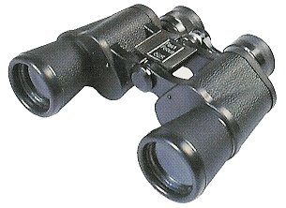 | Binoculars - Size 7 x 50 are preferred. Binoculars are needed to view aids or objects that are located in locations where it may be unsafe to operate an operational facility (OPFAC) to get a close up view of potential discrepancies. Many small, inexpensive and powerful binoculars or monoculars are commercially available and will make a perfect addition to your personal Navigation Kit.

Time Piece - A stopwatch is a useful tool for timing the period of an aid’s light. Any good wristwatch also satisfies this operational need. Your GPS set can provide very accurate date and time information that must be reported when taking fixes and depths alongside aids. Set up a GPS screen to show time, Lat/Lon, and EPE (Estimated Position Error). The screen set up in Figure 1 below is a very handy reference for collecting data when locating objects on-scene. | 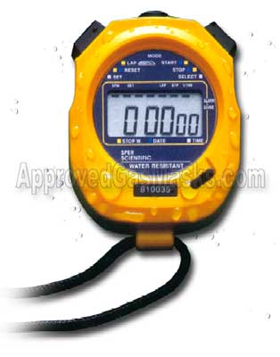

Figure 1 – Three-line GPS Screen
Latitude Longitude
42–36.450 N 070-23.300 W
12.4 ft EPE
Time: 14:45

GPS - A GPS set with DGPS (Differential GPS) or WAAS (Wide Area Augmentation System) can provide location (LAT/LON) data accurate to within 8 to 10 feet. WAAS usually comes as a standard feature on new GPS sets. Ten feet is inside the limits of the width of the ordinary OPFAC. If you use one of the fine hand-held GPS models that are currently available, be sure to buy a power cable that plugs into your vessel’s 12v power. Also, add spare batteries for your GPS to your Navigation Kit. Consider purchasing a hand-held GPS mounting bracket and attaching your hand-held GPS to a plotting board or large clipboard. The board will hold your GPS set while underway and can keep your reference documents from blowing away. Good organizational practices speed up the on-scene observations and recording time. | 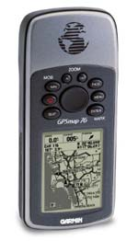

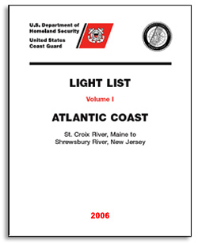 | The Light List contains a listing for most of the aids to navigation in your AOR. Some private aids are not listed in the Light List. Different volumes are available depending on your geographic location. Links to the Light List is available on line from the Internet at “http://www.navcen.uscg.auxodept.org/atons.htm.” Print out only those pages that relate to the area where you operate your boat. Use the National Aid to Navigation Web Site for a link to the Light List that covers your AOR. Check the on-scene observations of each aid to navigation against its entry in the Light List. Also, validate the observation of the aid and the entry in the Light List to the symbols and abbreviations used to identify the aid on a nautical chart. Any mismatch is a reportable discrepancy. Charted errors provide an additional Chart Updating report to NOAA. The assigned position of a charted aid is changed by NOAA from reports made to the Coast Guard. NOAA picks up aid position corrections from official Coast Guard reports.
LNM – Local Notice to Mariners - Keep your flotilla charts and other nautical publications updated to the latest Notice to Mariners. The LNM is available on a weekly basis and is published on the Coast Guard’s Navigation Center web site. Prudent mariners update their nautical chart(s), Light List and Coast Pilot before every ATON patrol.

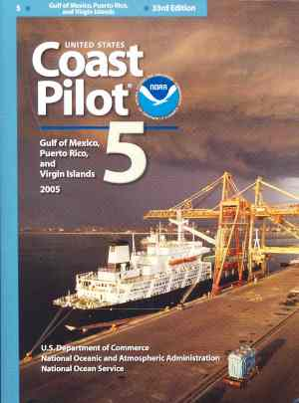 | Coast Pilots contain information that is not easily included on the nautical chart. Links to this publication are available on line at “http://www.auxodept.org/atons.htm.” Print out only those pages that pertain to your area of operation (AOR) and keep them in your personal Navigation Kit. Use the National Aid to Navigation Web Site for a link to the Coast Pilot with coverage for your AOR. It is always a good practice to review the Coast Pilot data while you are performing ATON activity or when you are planning a patrol. Usually, if you do not preplan an event, nothing productive happens. Submitting Chart Update and Small Craft Facility reports to NOAA update Coast Pilots.

Chart No. 1 contains every abbreviation and symbol used on a nautical chart and should be part of the Navigation Kit of every serious navigator. While this publication is also available on-line, it is better to purchase a hard copy. Every authorized marine chart dealer should stock a copy or you can purchase a copy from the major on-line book dealers. Use the National Aid to Navigation Web Site for a link to this publication. | 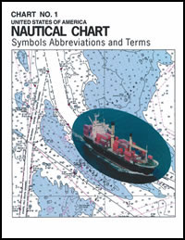

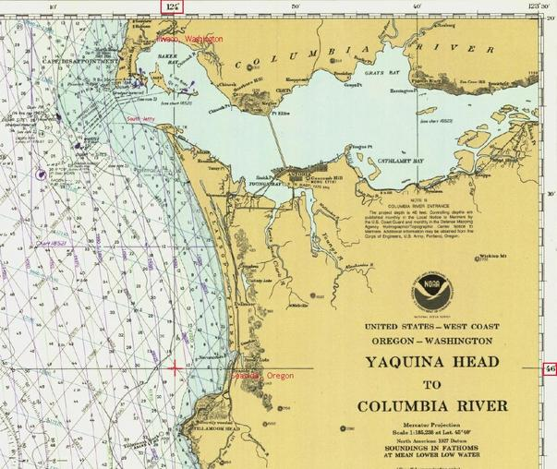 | NOAA Nautical Chart - Every OPFAC should be using the latest NOAA nautical chart that is updated to the latest LNM - Local Notice to Mariners.  A link to NOAA Nautical Charts is available on line at: “http://www.auxodept.org/atons.htm.” A link to the LNM corrections for every NOAA nautical chart is available on the National Aid to Navigation Web Site. Keep copies of the current NOAA Nautical Charts in your personal Navigation Kit.  While coxswains and OPFAC owners are responsible for maintaining up-to-date nautical charts on their OPFAC, FSO Staff officers should offer their chart correcting skills and services to the OPFAC owners in the flotilla as a regular part of their job.  Starting on April 1, 2007, members who submit chart updates to NOAA can order and receive a free replacement chart from NOAA. The Flotilla Chart Updating activity should be managed by the FSO-AN.

The “ANSC-7054 Aid to Navigation Report” is available on the National Forms Web Site. Print out some blank forms for use while on patrol. Keep adequate copies of this form in your Navigation Kit along with a copy of the form’s instructions.

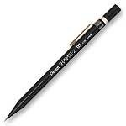 | Pencil - An automatic pencil using 0.5 HB lead with an eraser is ideal. It is always sharp. Include extra pencils, leads and erasers in your personal Navigation Kit. If you decide to use regular wooden pencils, add a small pencil sharpener to your personal Navigation Kit.

Plotter – A paraglide plotter is the more practical plotting instrument to use on a small boat. Be sure your plotter has wheels to easily roll it on your chart without losing the course angle. Prudent mariners always plot their intended courses on their nautical chart before they get underway. Modern mariners take the extra step to establish waypoints and routes in their GPS, and schedule their aid verifications and checks along the route. This practice not only speeds up the ATON patrol but also saves much time and fuel. It also provides a great opportunity to teach navigation to the crew between planned ATON events. There are many different plotters available. | 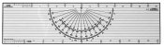

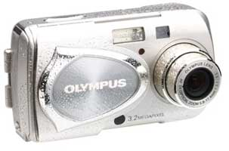 | Digital Camera – A digital camera is a great tool for communicating discrepancies to the Coast Guard. Purchase a computer cable with your camera to be able to download your pictures to your PC so that they can be transmitted to the appropriate C.G. Unit or Agency. One picture of a discrepancy is often worth a thousand words. This phrase may sound trite but it is true and photos of a discrepancy greatly increase the credibility of your discrepancy reports with the Coast Guard.  Remember to record the number that is assigned to the picture by the camera on your “ANSC 7054 Aid to Navigation Report” form as you take the photos. This practice eliminates any confusion about what has been photographed when you are finalizing your report for the Coast Guard.

Special Developments  Some Auxiliarists have fabricated many unique tools and instruments. Examples are sounding poles for shallow depths, chain and wire drags, tools for measuring the angle of leaning aids, and plotting boards fitted with mounting devices for hand held GPS sets. Also, there are EXCEL systems developed that calculates the distance an aid is off station using location (Lat/Lon) and almanac data available on your GPS. Check out the “Vertical and Horizontal Error Calculator” on the National ATON Web site at http://www.auxodept.org/atons/htm. The use of GPS sets with chart plotters and computerized charts facilitate the checking of whether aids are on station | Calculators  There are many calculations that are needed when checking and preparing Federal Aid discrepancy reports. Add a good calculator to your Navigation Kit. The ideal unit would have a solar panel and a battery system for nighttime use. You may have to get two units. Do not forget to add spare batteries to your personal Navigation kit. | 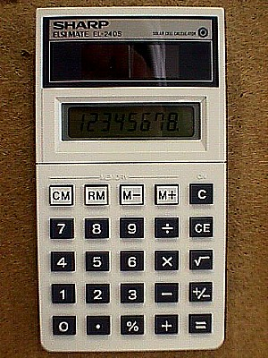
 |  | Hand Held Calculator with solar panel.

References:

USCG Aids to Navigation Manual – Administration COMDTINST M16500.7A
Light List – COMDTPUB P16502.1
The Coast Pilot
Chart No. 1
LNM - Local Notice to Mariners
NOAA Nautical Charts
CDB - Conventional Direction of Buoyage
In U.S. waters, the IALA-B system of lateral marks, with few exceptions, is arranged in geographic order known as the “conventional direction of buoyage”. The memory aid 3R rule of "Red, Right, Returning from the sea" applies. This means “keep the red markers to the right hand side of the vessel” when returning from seaward and when transiting from north to south along the Atlantic Coast, from south to north and east to west along the Gulf Coast, from south to north and east to west along the Pacific Coast, and from east to west in the Great Lakes except for Lake Michigan which is north to south.

Figure 2 – CDB - Conventional Direction of Buoyage Graphic
The IALA-B System of Aids to Navigation
The U.S. Aids to Navigation System is predominantly a lateral system, which is consistent with Region B requirements of the International Association of Marine Aids to Navigation and Lighthouse Authorities (IALA-B) Maritime Buoyage System, except for the U.S. possessions west of the International Date Line and those south of 10 degrees north latitude, which follow the IALA-A Aid to Navigation System.

THE LATERAL SYSTEM AS SEEN WHEN ENTERING FROM SEAWARD

Lateral marks define the port and starboard sides of a route to be followed. Their most frequent use is to mark the sides of channels. However, they may be used individually to mark obstructions located outside of clearly defined channels. Lateral marks normally have three criteria that assist the mariner in their quick identification – shape, color, and numbering. Lighted lateral aids use the same light color as the aid color. Lighted aids are often made up from a buoy body and the structure on which the light is mounted. While this voids the shape criterion, the light color becomes the third criteria during the nighttime and periods of reduced visibility. All solid red and solid green aids are numbered , with red aids bearing even numbers and green aids bearing odd numbers. Numbering increases from seaward toward the land, from the mouth of rivers upstream, and clockwise around islands. Numbers are kept approximately sequenced on both sides of the channel by omitting numbers where necessary.

Only sidemarks are numbered. However, aids other than those indicated above may be lettered to assist in their identification, or to indicate their purpose. Sidemarks may carry letters in addition to numbers to identify the first aid to navigation in a waterway, or when new aids to navigation are added to channels with existing completed numberical sequences. Letters on sidemarks will follow alphabetical order from seaward and proceeding toward the Conventual Direction of Buoyage. Letters will be added to numbers as suffixes.

Aids to Navigation may be fitted with light-reflecting material to increase their visibility in darkness. The color of this material may convey the same significance as the aid except that letters and numbers may be white. Exceptions will be found on Western Rivers.

Lateral marks include side marks and preferred channel marks. Side marks are not always placed directly on a channel’s edge and may be positioned outside the channel as indicated on charts and nautical publications.

Port Side Marks indicate the left side of channels when proceeding in the Conventional Directions of Buoyage. They normally show as a square or can in shape, are green in color, and are numbering. Beacons have green square daymarks while buoys are green cans or pillar buoys. Green lights of various rhythms are used on port hand marks.

Figure 3 - Port Side Odd Numbered Aids

 | Green Light Only
 | Flashing (2)
 | Flashing
 | Occulting
 | Quick Flashing
 | ISO
 |   Light | 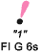 |   Lighted Buoy | 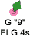
 |   Can |  |   Daybeacon
Note that the numbers on daymarks are the color of the aid while the numbers on buoys are white.

Preferred Channel Aids
Figure 4 – Preferred Channel Aids

Preferred Channel to Starboard - have no numbers but may be lettered.
Use as Port Side aids in the Primary Channel; used as Starboard Side aids in the Secondary Channel.
The topmost bands are colored green.
 |  | Green Light Only
Composite Group Flashing (2+1)
 |  |  | 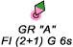
 |   Daybeacon |  |   Can
Preferred Channel to Port - have no numbers but may be lettered.
Use as a Starboard Side aids in the primary channel, used as a Port Side aids in the Secondary Channel.
The topmost bands are colored red.
 |  | Red Light Only
Composite Group Flashing (2+1)
 |  | 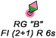 | 
 | 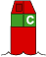  Nun | 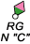 |   Daybeacon

Starboard Side Marks indicate the right side of channels when proceeding in the conventional directions of buoyage. They normally show as a conical or nun shape, are red in color, and have even numbering. Beacons have triangular red daymarks while buoys are red nuns or pillar buoys. Red lights of various rhythms are used on starboard hand marks.

Figure 5 – Starboard Side Even Numbered Aids
 | Red Light Only
 | Flashing (2)
 | Flashing
 | Occulting
 | Quick Flashing
 | ISO
 |   Light | "2"  FI R 6s |   Lighted Buoy | 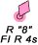
 | Note that daymarks have colored numbers. |  | Note that buoys have white numbers.
 | 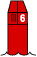  Nun | R  N"6" | 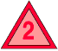  Daybeacon | 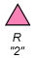
Note that the numbers on daymarks are the color of the aid while the numbers on buoys are white.

Junction – The point where a channel divides when proceeding to seaward. The point where a tributary departs from the main channel

Bifurcation – The point where a channel divides when proceeding from seaward--the place where two tributaries meet.

Crossing – The point where a main and secondary channel cross each other.

Note the placement of the preferred channel buoys in the three examples below. The main channels are labeled as 1. The secondary channels are labeled as 2.
Figure 6 – Junctions and Bifurcation Patterns

Strictly defined, a Beacon is any fixed aid to navigation. For our purposes, however, we take beacons to mean all minor lights of relatively low candlepower and daybeacons. Fixed aids provide immobile, stable signals. Floating aids do not. Beacons, therefore, are superior to floating aids in the signal quality they provide to the mariner. Beacons may be set back from the channel edge to protect them from damage. The utility of a beacon decreases as its distance from the channel edge increases. When beacons must be set back, the distance from the channel edge should remain constant within a waterway.

Buoyant beacons appear to be fixed, but in actuality are moored to the bottom by a sinker. They remain afloat through use of a buoyant collar attached below the waterline. Buoyant beacons are deployed only in unusual situations where their high cost is offset by the requirement for a reduced watch circle. An articulated light is a vertical pipe structure supported by a submerged buoyancy chamber and attached by a universal coupling to a weighted sinker on the seafloor. The light, allowed to move about by the universal coupling, is not as precise as a fixed aid. However, it has a much smaller watch circle than a conventional buoy, because the buoyancy chamber tends to force the pipe back to a vertical position when it heels over under the effects of wind, wave, or current. Articulated lights are primarily designed to mark narrow channels with greater precision than conventional buoys.

Buoys are unmanned, floating aids to navigation moored to the seabed. They may be lighted or unlighted.

AIDS TO NAVIGATION HAVING NO LATERAL SIGNIFICANCE

Safe Water Marks indicate that there is navigable water all around the mark. They are often mark fairways, midchannels, and offshore approach points or ends of channels. Safe watermarks have red and white vertical stripes, are spherical in shape and are never numbered. When a Safe Water mark is lighted or fitted with a sound signal, its buoy displays a red spherical topmark. Daybeacons have octagonal daymarks. Lighted Safe Water marks show a white light with a Morse Code “A” rhythm. | 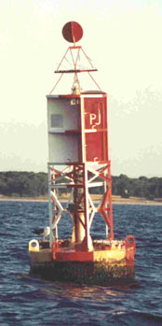

Figure 7 - Safe Water Marks
Have no numbers but may be lettered.
White light only, shows a Morse code rhythm.
Mo(A)
 | RW N"  Mo(A) |  | RW  "A" |   Can |  |  | RW "N"

Isolated Danger marks are erected on, moored over, or placed immediately adjacent to an isolated danger which may be passed on all sides by mariners. They are black with one or more broad horizontal red bands and are fitted with a topmark of two black spheres, one above the other. When lighted, they display a white light, group flashing (two) with a period of five seconds. Do not approach these aids closely without special caution.

Figure 8 - Isolated Danger Marks
Have no numbers but may be lettered.
White Light Only
FI(2) 5s
 |  | BR"A"  FI(2) 5s | Lighted |  | Unlighted | BR "C"

Special Marks are not primarily intended to assist safe navigation, but more to indicate a special area or a feature referenced on charts or in another nautical publication. They may be used, for example, to mark anchorages, cable or pipeline areas, traffic separation schemes, military exercise zones, ocean data acquisitions systems, etc. Special marks are colored solid yellow and, when lighted, show yellow lights with a slow-flashing rhythm preferred. Special marks may not show a quick-flashing rhythm. Yellow retro-reflected material is used on Special Marks. Many special marks are often private aids.

Figure 9 - Special Marks — May Be Lettered.
Yellow Light Only
 |  |  | Fixed
 |  |  | Flashing
 |  |  |  |  |  | 

Information and Regulatory Marks are used to alert the mariner about various conditions or regulatory matters. These marks have orange geometric shapes against a white background. When lighted, these marks show a white light with any rhythm not reserved for other types of aids. The meanings of the orange shapes are:

A vertical open-faced diamond shape signifies danger. These buoys are often termed, “Danger Buoys.” The nature of the danger is often indicated inside the diamond shape, such as, Dam, Rock, Shoal, etc.

A vertical diamond shape with a cross centered within the diamond indicates that vessels are excluded from the marked area. These buoys are often called, “Exclusion Buoys.” The explanation for the exclusion may be placed outside the crossed diamond shape, such as, Exclusion Area, Dam, Rapids, Falls, etc.

A circular shape indicates that certain operating restrictions or controls are in effect within the marked area. These buoys have various names, such as, No Wake Buoy, Speed Buoy, Regulatory Buoy, Swim Buoy, etc. The type of control is shown within the circle. Other restrictions may be placed outside the circle.

A square or rectangular shape will displaying information such as directions, locations, distances, etc.

Many Class 3 private aids are regulatory marks. Figure 10 below depicts examples of Information and Regulatory Marks.

Figure 10 - Information and Regulatory Marks
When lighted, may display any light rhythm except quick flashing and flashing (2)
NW White Light Only
 |   Exclusion  Area |   Restricted  Operations | Danger

Information and Regulatory Marks are used to alert vessel operators to various warnings or regulatory matters. Examples:
Boat Exclusion  Area   | Danger   | Controlled  Area  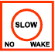
Explanation may be placed outside the crossed diamond shape. | The nature of danger may be indicated inside the diamond shape, such as rock, wreck, shoal, dam, etc. | Type of control is indicated in the circle, such as slow, no wake, anchoring, etc.
Information  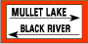 |  | 
Used to display directions, distances, locations, etc. | This buoy may be used to display regulatory markers. | May show white light and  may be lettered.

Mooring Buoys are white with a blue horizontal band. This distinctive color scheme facilitates identification and helps the mariner distinguish these buoys from regular aids to navigation. When lighted, mooring buoys display a white light with any rhythm not reserved for aids to navigation. Federal mooring buoys and those private mooring buoys that are permitted as Private Aids to Navigation and are charted or included in the Light List shall be listed in I-ATONIS. Ball-shaped mooring buoys are more common. | Mooring Buoys  May show white light or white reflector.
   | 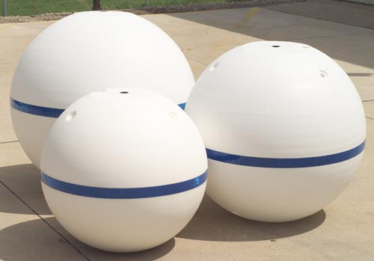

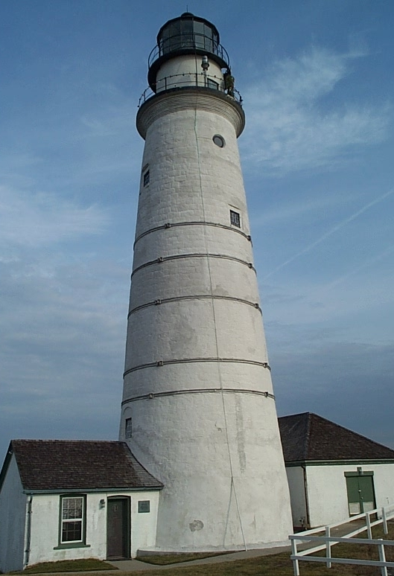 | Major Lights are lights of moderate to high candlepower and reliability that are exhibited from a fixed structure. They do not fall under the IALA agreement. While their signal characteristics are largely discretionary, they will be marked to provide maximum information while avoiding conflicts with nearby aids displaying IALA markings. The coloration of a light is often distinctive in order to avoid confusion with any nearby lights. The color of the structure is intended to allow the light tower to clearly stand out from its background.  A major light may or may not have colored sectors with higher intensities. Major lights have an availability standard of 90% and fall into two broad categories:
Coastal or seacoast lights assist vessels during coastal navigation or when making a landfall. Their operational range should, based on local visibility conditions, supply needed navigation data 90% of the time for the transition of the mariner into waters marked by the short range system.

Inland major lights are found in bays, sounds, and coastal approaches. They can serve a variety of functions including use as a leading light, a range light, an obstruction mark, a sector light, or simply a reference mark from which to obtain a needed visual bearing or radar range. They should have sufficient intensity so they are visible over their usable range 90% of the nights of the year when local visibility conditions are considered.
Discrepancies on major lights.

- Aid is extinguished. Most major lights are unmanned and therefore should be checked each time they are passed. Many lights operate 24/7 and can be checked during daylight hours.

- Aid has been vandalized. Most major lights are located in remote areas and, since they are unmanned, are susceptible to vandalism.

- Also, check the discrepancies related to lanterns.

Directional or Sector Lights are devices that generate two or more defined regions by displaying different light color characteristics. In practice, directional lights have three sectors, usually have red and green sectors separated by a white sector. They are used to give an indication of a vessel’s position with respect to the center of a waterway. Because there is only one light source, the mariner has no indication of how fast a vessel is moving across a given sector nor how far into a sector has a vessel moved. Directional lights should be avoided when an aid is needed to initiate a turn and the turn must be started an appropriate distance before the intersection of the channel centerlines. | Sector Lights  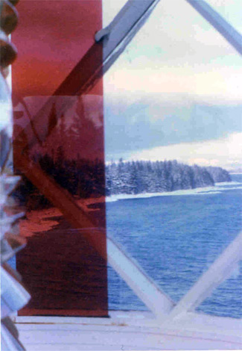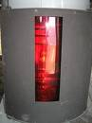

Sector lights are commonly used to provide mariners with a warning that they are in an area where navigation may be impaired by a shoal, rock, etc. The mariner will have to use other aids or navigational tools to determine position relative to the danger. In practice, sector lights commonly have two sectors (usually red and white).

Fog Detector  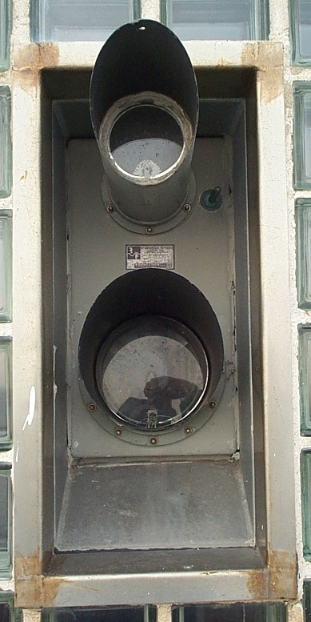 | Fog detectors are very convenient devices for controlling sound signal operation. They are particularly useful where a live watch could be reduced or a radio link to a remote station could be eliminated. Fog signals are usually calibrated to energize the sound signal when the visibility drops below 3 miles.  Discrepancy on a fog detector.  - The fog detector is inoperative.

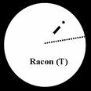  A RACON is a radar transponder, which produces a coded response, or radar paint to the interrogating radar set, when triggered by a surface search radar signal. Normally, they are operated in the frequency ranges of the X-band and S-band marine radars. RACONs provide radar enhancement, help improve aid identification, and help during the transition from ocean to inland navigation. This is accomplished by placing a RACON:  - On a prominent point of land that allows the mariner to make a positive identification of the point for a landfall.  - On an aid to distinguish the aid from other aids and vessels where many echoes appear on the radar screen.  - Temporarily, on an aid that marks a new danger.  RACONs are coded with Morse-code letters that begin with a dash and contain no more than four elements. The code usually reflects letters that are consistent with the name of the location. The letter “D” is reserved for RACONs marking new, uncharted dangers. | RACON  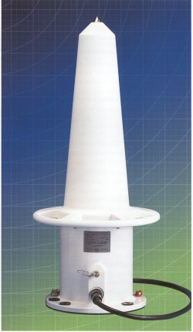
Discrepancies on a RACON:

      - The aid’s RACON is off the air.

      - The aid’s RACON is emitting improper characteristics per the Light List.

A Sound Signal is located on or adjacent to aids to navigation . When visual signals are obscured, sound signals warn mariners of the proximity of danger. A fog signal is a device that transmits sound, intended to provide information to mariners during periods of restricted visibility. The term also applies to the sound emitted by the device. Sound signals are distinguished by their tone and phase characteristics.  Phase characteristics are defined by the signal’s sound pattern—the numbers of blasts and silent periods per minute and their duration. Tones are determined by the devices producing the sound—diaphones, diaphragm, reed horns, sirens, whistles, bells and gongs.  Due to the inability of the human ear to accurately judge the direction of a sound source, these signals are limited to only one general use—the signal serves to warn mariners of the proximity of an obstruction.  Although sound signals are valuable, mariners should not implicitly rely on them when navigating. Instead, they should be considered supplements to radar and radio-navigation aids during reduced visibility navigation.  Wave actuated signals are used where environmental conditions permit. When two or more channels are located in the same general area, such as near a junction or bifurcation, a different signal type is used for each waterway to assist in identification. Historically, mid-channels, fairways, and approaches have been marked with whistles. They can also be marked with an electronic horn.  The Coast Guard is discouraging the use of sound signals in lateral situations such as placing gongs to port and bells to starboard and is discouraging mariners from relying implicitly on sound signals.  Discrepancy on a sound signal:  - The sound signal, either a bell, a gong, a horn, or a whistle, is inoperative. Sound signals may be electrically operated or wave actuated.  - The tappers on a gong or a bell are missing.  - The sounding device is missing.  - The fog horn is inoperative | Sound  Fog Signals  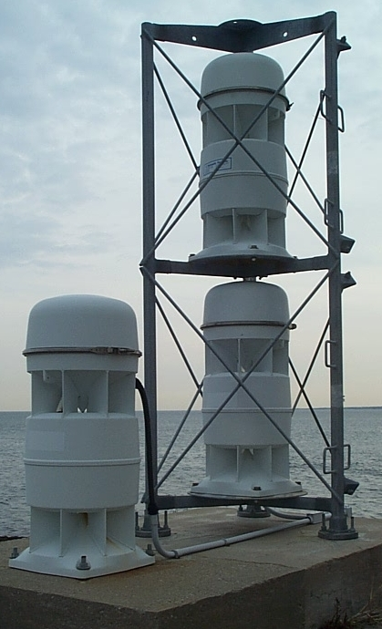  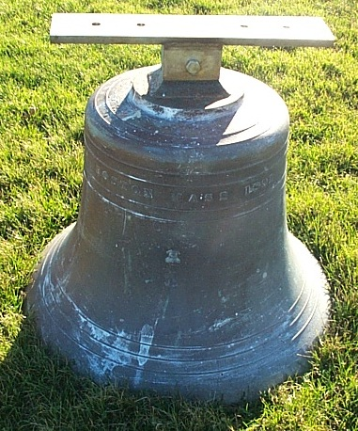
Other ranges, sector lights, and crossing marks do not fall under the IALA agreement. While their signal characteristics are largely discretionary, these aids should be marked to provide maximum information to the mariner while avoiding conflicts with nearby aids displaying IALA markings.
Maritime Radiobeacons
Maritime radiobeacons operate during specific intervals as published in the Coast Guard Light List. For station identification, simple characteristics of combinations of dots and dashes are used. These characteristics are transmitted within a 15 second cycle followed by a silent period that completes the cycle. The transmitter power of each radiobeacon is adjusted to provide a useable signal at the required service range for the radiobeacon. Marker-beacons are of low power for local use only. Coast Guard radiobeacons operate within the frequency band 275-335 kilohertz.

The Western River System

The Western Rivers system differs from the U. S. Aids to Navigation System due to the unstable nature of the river waters and channels. The Coast Guard operates this system on the Mississippi River, its tributaries, South Pass and Southwest Pass to the navigational demarcation lines dividing the high seas from harbors, rivers and other inland waters of the United States. The system is also used on the following rivers and waterways

Port Allen-Morgan City Alternative Route.

That part of the Atchafalaya River above its junction with the Port Allen-Morgan City Alternative Route including Old River and the New River.

The Tennessee-Tombighee Waterway.

Tombigbee River.

Black Warrior River.

Alabama River.

Coosa River.

Mobile River above Cochrane Bridge at St. Louis Point.

Flint River.

Chattachoochee River, and

Apalachicola River above its confluence with the Jackson River.

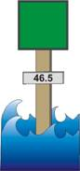 | The Western Rivers marking system differs from the U.S. system in that:  - Buoys are not numbered and shore structures are not numbered laterally.  - Numbers displayed on distance markers suspended on shore structures, or from lateral or crossing day boards, indicate mileage from a designated point established by each District.  - Charts are marked with a magenta line perpendicular to the waterway channel with the statute mileage given every five miles.  - Diamond-shaped non-lateral daymarks, checkered red-and-white or green-and-white as appropriate, are used instead of triangular or square lateral daymarks where the river channel crosses from one bank to the other.

- The Conventional Direction of Buoyage, for installing the proper aid signals, is upstream. Local terminology, however, refers to the "left" and "right" banks viewed from a vessel proceeding downstream.

- Lights on the right descending bank show single flashing rhythms and may be green or white. Lights on the left descending bank show "group-flashing-two" rhythms and may be red or white.

- In pooled waters (behind dams), buoys should mark the nine-foot contour for normal pool elevations.

- In unstable waters (free-flowing rivers), buoys should mark the project depth for the prevailing river stage. Buoys may be set in deeper water when a drop in water level is predicted. Buoys should not normally be set, however, in water depths less than the project depth when a rise in water level is predicted. Constantly changing river conditions prevent strict design guidelines. Unit Commanding Officers and Officers-in-Charge must use their best judgment concerning the number and placement of aids. Isolated danger marks are not used.

Figure 11 – Western Rivers - Port Side or Right Descending Bank
Green or White Lights
Flashing
ISO
  Center |   Lighted Buoy |  | Can
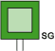  Passing Daybeacon |  |   Crossing Daybeacon | May Be Lighted
 | Statute Mile Board (Marker)

Figure 12 – Western Rivers - Preferred Channel Marks
Mark Junctions and Obstructions
Composite Group Flashing (2)

Preferred Channel to Starboard  Topmost Band is Green | Preferred Channel to Port  Topmost Band is Red
FI (2+1) G | FI (2+1) R
 |  |  | 
Lighted Buoy | Can | Lighted Buoy | Nun

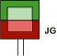 | 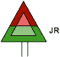
Passing Daybeacon | Passing Daybeacon

Figure 13 – Western Rivers - Starboard Side or Left Descending Bank
Red or White Lights
Flashing
ISO
  Light |   Lighted Buoy |  |   Nun
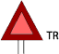  Passing Daybeacon |  | 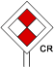  Crossing Daybeacon | May Be Lighted
Statute Mile Board or
Distance Marker

Western Rivers Light Rhythms
Light rhythms are employed as follows:

- Aids with lateral significance display regularly flashing or occulting light rhythms. Ordinarily, flashing lights will be used—frequency not exceeding 30 flashes per minute.
  - Lights on green buoys and on beacons with green daymarks show a single flash which may be green or white.
  - Lights on red buoys and on beacons with red daymarks show a double flash—group flashing 2—which may be red or white.
- Preferred Channel Marks display a composite group flashing light rhythm—groups of two flashes followed by one flash.
- Safe Water Marks display a white Morse Code “A” rhythm—short-long flash.
- Isolated Danger Marks, when used, display a white group flashing two rhythm.
- Special Marks display yellow lights with fixed or slow flashing rhythm preferred.
- Mooring Buoys and Information and Regulatory Marks display white lights of various rhythms.
- For situations where lights require a distinct cautionary significance, as at sharp turns, sudden channel constrictions, wrecks or obstructions, a quick flashing light rhythm may be used—60 flashes per minute.
- The Intracoastal Waterway System – ICW
The ICW variation of the U.S. Marking System is employed along the Atlantic and Gulf Intracoastal Waterways. It differs from the standard U. S. Marking System by displaying distinctive yellow bands, triangles, or squares to signify ICW significance and distinguish them from other aids marking other waters. In addition to the conventional signals, aids marking the ICW differ from the U.S. Aids to Navigation System in that:

- ICW aids display a distinctive yellow symbol according to aid type and function. Distance Markers may be used. The distance indicated is from a designated point established by each district.

ICW Markings. Yellow symbols indicate that an aid marks the Conventional Direction of Buoyage on the Intracoastal Waterway—southerly along the East coast, westerly along the Okeechobee waterway, and westerly along the Gulf coast. Yellow retro-reflective tape is used on Intracoastal Waterway marks.

Yellow Triangles indicate starboard hand aids when following the ICW's conventional direction of buoyage. Aids with yellow triangles should be passed by keeping them on the starboard (right) side of the vessel.

Yellow Squares indicate port hand aids when following the ICW's conventional direction of buoyage. Aids with yellow squares should be passed by keeping them on the port (left) side of the vessel.

Yellow Horizontal Bands are used on non-lateral aids such as:
- Safe Water Marks,
- Isolated Danger Marks,
- Front Range boards. Rear range boards do not display the yellow band because it would be too inconspicuous.
- Preferred Channel Marks. At a junction with a federally maintained waterway, the preferred channel mark will display a yellow triangle or square as appropriate for the conventional direction of buoyage of the ICW. Junctions with the ICW and privately maintained waterways are not marked with preferred channel buoys.

The yellow horizontal band provides no lateral information, but simply identifies the aid as marking the ICW.

Dual Purpose Aids. When a regular channel is also used as an ICW channel or crosses an ICW channel, the IALA-B System of Aids to Navigation applies for the regular channel, and this role is reversed and marked for ICW transit. In this situation, cans may be marked with yellow triangles and nuns may be marked with yellow squares—therefore, the term Dual Purpose. Vessels transiting the regular channel follow the IALA-B system of Aids to Navigation. Vessels transiting the ICW would observe the yellow ICW markings.

Figure 14 – Samples of ICW marked Aids

 |  |  |  |  |  |  | 

Marking of Co-axial Waterways

Occasionally, it is necessary, in a wider waterway, to mark a deep draft channel along with wider boundaries for a shallow draft channel. In this situation, the aids in the deep draft channel are named and numbered first. The name will include a noun indicating a feature of that route (channel, traffic lane, cut, or canal). The aids that mark the broader expanse of water are numbered next. They would not reference the noun used for the deep draft channel. Also, it may not be numbered in pure numerical sequence with the deep draft channel. Alpha-numerics are often used for the shallow draft channel aids. However, on a wide river, the shallow draft channel could be numbered totally independent from the deep draft channel.

Figure 15 – Co-axial Waterway
Variations on the Conventional Direction of Buoyage

At times, strict adherence to the use of flood to determine the conventional direction of buoyage can cause confusion and result in an inconsistent marking scheme. This situation is more likely to occur near islands or river mouths. In the figure below, an apparent confusing situation exists between points “B” and “C”. This was eliminated by deviating from the rules and changing the direction of buoyage to go from point “B” to point “C.

Figure 16 – Variations on the direction of Conventional Buoyage

The Uniform State Waterway Marking System (USWMS)

Inland Waters Obstruction Mark. On inland waters designated by the Commandant as State waters, in accordance with 33 CFR66.05-5 (33CFR66.05-100) provides the specific listing of navigable waters designated as State waters), and on non-navigable internal waters of a State. which have no defined head of navigation, a buoy showing alternate vertical black and white stripes may be used to indicate to a vessel operator that an obstruction to navigation extends from the nearest shore to the buoy. The black and white buoy's meaning is “do not pass between the buoy and the shore''. The number of white and black stripes is discretionary, provided that the white stripes are twice the width of the black stripes. | Figure 17  Inland (State) Waters  Obstruction Mark  May show a white reflector or a quick flashing white light.  

Cardinal Marks. These marks indicate, in the cardinal points of the compass, the direction of good water from the aid. They are not used in the U.S. Marking System but may be encountered in Canadian waters. .
Figure 18 - Cardinal System Marks may show a white reflector or a white light.
 |  | 
Red striped  white buoy | Black topped  white buoy | Red topped  white buoy
Do not pass between buoy and nearest shore. | Think that the black top represents a northeast storm. Pass to north or east of this buoy | Think that the red top represents heat and the hottest area is in the southwest. Pass to south or west of this buoy

Lanterns, Navigational

Figure 19 - The Elements of a Navigational Lanterns

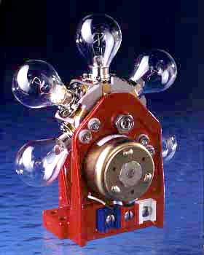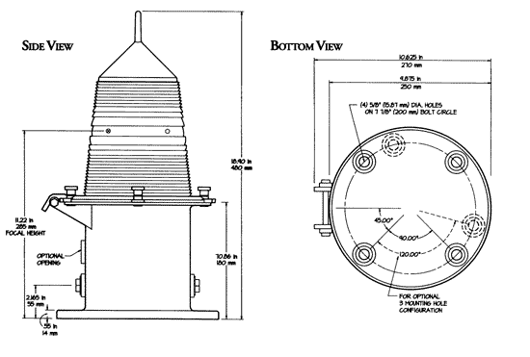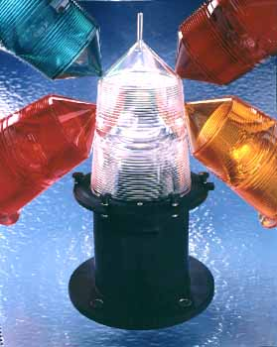
6 Place Lamp changer 155 MM Lanterns

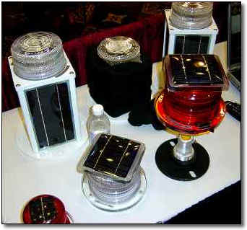 | Solar LED Lanterns are self-contained units that eliminate the mechanical problems of previous lanterns such as the lamp changer. Each unit comes equipped with a battery, solar panels, and an LED light. They provide a high level of reliability while expanding the servicing cycle of the aid. Different sizes are available depending on the size of the solar panel required to maintain the light on the aid. While the light color is unalterable, the units provide options for different light characteristics and rhythms. The lights are available with different color lights, and solar panel power production. Solar LED lanterns are currently being deployed throughout the country.  Smaller size LED lanterns are available for use on private aids.

Figure 20 – Solar LED Lanterns

Light Characteristics

An aid's light characteristic consists of its color and rhythm. Authorized colors are red, green, white, and yellow. A light’s characteristic is determined by the aid’s function. The quick rhythm is the most conspicuous and is used on important lateral aids, such as aids in turns, marking shoals, and marking wrecks. Light characteristics convey additional information:

When proceeding in the Conventional Direction of Buoyage, aids to navigation, if lighted, display light characteristics as follows:
- Green lights mark the port (left) side of channels and locations of wrecks or obstructions which are to be passed by keeping these lights on the port (left) side of the vessel. Green lights are also used on Preferred Channel Markers where the topmost band is green.
- Red lights mark the starboard (right) side of channels and locations of wrecks or obstructions which are to be passed on the starboard (right) side of a vessel. Red lights are also used on Preferred Channel Markers where the topmost band is red.
- Certain lights on the Intracoastal Waterway may display reversed lateral significance.
- Yellow lights have no lateral significance.
- White lights, except on the Western Rivers, have no lateral significance. The purpose of aids exhibiting white lights may be determined by their shape, color, letters or numbers, and the light rhythm employed.

Authorized rhythms are:

Fixed (F) – shows a continuous, unblinking light. Not authorized for lateral aids.

Flashing (Fl) – the duration of light is clearly shorter than the duration of darkness. Frequency not greater than 30 flashes per minute.

Quick Flashing (Q) – the light duration is shorter than the duration of darkness. Frequency is at least 60 or more per minute.

Very Quick Flashing (VQ) – the light duration is shorter than the duration of darkness. Frequency is at least 100 per minute.

Interrupted Quick Flashing (IQ) – is similar to quick flashing but has a brief, extended darkness period.

Group Flashing (Gp Fl (x+x)) – Combination of two patterns in one period, i.e. 2 flashes followed by three flashes would appear as Gp Fl (2 + 3). The darkness in between the groups is clearly longer than the darkness between flashes.

Long Flashing (LFL) – One long flash in a lighted period of at least 2 seconds.

Slow Flashing – less than 30 flashes per minute. The adjective ‘slow” is usually omitted.

Isophase (Iso) – Light has equal duration between light and darkness. Period consists of both light and dark interval. Also called Equal Interval (E Int).

Occulting (Occ) – is the opposite of flashing – the light is on more than it is off.

Alternating (AL) – an alternating light changes color. It is used as a special purpose light for situations requiring significant caution.

Morse (Mo) – groups flashes (long and short) to form Morse code characters. Example: Morse code “U” shows two short flashes followed by one prolonged flash then a period of darkness.

Discrepancies on lights:

      - The light signal is showing improper characteristics or rhythm. Must be observed during periods of darkness.

      - The light signal is obscured. Explain the circumstances in the comment section on your report.

      - The light signal is extinguished. Must be observed during periods of darkness.

      - The lantern is damaged. This is always a good photo opportunity.

      - The light is burning dim or showing reduced intensity. Verify by close examination that the "burning dim" or "reduced intensity" condition is not being caused by smoke, by some other atmospheric conditions, by smoke, or by the viewing angle.

      - The aid’s light is partially obscured by dayboards.

      - The battery box is missing or damaged. Note that many lighted aids are being equipped with Solar LED Lanterns which do not need a battery box. The LED lights are self-contained fixtures—LED light, battery and solar panel.

      - The vent valve on a lighted buoy is missing. Aids with Solar LED Light fixtures do not need vent valves.

      - The vent tube(s) on a lighted buoy is broken. Aids with Solar LED Light fixtures do not need vent valves.

      - Bird nests are obscuring the light.

      - The solar panel is damaged or is not oriented correctly. Usually does not apply to Solar LED fixtures. However, do check for damage or vandalism.

RANGES are an aligned pairs of beacons placed to define a line down the center of a navigable channel. They are usually, but need not be, lighted. Criteria for the selection of range sites are:  - Use of existing structures such as lights, or daybeacons whenever possible.  - Shoal areas where shallow water depths will decrease structure construction costs are utilized.  - Access to available commercial power is preferred. | Figure 21 - RANGES  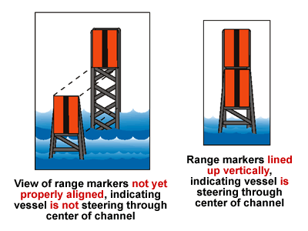
The Front Range (FR) panel or light is usually lower than the rear range (RR) panel or light. Each range provides a mariner with a given lateral sensitivity at a given distance from the near end of the channel. Lateral sensitivity is expressed as Cross-Track Factor and lends a more physical feel to the performance of the range.

- The cross-track factor is a measure of effectiveness for finding and maintaining track on the range axis. A cross-track factor of 25% means that a mariner may be as far as 25% of the distance from the channel centerline to the edge of the channel before determining the vessel is off the centerline.
- Distances of less than two miles are usually marked with dayboards and using standard omni-directional lanterns for nighttime operation.

- Distances of over four miles are commonly marked with daytime lights provided there is an operational requirement to mark the entire channel.

- Distances between 2 and 4 miles are marked as operationally required or as economical as possible.

Discrepancies on ranges:

- Range is not marking the center of the navigable channel. See the Chart Updating section of this manual for instructions for the proper reporting of this discrepancy to the Coast Guard and NOAA.

- Range Panels have faded. Since fading is such a subjective opinion, use the criterion, “Can the range panel colors be interpreted as the wrong color, such as, red for orange or yellow, green for yellow, etc. Then, report the panel as faded.

- Range panels are missing. Note that many ranges that are lighted 24/7 may not have range panels. Recent efficiency improvements in optics combined with solar power has allowed the Coast Guard to expand the use of daytime lighted ranges even when commercial power is not available.

- Range panels are obstructed by brush or new construction. Good photo opportunity.

- Range supporting structure is deteriorated, rotting, or eroding. Good photo opportunity

- Range lights are extinguished.
Guideline for extra pre-underway electronic equipment checks before AN Patrols or activity.

ATON patrols require a very precise use of navigational equipment. Unfortunately, you may find that some of the equipment found on an OPFAC does not meet the accuracy and quality standards needed for taking on scene fixes and depths for the Aid to Navigation program. Do not embarrass yourself by submitting low quality data or by not being able to make proper measurements due to equipment breakdowns or failure. Always be prepared. The two major problematic items are GPS sets and echo sounders.

A handheld GPS that is equipped with WAAS is a great adjunct to your personal Navigation Kit. Verify that it is operating accurately during the pre-underway check by checking it against the OPFAC’s GPS or against a known charted position. Indicate how your GPS was calibrated on your pre-underway checklist. Mount the hand-held GPS to a large clipboard to keep it available throughout the patrol. Purchase a power cord for your handheld GPS that can plug into the OPFAC’s cigarette receptacle to save your GPS batteries. Keep the power cord in your personal Navigation Kit along with spare batteries.

As part of the OPFAC’s pre-underway check, verify that the vessel’s GPS is set up correctly. “Figure 22 – A Suggested Pre-Underway Check List for AN Patrols” lists special items that are tailored for the AN member. Here are a few key items can have a serious effect on the accuracy of your reports.

- Horizontal Datum – Does it match the NOAA nautical chart that you will be using? If not, correct the horizontal datum in the GPS set to match the nautical chart. New GPS sets usually come preset to WGS84 and most NOAA charts have WGS84 datum references.

- Vertical Datum – (Depth) Does the unit of measure on the echo sounder match the depth showing in the General Information Block on the nautical chart that you will be using. When they do not match, adjust the depth unit of measure on your echo sounder before you get underway.

- Nautical miles vs. statute miles – New GPS sets usually come set to statute miles. Ensure that the GPS set you use is reading out in nautical miles.

- GPS headings and bearings – Check whether the read out on the GPS set and the compass match--True or Magnetic. Be sure that you understand how your electronic equipment is reading before you use it.

- Check that the compass is operating correctly – Validate that the OPFAC’s compass is operating accurately. If your boat is moored to a finger float, check the reading that should be constant. Otherwise, use a known range. Electronic compasses are equipped with deviation error compensation features and procedures for correcting for variation error.

- Patrol’s planned route is loaded into the GPS?

- Pre-calibrate the echo sounder. This can be accomplished with a lead line or a sounding pole.

- Check that the OPFACs nautical chart is current and updated to the latest LNM. To be safe, carry the latest nautical charts in your personal Navigation Kit.

Figure 22 – A Suggested Pre-Underway Check List for AN Patrols

Boat Name |  | Length | OPFAC Number | State Reg. Number
Item | Process | Status | Item | Process | Status
Engine | Fuel - Indicate amt of fuel in tank. |  | Boat Gear | Are there sufficient Anchors (2 required)?
Engine | Oil - Checked reservoir |  | Boat Gear | What is length of the Anchor Rode? | ft
Engine | Is there spare oil on board? |  | Boat Gear | Are the heaving lines available on deck?
Engine | Is the Tool kit readably available? |  | Boat Gear | Are there mooring lines?
Engine | Is the Backfire Flame arrestor mounted? |  | Boat Gear | Are there sufficient Fenders?
Engine | Belts – good condition? – spare belt? |  | Boat Gear | Is there a Horn?
Engine | Batteries – charged and covered.? |  | Boat Gear | Is there a Bell?
Engine | Fuel shut offs – where located? |  | Boat Gear | Is a Boot Hook available on deck?
Engine | Transmission fluid – checked? |  | Boat Gear | Radio is operating?  Working channel:  Alternative channel:
Engine | Engine Coolant – checked? |  | Boat Gear | Radio is operating?  Working channel:  Alternative channel: | CH
Engine | Fire Extinguisher System operational? |  | Boat Gear | Radio is operating?  Working channel:  Alternative channel: | CH
Engine | Pollution Placard mounted? |  | Boat Gear | Are the mooring cleats backed?
Engine | Ventilation?  Bilge Blower – checked? |  | Boat Gear | Are the towing cleats backed?
Engine | Ventilation?  Bilge Blower – checked? |  | Boat Gear | Is there an alternative means of bailing?
Engine | Bilge pumps – Fore and Aft? |  | Boat Gear | Is a MSD installed?
Nav Gear | Are the NOAA Charts of AOR on board? |  | Boat Gear | Is there a Swim Platform or  Is there a Boarding Ladder?
Nav Gear | Is the Navigation Kit on board? |  | Boat Gear | Is there a Swim Platform or  Is there a Boarding Ladder?
Nav Gear | Are the Binoculars on board? |  | Boat Gear | Is there a spotlight on board?
Nav Gear | Was the compass pre-calibrated?  Read out is (True or Magnetic)?  Is a Deviation Table available? |  | Boat Gear | Are there flash lights on board?
Nav Gear |  |  | Boat Gear | Is there a Capacity Plate?
Nav Gear |  |  | Boat Gear | Is there a Certificate of compliance?
Nav Gear | Is a RPM Table available on board? |  | Boat Gear | Is there a galley trash disposal card?
Nav Gear | Is there a Timepiece on board? |  | Boat Gear | Knife (min. 3” inches)
Nav Gear | How was Echo Sounder pre-calibrated?  Correction for transducer location (ft) |  | Boat Gear | Are navigation lights operating properly?  Is the anchor light operating properly?  Are there spare bulbs on board?
Nav Gear | Does the Vert. Datum match the chart? |  | Boat Gear
Nav Gear | Is the Light List on board? |  | Boat Gear
Nav Gear | Is the Coast Pilot on board? |  | Boat Gear | Electrical System condition?  Are there spare fuses on board.?
Nav Gear | Is the Tide Tables on board? |  | Boat Gear
Nav Gear | Is the Nav Rules on board? |  | Boat Gear | Is the National Ensign installed?
Nav Gear | Forms, pencils, and paper on board? |  | Boat Gear | Are there Fire extinguishers plus 2?
GPS | How was the GPS calibrated? |  | Boat Gear | Is there a First Aid Kit on board?
GPS | Is the Hor. Datum the same as chart? |  | Boat Gear | Are Blankets (2) available?
GPS | Does GPS Distance = Nautical Miles? |  | Boat Gear | Are PFDs (wearable) plus 2 available?
GPS | Heading (True or Magnetic)? |  | Boat Gear | Are PFDs (throwable) available on deck?
GPS | Vertical Datum (Feet, Fathoms)? |  | Boat Gear | Are VDS available on deck?
SAR | Is there a Portable Pump on board? |  | Boat Gear | Is Auxiliary Ensign on board?
SAR | Is Towing Harness on board? |  | SAR | Are SAR Accident Reports on board?
SAR | Is Towing Line faked out on deck. |  | SAR | Are Patrol Orders on board?
SAR | Are Bridles available on deck? |  | SAR | 7030 - Activity Report Mission on board?
SAR | Are Spring Lines available on deck? |  | SAR | Are extra Fenders available on deck?
SAR | Are Sign Boards installed? |  | SAR | Are Wire Cutters available on deck?
SAR | Is Kicker Hook available on deck? |  | SAR | Is SAR Plotting Guide on board?

Guideline for Checking a Federal Aid.
It is always a good practice to advise the local C.G. Unit or agency in charge of the Federal Aids in your area when you will be conducting an ATON Patrol. Follow your District policy for making this contact. There may be some specific items that need to be checked. Here are a series of suggestions for the proper checking of a Federal Aid.

CAUTION - Auxiliarists are advised to always stay in the navigable channel while checking the location and depth alongside a floating Federal aid, and to exercise extra caution when approaching fixed aids, being alert for riprap or other protection materials often located at the base of these aids.

Step One – Confirm the following conditions about each Federal Aid that you check. Report any inconsistency as a Federal ATON discrepancy.

a. Check your observations of the aid against the aid’s characteristics in the Light List and any LNM-Local Notice to Mariners updates. From the Light List, you should be able to discern the aid type, the aid color, the aid’s number or letters, the latitude and longitude, deployment schedule, whether it is a Federal or Private aid, electronic equipment, sounding devices, fog signals, signal characteristics, light, light color, light characteristics, RACON, light height, etc

b. Check your on-scene observations about the aid against the symbols and chart abbreviations on the nautical chart? Verify that the charted symbol color and the light characteristic abbreviations are correct? Confirm that the charted symbols and abbreviations match those listed in the Light List for the aid. Report any charted abbreviations, symbol, and color discrepancies to NOAA as a chart updating corrections. Use Chart No. 1 as a reference guide.

c. Check that your observation of the aid’s characteristics—shape, color, light, and numbering or lettering—comply with the IALA-B Aid to Navigation System standards.

Step Two – Check the location (LAT/LON) for the aid. See the Guideline for taking and reporting a fix to the Coast Guard below.

Terminology update – The Coast Guard positions aids, the Auxiliary locates aids with fixes. There are major technological differences between these two procedures, and it is important that we do not confuse anyone as to the technological capabilities of the Auxiliary.

Auxiliary Restriction - All floating aids are connected to the seabed with a harness and an anchor. The Auxiliary is never allowed to pull an aid to short stay in order to determine its exact position, so an aid may be observed anywhere within it watch circle. Since the aid’s harness length is unknown, the aid’s watch circle can only be estimated. The location of the aid within the watch circle is affected by the direction and force of the wind and the set of the current. Therefore, the only valid judgment that an Auxiliarist can make is a comparison between the aid’s assigned position and the fix taken by the member alongside the aid. Auxiliarists must realize that a change of tide or a shift in the wind will change the location of the aid.

While underway, keep aware of whether the GPS is reading in 3D mode. Be prepared to record the EPE or HDOP, and the date and time for every LAT/LON fix that you take. Think quality!

Caveat on reporting Federal Aids as “off station” – Whenever a Federal Aid is reported to be off station, the Coast Guard Unit may have to dispatch a unit to verify the aid’s position and, if necessary, reset it. Be absolutely sure of your estimates and calculations before you make an off-station report. Include the calculation details (as described in the guidelines below) with your report so that the C.G. Unit or agency can make a proper assessment of your report. Also indicate the type of GPS used to determine the fix, the name and model number of the GPS, and the method used to prove the accuracy of your GPS set at the time that the fix was taken, such as EPE or HDOP.

Never report minor location (Lat/Lon) errors. When an aid is found to be a considerable distance off station, always check the Local Notice to Mariners for any recent changes to the aids assigned position before making a formal report. Unfortunately, many aids do not show an “assigned position” (LAT/LON) in the Light List. Extract the LAT/LON for the aid from a nautical chart and compare it to the observed location.

When you discover an obvious problem, it is a prudent practice to communicate directly with the C.G. Unit or agency to discuss the problem. If agreement that a problem exists is concluded, follow up the conversation with the formal discrepancy report. Hard-copy follow up reports may be required in some districts.

Step Three – Take the depth alongside the aid while in the navigation channel. See the Guideline for taking and reporting a Depth reading to the Coast Guard below.

Step Four – Scan the Federal Aid for discrepancies. See the Federal Aid Discrepancy section below.

Step Five – Double check your recorded observations for completeness and accuracy before you leave the scene. It is best to prepare your discrepancy report while still on scene at the aid. This practice helps avoid missing required data and saves time by not having to return to collect the missing data.
Guidelines for taking and reporting a Fix to the Coast Guard:

Fixes taken for floating and fixed lateral aids need to be highly accurate. These guidelines reflect this need.

- During the Pre-underway Check of the OPFAC:

- Verify that the DGPS or WAAS feature is activated in the GPS set.

- Confirm that the horizontal datum in the GPS set matches the horizontal datum on the nautical chart that you will be using during the patrol.

- Check that the distance unit of measurement on the GPS is set to NM - nautical miles not statute miles.

- Be sure that the unit of measure for bearing or heading in the GPS set matches the unit of measure read out capability of the compass on the OPFAC. If the compass reads magnetic, get a copy of the vessel’s Deviation Table.

- Set the Latitude / Longitude in the GPS to degrees, minutes, and seconds. This is the standard for the Coast Guard. It also reflects the LAT/LON used in the Light List.

- Explain how you determined and/or calculated the fix alongside the aid to navigation.

- A GPS set using WAAS, or a DGPS set, is the recommended tool for taking a fix. Hand held GPS sets with WAAS can produce LAT/LON (Fixes) within 8 to 12 feet of the actual position of the aid on the earth’s surface. That is inside the head of a pinhole on the chart.

- Horizontal sextant angles and bearings using a hand-held compass are not considered sufficiently accurate for use in the Auxiliary ATON program to determine a fix for a lateral aid.

- Take the Fix when close aboard lateral aids while remaining in the navigable channel.

- Fixes should be taken after the vessel stops alongside the aid. Recording fixes while an OPFAC in motion can introduce excess error to the GPS and will produce inaccurate reports.

- Show any quality control support for the fix, such as EPE and HDOP readings that are recorded from the GPS during the process of taking the fix. Also show date and time. This practice significantly improves the quality of your reports.

- Reference the make and model of the GPS equipment that you used to determine the fix.

Guidelines for taking and reporting a Depth reading to the Coast Guard:
Random reporting of depth readings from echo sounders does not produce useful data. Besides the need to control the quality of the instrument, from a practical use, depths must relate to charted depths or depths recorded in the aid specification record. Otherwise, depths reported in areas affected by the tide are always vacillating. This difference becomes more significant in areas within the higher latitudes where tidal ranges vary 10 to 12 feet.

- During the pre-underway check of the OPFAC, check that the depth datum on your echo sounder is set to the vertical datum shown in the “General Information Block” printed on the nautical chart.

  - If your echo sounder is integrated to your GPS set, verify that the depth datum’s unit of measure on the chart, on the echo sounder, and the GPS are matching.

  - Use a lead line or a sounding pole. Make note of the distance from the waterline to the position of the transducer so you can correct depth readings.

  - Carry a lead line in your navigation kit as backup so, if the vessel’s depth sounder fails, you can continue to record accurate depths during the patrol.

- Report the method that is used for taking the depth alongside the aid

- List the equipment that you use—echo sounder, lead line, chain or dragline, or sounding pole. When an echo sounder is used, show the manufacturer’s name and model number on your report.

- When an echo sounder is used, list the distance from the transducer to the water line on the report.

- Always show the time when the depth was taken.

- If you operate in a tidal zone area, show the height of tide for the time when the depth is taken. Height of tide can be read from the almanac screen on a GPS or on-line from “http://tidesonline.nos.noaa.gov.” Be sure that the Almanac is reading the closest substation. This also is an easy adjustment on the Almanac screen.

- Correct the observed depth reading to the charted datum. The formula for an echo sounder is: ((Observed Depth plus Distance from transducer to the water line) minus the Height of Tide = Estimated Depth at Datum)). The formula for a sounding pole or a lead line is: (Observed Depth minus the Height of Tide)

- Compare the “Corrected depth at datum” to the charted depth. Large depth discrepancies can be an indication that an aid may not be on station.

If you are not following the guidelines explained above, you may not be doing a complete and accurate job of checking a Federal Aid. An ATON Patrol provides a good opportunity to delegate various aid checking assignments to your boat crew and to expose crew to different navigational experiences.

Suggested boat crew assignments:
Make your patrol a team effort. You will be able to teach members new navigation techniques keep your crew members involved with the patrol, cause time to pass quickly, and have a lot more fun while underway.

- Recorder – writes down the data as it is called out by other crewmembers. Prepares the final ATON discrepancy report.

- Document Checker – uses copies of the Light List and Coast Pilot to verify that the observations of the aid match the data printed in the Light List.

- Instrument Reader(s) – Reads the echo sounder and/or the GPS when the OPFAC is close aboard the Federal Aid. Use the GPS’ almanac screen to determine the Height of Tide. Compare the observed depth at the charted datum to the charted depth for the aid. Also, provide the fix data (LAT/LON) and the quality readings of either an EPE or HDOP.

- Navigator – Reviews the data on the nautical chart against the observations taken on scene at the aid. Verifies that the charted abbreviations for the aid match the data published in the Light List.

- Observer – Checks whether the Federal Aid conforms to the IALA-B Aid to Navigation System standards. This crewmember can be assigned the duty to photograph the aid and advise the Recorder of the photo number assigned by the camera.

Federal Aid Discrepancies

A discrepancy to an aid to navigation is defined as a defect on the unit, which, therefore, is not watching properly. Always refer to the latest LNM to check whether the discrepancy on the aid has already been reported. Discrepancies to Federal Aids are divided into three categories. The purpose of these categorizations is to establish a defect hierarchy that determines the method used for setting the priority for reporting the discrepancy to the Coast Guard. The three discrepancy categories for Aids to Navigation are CRITICAL, URGENT and ROUTINE.

CRITICAL identifies those discrepancies, where failure to report by the most expeditious means, may result in loss of life or damage to a vessel.

URGENT identifies those discrepancies, where failure to report will result in no danger or loss of life or vessel damage, but may contribute to grounding or stranding of a vessel.

ROUTINE identifies those discrepancies, where failure to report will result in very low likelihood of grounding or stranding, but where corrective maintenance to the aid may be necessary.

CRITICAL Discrepancies

Report Critical Discrepancies by the most expeditious means available to the local CG Unit or agency. Depending on your District AN procedures, this could be a phone call, an E-mail, or a written report. Always follow up with a hard-copy report within 24 hours to the designated function or AN Staff Officer in your District, who is assigned as liaison with the local C.G. Agency responsible for Federal Aids in your District.

      - The aid is totally covered or shrouded in ice.

      - The light signal is showing improper characteristics or rhythm. Normally determined at night.

      - The light is obscured. Explain the circumstances in the comment section of your report.

      - The light is extinguished. Normally determined at night.

      - The lantern is damaged. This is a great photo opportunity that adds credibility to your discrepancy report.

      - The buoy is sinking. Double check before reporting. Return to the scene after an elapse of time to check whether the buoy is actually sinking or is just an aid that floats low in the water.

      - The buoy has submerged. The assumption is that you can still see the aid and it has possibly become a hazard to navigation.

      - The buoy has capsized. This is a great photo opportunity.

      - The buoy off station. Be sure you are right before making this report.

      - The buoy is missing. Enter the LAT/LON of the buoy as a waypoint on your GPS and use the “GO TO” command to try to locate the aid. Be sure to stay in the navigable channel during this procedure.

      - The aid is adrift. Radio or call for instructions from your OPFAC. You may be instructed to take it under tow or tie it off to another aid.

      - The buoy is stranded.

      - The aid is showing improper characteristics. Improper characteristics can mean problems with aid color, rhythm, or number.

      - The aid’s RACON is off the air. You need a RADAR set to make this determination.

      - The aid’s RACON is emitting improper characteristics per the Light List. You need a RADAR set to make this determination, need a radio direction finder (RDF) and must be able to read Morse code to make this determination.

      - The aid is vandalized (either in progress or the result of such action). If the vandalism is in process, do not approach the vandals. Notify the Coast Guard and request instructions. This is a good photo opportunity.

      - A dayboard or bird’s nest is obstructing the aid’s light. This is a good photo opportunity.

      - The aid’s structure has collapsed. This is a good photo opportunity.

URGENT Discrepancies

Report by telephone to your local C.G. Unit. Depending on your District AN policy, this could be a phone call, an e-mail, or a written report. Always follow up with a hard copy within 24 hours to the designated function or AN Staff Officer in your District, who is assigned as liaison with the local CG Unit or agency responsible for Federal Aids in your District.

      - The light is burning dim or showing reduced intensity. Verify by close examination that the "burning dim" or "reduced intensity" condition is not being caused by smoke, other atmospheric conditions, or viewing angle.

      - The aid’s light is partially obscured by dayboards. This is a good photo opportunity.

      - Dayboards are missing. This is a good photo opportunity.

      - The sound signal, either a bell, a gong, a horn, or a whistle, is inoperative. Sound signals may be electrically operated or wave actuated. Manual signals can be actuated by generating a wave near the aid with the OPFAC and listening. Some sound signals may be remotely activated or triggered by a Fog Detector.

      - The battery box is missing or damaged. Note that many lighted aids are being equipped with Solar LED lanterns which do not need a battery box. The LED lights are self contained—LED light, battery and solar panel.

      - The fog signal is inoperative.

ROUTINE Discrepancies

Submit details by hard-copy report within 24 hours to the designated function or AN Staff Officer in your District, who is assigned as liaison with the local C.G. Agency responsible for Federal Aids in your District.

      - The aid is obscured by foliage or other objects that should be removed. This could be classified as CRITICAL if the aid is completely obscured.

      - Daymark(s) is faded so that the color of the aid is compromised. The aid could be located in the water or onshore. Fading is a very subjective call. This is a good photo opportunity to show the problem.

      - There is extensive bird fowling on the aid so that the color of the aid is compromised. This is a good photo opportunity.

      - Dayboard(s) is damaged. This is a good photo opportunity.

      - Aid is damaged by collision. Explain the extent of the damage as part of your report. Submit photos and the registration numbers or name of the boat, if known. This is a good photo opportunity.

      - Peeling paint is interfering with ability to identify the lateral color of aid. This is a good photo opportunity.

      - Dayboard(s) is delaminating. This is a good photo opportunity.

      - Dayboard characteristics do not match what is published in the Light List.

      - The numbers on the aid are obliterated and not easily read or identifiable. When all the numbers on the aid are missing, this becomes the CRITICAL discrepancy – “The aid is showing improper characteristics.” This is a good photo opportunity.

      - Wood supporting structure(s) have extensive deterioration and/or is rotting. This is a good photo opportunity.

      - The aid’s structure is leaning - more than 15 degrees from the vertical. This is a good photo opportunity.

      - A bird nest(s) that affects the intended purpose of the aid is on an aid. This is a good photo opportunity.

      - The retro-reflective material on the aid is peeling, missing or inadequate. This is a good photo opportunity.

      - Dayboard is missing. Refers to a single dayboard in a three or four dayboard cluster.

      - The vent valve on a lighted buoy is missing. Not applicable to new LED lanterns.

      - The vent tube(s) on a lighted buoy is broken. Not applicable to new LED lanterns.

      - RADAR reflector is missing or severely damaged. This is a good photo opportunity.

      - The tapper(s) on a sound signal is missing.
Important Points to Remember
    - Whenever a discrepancy on an aid to navigation is reported via radio, telephone or government mail and followed-up with an “ANSC-7054 – Aid to Navigation Report” (if a hard-copy follow-up report is required in your District) and the BNM-Broadcast Notice to Mariners has been aired by the Coast Guard or the USCG District AN office has published the item, no further Auxiliary reporting about the Federal Aid is necessary.

    - When you discover a discrepancy on an Aid to Navigation and it is not noted in the LNM, assume you are the first to discover it and make a discrepancy report to the Coast Guard.

- AN Staff Officers when forwarding Aid to Navigation discrepancy reports that have been previously communicated directly to the C.G. Unit or agency should assure that they are not duplicated by completing the “Coast Guard Notification” section on their report.

    - Every Auxiliary member should be checking for and reporting discrepancies to the Coast Guard observed on every Aid to Navigation that they pass whenever they are underway on an Auxiliary facility.

    - While Federal Aids found watching properly are not reported to the Coast Guard normally, credit for this activity should always be reported to AUXDATA on an “ANSC 7030 – Activity Report – Mission – Individual” form. Include both Federal Aids found “watching properly” as well as Federal Aid observed with discrepancies to AUXDATA for AN Mission credits.

    - Checking a Federal Aid for a discrepancy cannot be properly accomplished with a so-called drive-by cursory look. At a minimum, in order to examine an aid properly, the time on scene is estimated to take 5 to 8 minutes. Besides observing that the aid complies with IALA-B characteristics, a proper Federal Aid check involves determining the aid’s assigned position against the observed LAT/LON (Fix); measuring the depth, correcting it to vertical datum with height-of-tide data and comparing it to charted depth; reviewing the Light List and checking the abbreviations and symbols on the nautical against the observations of the aid; checking that the light is displaying the correct characteristics; verifying the light’s color; checking for lantern and solar panel damage; observing the condition of the paint condition on the aid; checking structures for rot, viewing the battery, vent tubes and valves for damage, etc.

In effect, all the information presented in this study guide comes into play during the checking process of a Federal Aid. This means that the number of ATONs that a member could check each hour is limited to about five aids allowing for time of travel between the aids. The total will be less when a bridge is encountered and checked, or when a chart update is discovered and reported. This time estimate includes the time to prepare the reports. Productivity increases when the team checking approach is used and as the boat crew are trained will cut down the time on scene. Allotting the total aids checked during the patrol among the crewmembers on the OPFAC will also cut down the per capita report counts.

Based on these new guidelines, it will become obvious to everyone when a member uses the old drive-by approach for this task, and reports large quantities of verifications within a short time interval. The new guidelines in this study guide should insure that the Coast Guard receives high quality ATON discrepancy reports and increases the overall credibility of the Auxiliary while encouraging members to participate in the ATON program.
Reporting ATON Patrols and AN Activity to AUXDATA

Three separate reports may be required. Do not confuse their use or purpose.

- ATON Discrepancies are reported to the local C.G.Unit on an ANSC 7054 – Aid to Navigation report.

  - This report alerts the Coast Guard about the problem on the aid. Urgent and Critical discrepancies are phoned or e-mailed directly to the C.G Unit.

  - When no discrepancies are observed on the ATON – Federal Aid (i.e., aid is watching properly), it is not necessary to make a report to the C.G. Unit or agency unless they specifically request it.

  - Note that the ANSC 7054 report alerts the Coast Guard but does not interface with the AUXDATA system. If you only make this report, you do not get any credit for underway hours in the Boat Crew program and do not receive any credit for your AN Mission activity.

- ATON Patrols hours are reported to AUXDATA on an ANSC 7030 – Activity Report – Mission – Boat, manually or via POMS, through the IS Staff Officer.

  - The “ANSC Activity Report – Mission – Boat” report is submitted by the coxswain or owner of the OPFAC.

  - This report accounts for the hours underway for the Boat Crew program in AUXDATA. This includes everyone on the OPFAC except a Q.E.

  - When the AN Patrol is performed by private vehicle or on foot, this report is not required.

  - Note that the “ANSC 7030 Activity Report – Mission – Boat” form that is submitted through POMS or as a standalone report to the IS Staff Officer provides you credit for underway hours in the Boat Crew program but does do not provide any credit for your Individual AN Mission activity in AUXDATA. Also, the 7030 report does not provide the local C.G. Unit or agency with any discrepancy information.

- All individual AN mission activity is reported to AUXDATA on an “ANSC 7030 Activity Report – Mission – Unit/Individual,” through the IS Staff Officer.

  - Report all your AN activity, including the aids observed as “watching properly” and those observed as “discrepant.”

  - Note that the “ANSC 7030 – Activity Report – Mission – Individual” report that is submitted to AUXDATA through the IS Staff Officer accounts for your individual AN activity in AUXDATA but does not provide you credit for underway hours in the Boat Crew Program, nor does it interface with the local C.G. Unit or agency.

  - Only one member may submit an “ANSC 7030 – Activity Report Mission – Individual” report for each aid verified. Only one member should be listed on this report. Credit for activity at a single aid cannot be split among many members. The only program option available for distributing credit is to allocate credit among the crew members on the patrol. However, the total ATONs, PATONs, and Bridges checked on the patrol should equal the total ATONs, PATONs, and Bridges reported to AUXDATA. Multiple crewmembers cannot take credit for the same aid. This is considered double dipping.

Submitting one report without the other two takes care of only one-third of the reporting job and leaves two important aspects of the AN job undone.

All Auxiliary Aid to Navigation hourly statistics in support of the Coast Guard are retrieved from AUXDATA. In order to provide evidence of the support hours that the Auxiliary provides to the Coast Guard, reporting AN patrol time to AUXDATA is extremely important. Hours reported while underway on an authorized patrol are credited toward your annual underway hours requirements for the Boat Crew program. But, only AN Mission activity is used to calculate the statistics for annual AN awards, not hours.
In summary, to successfully report AN patrol hours and AN Mission activity, you must understand the difference between:

- AN Patrols,

- Individual Aid to Navigation Missions, and

- Individual AN Activity Reports.

They are distinguished as follows:

- AN Patrols

- Are only performed aboard a properly equipped and crewed operational facility under orders. Reference the Operations Policy Manual for proper procedures.

- Should be of at least four hours duration. Time is not the primary issue. More important is the AN activity that is accomplished during the Patrol.

- Are recorded in AUXDATA by the coxswain or owner of the OPFAC as a Type 03 patrol using an “ANSC 7030 – Activity Report-Mission – Boat” form that can be generated through POMS. Much AN activity is also conducted as part of multi-mission patrols under other patrol type codes.

- Individual Aid to Navigation Missions

- AN mission activity is reported on an “ANSC 7030 Activity Report – Mission – Individual”, as follows:
Mission 30 – Federal Aid Activity
Mission 31 – Private Aid Activity.
Mission 32 – Bridge Activity.

- Individual AN Activity Reporting

- Is a method for reporting the totals of your particular AN activity on an “ANSC 7030 –Activity Report – Mission – Individual” form.” Only one member should be listed on this report.

- Should never be confused with reporting underway patrol hours on an “ANSC 7030 – Activity Report – Mission – Boat,” form generated manually or via POMS.

- Arranges and reports observed totals of your particular AN activity as either discrepant and as watching properly.

- Includes all AN activity performed by a particular Auxiliary member aboard a boat on any type of patrol, or individually while in a privately owned vehicle, boat, on foot, or other conveyance.

- In order to get credit in AUXDATA, each member must submit their own individual “ANSC 7030 Activity Report – Mission – Individual” report to their IS Staff Officer reflecting the total number of ATONs, PATONs, and/or Bridges that were observed as “watching properly” and as “discrepant.”

- When AN activity is performed while acting as an authorized coxswain or crewmember on an authorized operational patrol, limit the time reported on the “ANSC 7030 Activity Report – Mission – Individual” submissions to 15 minutes and report time outside of the time-window reported for the patrol.

- When performing AN activity on an OPFAC on an authorized patrol but not boat-crew qualified and not participating as a Boat Crew Trainee, you will be listed as being on the patrol on POMS and on the “ANSC 7030 Activity Report – Mission – Boat” that is submitted to AUXDATA by the coxswain or OPFAC owner. You will receive credit in AUXDATA for your underway times. When submitting your “ANSC 7030 Activity Report – Mission – Individual” form to report your AN activity, limit the time reported to 15 minutes and report time outside of the time-window reported for the patrol.

- Remember, there can be no splitting of AN activity credit for checking an aid. Only one member can report one aid to AUXDATA at a time. The member who submits the ANSC 7030 report gets the AUXDATA credit for the activity. While there may be other crew members aboard the boat, multiple members can not take individual AN activity credit for the same aid.

INDEX
Aids Off Station – 26
Aid to Navigation Activity – 33, 34
Aid to Navigation Kit – see Navigation Kit.
Aid to Navigation Missions -
AN Patrols – 33
ANSC 7054 – Aid to Navigation Report – 5, 31, 33.
ANSC 7030 – AUXDATA Activity Report, Mission – 3, 31, 33, 34, 35
AUXDATA – 3, 31, 33, 34
Awards, AN – 3, 33
Beacons - 11
Beacons, Buoyant – 11
Bearings, GPS - 31
Bifurcation – 10, 11
Binoculars – 4
Buoys – 11
Buoys, Mooring - 14
Calculator - 6
Camera, Digital - 5
Cardinal Marks – 23
Chain Drag – 6, 27
Chart No. 1 – 5, 6
Chart Updating - 4
Coast Light - 14
Coast Pilot – 4, 5, 6
Conventional Direction of Buoyage – 7, 17, 20, 22
Conventional Direction of Buoyage, Variations on the – 22
Critical Discrepancies – 29
Crossing – 10, 11
Co-axial Waterways – 21
Danger Buoys – 13, 14
Depths - 26
DGPS - 27
Directional Lights – 15
Discrepancies on Lights - 25
Discrepancies on Fog Detectors - 15
Discrepancies on Major Lights – 15
Discrepancies on RACONs – 15
Discrepancies on Ranges - 25
Discrepancy on Sound Signals – 16
Document Checker - 28
Dual Purpose Aids – 20
Echo Sounder – 27
EPE – 4, 27, 31
Estimated Position Error – 4, 27
EXCEL Systems – 6
Exclusion Buoys – 13, 14
Federal Aid Discrepancies - 25
Fix – 26, 27, 31
Fog Detector – 12
FSO-AN - 5
General Information Block - 27
GPS – 4, 5, 6, 27, 31
Guidelines for checking a Federal Aid – 26
Guidelines for taking Depth - 27
Guidelines for taking a Fix – 27
HDOP – 27, 31
Height of Tide – 27, 28
Horizontal Datum - 31
IALA-B System – 7, 8, 14, 20, 26
I-ATONIS - 14
ICW Markings - 20
Important Points to Remember - 31
Information and Regulatory Marks – 13, 14
Inland, Major Light - 14
Inland Waters Obstruction Mark – 23
Instrument Reader - 28
Intracoastal Waterway System - 20
Isolated Danger Marks – 12, 20
Junction – 10, 11
Lanterns, Navigational – 23
Lanterns, Solar LED - 24
Lateral Marks – 7, 8
Latitude – 4, 6, 26, 27, 31
LAT/LON Conversion Table - 38
Lead Line – 27, 28
LED Lanterns - 24
Light Characteristics - 24
Light, Coastal – 14
Light, Directional – 15
Light, Inland Major - 14
Light List – 4, 6, 26
Light, Major – 14
Light, Seacoast - 14
Light, Sector - 15
LNM – Local Notice to Mariners – 4, 5, 6, 31
Longitude – 4, 6, 26, 27, 31
Major Inland, Light - 14
Major Light – 14
Marks, Cardinal - 23
Marks, Information and Regulatory – 13, 14
Marks, Inland Waters Obstruction –
Marks, Isolated Danger – 12, 20
Marks, Lateral –
Marks, Port Hand – 8
Marks, Port Side – Right Descending Bank –
Marks, Preferred Channel – 9, 18, 20
Marks, Safe Water – 12, 20
Marks, Special - 13
Marks, Starboard Hand – 10
Marks, Starboard Side – or Left Descending Bank –
Mission ATON – 3, 33
Mooring Buoys – 14
Morse Code – 12, 15
National Aid to Navigation Web Site – 4, 5
National Forms Web Site -
Nautical Chart – 5, 6, 26, 28
Nautical Miles – 27, 31
Navigation Kit – 4, 5, 6, 27, 31
Navigator - 28
NOAA – 4, 5
No Wake Buoy – 13, 14
Observer – 28
OPFAC – 4, 5, 27, 31, 33
Pencil – 5
Plotter – 5
Plotter Board – 6
POMS – 3, 33, 34
Port Hand Marks – 8
Port Side – Right Descending Bank Marks -
Preferred Channel Marks – 9, 18, 20
Pre-underway check of OPFAC – 26, 31, 32
RACON – 15
Ranges - 25
Range, Front Panel – 20, 25
Recorder – 28
Regulatory Buoy – 13, 14
Reporting, Observations - 3
Route, GPS – 3, 31
Routine Discrepancies – 29, 30
Safe Water Marks – 12, 20
Seacoast Light – 14
Sector Light - 15
Sidemarks -
Sounding Pole – 6, 27, 28
Sound Signal – 16
Special Marks – 13
Speed Buoy - 13
Starboard Hand Marks – 10
Starboard Side – or Left Descending Bank Marks –
Statute Miles – 31
Swim Buoy - 13
Timepiece – 4
Uniform State Waterway Marking System – USWMS – 23
Urgent Discrepancies – 29, 30
Vertical Datum - 31
WAAS – Wide Area Augmentation System – 4, 27, 31
Watch – 4
Western River System – 17, 18, 19
Wire Drag – 6, 27

LIST OF ACRONYMS and TERMS

AAPS - Automated Aid Positioning System

ADRIFT – Afloat and unattached in any way to the shore or seabed.

ADSO-OP - Assistant District Staff Officer, Operations.

AID TO NAVIGATION – any device external to a vessel intended to assist navigators in determining their position or safe course, or to warn them of dangers or obstructions to navigation

AN - Aids to Navigation – used when referencing all of the programs in the program or the department.

ANT – U.S.C.G. Aid to Navigation Team.

ANSC - Auxiliary National Supply Center.

ASSIGNED POSITION – the latitude and longitude position of record for an aid to navigation.

ATON - Aid to Navigation – reference is directed specifically to a Federal Aid to Navigation.

ATONIS – U.S.C.G. Aids to Navigation Information System.

AUXDATA – Auxiliary Data System.

AV - Aids Verifier.

AVC - Aids Verifier Candidate.

AVQ - Aids Verifier Qualifier.

BAP – Bridge Administration Program

BC-ONC - National Branch Chief, Aids to Navigation. Cartographic.

BC-ONP - National Branch Chief, Aids to Navigation-Private & Federal.

BC-ONB - National Branch Chief, Aids to Navigation, Bridge Administration.

BIFURCATION – The point where a channel divides when proceeding from seaward. The place where two tributaries meet.

BM - Boatswain Mate. The number suffix indicates the class of Petty Officer. BMs are the Coast Guards operational personnel for vessels.

BNM - BROADCAST NOTICE TO MARINERS – A radio broadcast designed to provide important marine information.

C&GS - Charting and Geodetic Services.

CDB – Conventional Direction of Buoyage

CFR - Code of Federal Regulations.

CGD1 - Coast Guard District 1—properly written as “First Coast Guard District.”

COMMISSIONED – The action of placing a previously discontinued aid to navigation back on station.

CU - Chart Updating Program.

DGPS - Differential Global Positioning System.

DIRAUX - Director of Auxiliary.

DISCONTINUE – To remove from operation (Permanently or Temporarily) a previously authorized aid to navigation.

DISCREPANCY – Failure of an aid to navigation to maintain its position or function as proscribed in the Light List.

DMAHTC - Defense Mapping Agency Hydrographic/Topographic Center.

DOP - Dilution of Position.

DSO-AN - District Staff Officer, Aids to Navigation.

DSO-IS - District Staff Officer, Information System.

DVC-ON - National Division Chief, Aids to Navigation.

EPE - Estimated Position Error – GPS.

ESTABLISH – To place an aid to navigation for the first time.

EXPOSED LOCATION – An offshore area which is not sheltered by adjacent land and , therefore, may be exposed to extreme weather and sea condition.

EXTINGUISHED – A lighted aid to navigation which fails to show a light characteristic.

FOG DETECTOR – An electronic device used to automatically determine conditions of visibility which warrant the activation of a sound signal or additional light signals.

FSO-AN - Flotilla Staff Officer, Aids to Navigation.

FSO-IS - Flotilla Staff Officer, Information System.

GPS - Global Positioning System.

IALA - International Association of Lighthouse Authorities.

I-ATONIS - Integrated Aids to Navigation Information System.

INOPERATIVE – Sound signal or electronic aid to navigation that is out of service due to a malfunction.

JUNCTION – The point where a channel divides when proceeding seaward or the place where a tributary departs from a main channel.

KNOTS (KTS) - Nautical Miles Per Hour.

LNM - Local Notice to Mariners - A written document issued by each U.S. Coast Guard district to disseminate important information affecting aids to navigation, dredging, marine construction, special marine activities, and bridge construction on waterways within the district.

LOP - Line of Position.

LUMINOUS RANGE – The distance at which a light is visible based on the visibility of an area.

MARK – An artificial or natural object of easily recognizable shape and color, situated in such a position that it may be identified on a chart. AN aid to navigation.

MPH - Statute Miles Per Hour.

NOAA - National Oceanic and Atmospheric Administration

NOMINAL RANGE - .The Nominal Range is the luminous range of a light when the meteorological visibility is 10 nautical miles, and a threshold of luminance of 0.67 sea-mile candela is used.

NOS - National Ocean Service.

OFF STATION – A floating aid to navigation not on its assigned position.

OINC - Officer in charge.

OPCON – Operating Facility Number assigned to a CG Command.

OPERATIONAL RANGE – The distance at which a light is required to be seen to meet the user requirements.

OPFAC – Operation Operational Facility

OTO - Assistant Director of Auxiliary, Operations and Training Officer.

PATON - Private Aid to Navigation.

PROTECTED LOCATION – Inshore areas that are not exposed to extremes of weather and sea condition.

POMS – Patrol Order Management System.
QM - Quarter Master. The number suffix indicates the class of Petty Officer. QMs are the Coast Guard’s navigation and signaling personnel.

RELIGHTED – An extinguished aid to navigation returned to its advertised light characteristics.

REPLACED – An aid to navigation previously off station, adrift or missing, restored by another aid to navigation different type and/or characteristics.

RESET – A floating aid to navigation previously off station, adrift, or missing, returned to its assigned position (station).

SAR - Search and Rescue.

SCF – Small Craft Facility.

SEMI-EXPOSED LOCATION – Offshore or inshore areas that may be sheltered by adjacent land and are exposed to lesser extremes of weather and sea conditions.

SO-AN - Division Staff Officer, Aids to Navigation.

SO-IS - Division Staff Officer, Information System.

SOUND SIGNAL – A device which transmits sound intended to provide information to mariners during periods of restricted visibility and foul weather.

USC - United States Code.

WAAS - Wide Area Augmentation System.

WAMS - Waterway Analysis Management System.

WATCHING PROPERLY – An aid to navigation on its assigned position exhibiting the advertised characteristics in all respects.

WATERWAY – A water area providing a means of transportation from one place to another, principally a water area providing a regular route for water traffic, such as a bay, channel, passage, river, or the regularly traveled parts of the open sea.

WITHDRAWN – The discontinuance of a floating aid to navigation during severe ice conditions or for the winter season.

XPO - Executive Petty Officer.

XTE - Cross Track Error.

LAT/LON Conversion Table
[Decimal minutes to seconds]
The Coast Guard required that all Latitude and Longitude expressions include Degrees, Minutes, and Seconds. Use this table to make your conversions. A simpler method is to adjust your GPS to read out in Degrees, Minutes, and Seconds. This is a quick and simple operation. Check your GPS Operating Manual for the proper procedure.

Decimal  Minutes | Seconds | Decimal  Minutes | Seconds | Decimal  Minutes | Seconds
.017 | 01 | .350 | 21 | .683 | 41
.033 | 02 | .367 | 22 | .700 | 42
.050 | 03 | .383 | 23 | .717 | 43
.067 | 04 | .400 | 24 | .733 | 44
.083 | 05 | .417 | 25 | .750 | 45
.100 | 06 | .433 | 26 | .767 | 46
.117 | 07 | .450 | 27 | .783 | 47
.133 | 08 | .467 | 28 | .800 | 48
.150 | 09 | .483 | 29 | .817 | 49
.167 | 10 | .500 | 30 | .833 | 50
.183 | 11 | .517 | 31 | .850 | 51
.200 | 12 | .533 | 32 | .867 | 52
.217 | 13 | .550 | 33 | .883 | 53
.233 | 14 | .567 | 34 | .900 | 54
.250 | 15 | .583 | 35 | .917 | 55
.267 | 16 | .600 | 36 | .933 | 56
.283 | 17 | .617 | 37 | .950 | 57
.300 | 18 | .633 | 38 | .967 | 58
.317 | 19 | .650 | 39 | .983 | 59
.333 | 20 | .667 | 40 | 1.000 | 60

