ATON KIT
(Federal Short Range Aids to Navigation)

Every member while underway on an authorized patrol should check every ATON—Federal Short Range Aid to Navigation—that they pass and report any observed discrepancies to the local C.G. Unit – ANT—Aid to Navigation Team.

Port hand marks indicate the left side of channels when proceeding in the Conventional Directions of Buoyage. They normally show as a square or can in shape, are green in color, and have odd numbering. Beacons have green square daymarks while buoys are green cans or pillar buoys. Green lights of various rhythms are used on port hand marks. Note that the numbers on daymarks are the color of the aid while the numbers on buoys are white.

Port Side Odd Numbered Aids

 | Green Light Only
 | Flashing (2)
 | Flashing
 | Occulting
 | Quick Flashing
 | ISO
 |   Light | 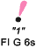 |   Lighted Buoy | 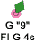
 |   Can |  |   Daybeacon

Preferred Channel to Starboard - have no numbers but may be lettered. Use as Port Side aids in the Primary Channel; used as Starboard Side aids in the Secondary Channel. The topmost bands are colored green.
 |  | Green Light Only
Composite Group Flashing (2+1)
 |  | 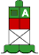 | 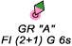
 |   Daybeacon |  | 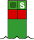  Can
Preferred Channel to Port - have no numbers but may be lettered.
Use as a Starboard Side aids in the primary channel, used as a Port Side aids in the Secondary Channel. The topmost bands are colored red.
 |  | Red Light Only
Composite Group Flashing (2+1)
 |  | 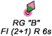 | 
 | 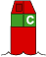  Nun | 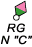 |   Daybeacon

Starboard Hand Marks indicate the right side of channels when proceeding in the conventional directions of buoyage. They normally show as a conical or nun shape, are red in color, and have even numbering. Beacons have triangular red daymarks while buoys are red nuns or pillar buoys. Red lights of various rhythms are used on starboard hand marks. Note that the numbers on daymarks are the color of the aid while the numbers on buoys are white.

Starboard Side Even Numbered Aids
 | Red Light Only
 | Flashing (2)
 | Flashing
 | Occulting
 | Quick Flashing
 | ISO
 |   Light | "2"  FI R 6s |   Lighted Buoy | 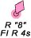
 | Note that daymarks have colored numbers. |  | Note that buoys have white numbers.
 | 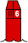  Nun | R  N"6" | 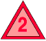  Daybeacon | 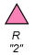

Safe Water Marks indicate that there is navigable water all around the mark. They usually mark fairways, midchannels, and offshore approach points. Safe watermarks have red and white vertical stripes, are spherical in shape and are never numbered. When a Safe Water mark is lighted or fitted with a sound signal, its buoy displays a red spherical topmark. Lighted Safe Water marks show a white light with a Morse Code “A” rhythm.

Safe Water Marks
Have no numbers but may be lettered.
White light only, shows a Morse code rhythm.
Mo(A)
 | RW N"  Mo(A) |  | RW  "A" | 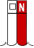  Can |  |  | RW "N"
Isolated Danger marks are erected on, moored over, or placed immediately adjacent to an isolated danger that may be passed on all sides by mariners. They are black with one or more broad horizontal red bands and are fitted with a topmark of two black spheres, one above the other. When lighted, they display a white light, group flashing (two) with a period of five seconds. These aids should not be approached closely without special caution.

Isolated Danger Marks
Have no numbers but may be lettered.
White Light Only
FI(2) 5s
 |  | BR"A"  FI(2) 5s | Lighted |  | Unlighted | BR "C"

Special Marks are not primarily intended to assist safe navigation, but more to indicate a special area or a feature referenced on charts or in another nautical publication. They may be used, for example, to mark anchorages, cable or pipeline areas, traffic separation schemes, military exercise zones, ocean data acquisitions systems, etc. Special marks are colored a solid yellow and, when lighted, show yellow lights with a slow-flashing rhythm preferred. Special marks may not show a quick-flashing rhythm. Many special marks are often private aids.

Special Marks — May Be Lettered.
Yellow Light Only
 |  |  |  | Fixed
 |  |  |  | Flashing
 |  |  |  |  |  |  |  | 
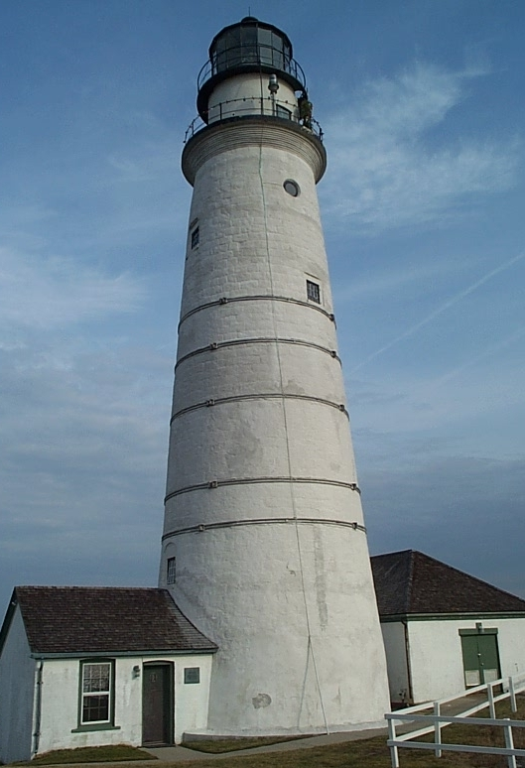 |  |  | Major Lights are lights of moderate to high candlepower and reliability that are exhibited from a fixed structure. They do not fall under the IALA agreement. While their signal characteristics are largely discretionary, they will be marked to provide maximum information while avoiding conflicts with nearby aids displaying IALA markings. The coloration of a light is often distinctive in order to avoid confusion with any nearby lights. The color of the structure is intended to allow the light tower to clearly stand out from its background.  A major light may or may not have colored sectors with higher intensities. Major lights have an availability standard of 90% and fall into two broad categories:

Light Characteristics

An aid's light characteristic consists of its color and rhythm. Authorized colors are red, green, white, and yellow. A light’s characteristic is determined by the aid’s function. The quick rhythm is the most conspicuous and is used on important lateral aids, such as aids in turns, marking shoals, and marking wrecks. Authorized rhythms are:

Fixed (F) – shows a continuous, unblinking light. Not authorized for lateral aids.

Flashing (Fl) – the duration of light is clearly shorter than the duration of darkness. Frequency not greater than 30 flashes per minute.

Quick Flashing (Q) – the light duration is shorter than the duration of darkness. Frequency is at least 60 or more per minute.

Very Quick Flashing (VQ) – the light duration is shorter than the duration of darkness. Frequency is at least 100 per minute.

Interrupted Quick Flashing (IQ) – is similar to quick flashing but has a brief, extended darkness period.

Group Flashing (Gp Fl (x+x)) – Combination of two patterns in one period, i.e. 2 flashes followed by three flashes would appear as Gp Fl (2 + 3). The darkness in between the groups is clearly longer than the darkness between flashes.

Long Flashing (LFL) – One long flash in a lighted period of at least 2 seconds.

Slow Flashing – less than 30 flashes per minute. The adjective ‘slow” is usually omitted.

Isophase (Iso) – Light has equal duration between light and darkness. Period consists of both light and dark interval. Also called Equal Interval (E Int).

Occulting (Occ) – is the opposite of flashing – the light is on more than it is off.

Alternating (AL) – an alternating light changes color. It is used as a special purpose light for situations requiring significant caution.

Morse (Mo) – groups flashes (long and short) to form Morse code characters. Example: Morse code “U” shows two short flashes followed by one prolonged flash then a period of darkness.

Federal Aid Discrepancies

A discrepancy to an aid to navigation is defined as a defect on the unit, which, therefore, is not watching properly. Always refer to the latest LNM to check whether the discrepancy on the aid has already been reported. Discrepancies to Federal Aids are divided into three categories. The purpose of these categorizations is to establish a defect hierarchy for reporting the discrepancy to the Coast Guard. The three discrepancy categories for Aids to Navigation are CRITICAL, URGENT and ROUTINE.

CRITICAL identifies those discrepancies, where failure to report by the most expeditious means, may result in loss of life or damage to a vessel.

URGENT identifies those discrepancies, where failure to report will result in no danger or loss of life or vessel damage, but may contribute to grounding or stranding of a vessel.

ROUTINE identifies those discrepancies, where failure to report will result in very low likelihood of grounding or stranding, but where corrective maintenance to the aid may be necessary.

CRITICAL Discrepancies

Report Critical Discrepancies by the most expeditious means available to the local CG Unit or agency. Depending on your District AN procedures, this could be a phone call, an E-mail, or a written report. Always follow up with a hard-copy report within 24 hours to the designated function or AN Staff Officer in your District, who is assigned as liaison with the local C.G. Agency responsible for Federal Aids in your District. Restrict CRITICAL reporting to lateral aids and lights.

      - The aid is totally covered or shrouded in ice.

      - The light signal is showing improper characteristics or rhythm. Normally determined at night.

      - The light is obscured. Explain the circumstances in the comment section of your report. What is obscuring the light?

      - The light is extinguished. Normally determined at night.

      - The lantern is damaged. This is a great photo opportunity that adds credibility to your discrepancy report. Has the damage caused a light failure?

      - The buoy is sinking. Double check before reporting. Return to the scene after an elapse of time to check whether the buoy is actually sinking or is just an aid that floats low in the water.

      - The buoy has submerged. The assumption is that you can still see the aid and it has possibly become a hazard to navigation.

      - The buoy has capsized. This is a great photo opportunity.

      - The buoy off station. Be sure you are right before making this report. Check the guidelines in the USCGAUX Federal Short Range Aid to Navigation Study Guide before making an “off station: report.

      - The buoy is missing. Enter the LAT/LON of the buoy as a waypoint on your GPS and use the “GO TO” command to try to locate the aid. Be sure to stay in the navigable channel during this procedure.

      - The aid is adrift. Radio or call for instructions from your OPFAC. You may be instructed to take it under tow or tie it off to another aid. Try to read the buoy’s ID Number that is welded on the body. This code will pinpoint for the Coast Guard where the adrift buoy originated from.

      - The buoy is stranded. Use extra caution when operating your OPFAC near a stranded buoy.

      - The aid is showing improper characteristics. Improper characteristics can mean problems with aid color, rhythm, or number. Always explain the reason in the comments section of the report.

      - The aid’s RACON is off the air. You need a RADAR set to make this determination.

      - The aid’s RACON is emitting improper characteristics per the Light List. You need a RADAR set to make this determination and must be able to read Morse code to make this determination.

      - The aid is vandalized (either in progress or the result of such action). If the vandalism is in process, do not approach the vandals. Notify the Coast Guard and request instructions. This is a good photo opportunity.

      - A dayboard or bird’s nest is obstructing the aid’s light. This is a good photo opportunity.

      - The aid’s structure has collapsed. This is a good photo opportunity.

URGENT Discrepancies

Report by telephone to your local C.G. Unit. Depending on your District AN policy, this could be a phone call, an e-mail, or a written report. Always follow up with a hard copy within 24 hours to the designated function or AN Staff Officer in your District, who is assigned as liaison with the local CG Unit or agency responsible for Federal Aids in your District. Restrict URGENT reporting to lateral aids to navigation and lights.

      - The light is burning dim or showing reduced intensity. Verify by close examination that the "burning dim" or "reduced intensity" condition is not being caused by smoke, other atmospheric conditions, or viewing angle...

      - The aid’s light is partially obscured by dayboards. This is a good photo opportunity.

      - Dayboards are missing. This is a good photo opportunity.

      - The sound signal, either a bell, a gong, a horn, or a whistle, is inoperative. Sound signals may be electrically operated or manual--wave actuated. Manual signals can be actuated by generating a wave near the aid with the OPFAC and listening. Some sound signals may be remotely activated or triggered by a Fog Detector.

      - The battery box is missing or damaged. Note that many lighted aids are being equipped with Solar LED lanterns which do not need a battery box. The LED lights are self contained—LED light, battery and solar panel.

      - The fog signal is inoperative.

ROUTINE Discrepancies

Submit details by hard-copy report within 24 hours to the designated function or AN Staff Officer in your District, who is assigned as liaison with the local C.G. Agency responsible for Federal Aids in your District.

      - The aid is obscured by foliage or other objects that should be removed. This could be classified as CRITICAL if the aid is completely obscured.

      - Daymark(s) is faded so that the color of the aid is compromised. The aid could be located in the water or onshore. Fading is a very subjective call. This is a good photo opportunity to show the problem.

      - There is extensive bird fowling on the aid so that the color of the aid is compromised. This is a good photo opportunity.

      - Dayboard(s) is damaged. This is a good photo opportunity.

      - Aid is damaged by collision. Explain the extent of the damage as part of your report. Submit photos and the registration numbers or name of the boat, if known. This is a good photo opportunity.

      - Peeling paint is interfering with ability to identify the lateral color of aid. This is a good photo opportunity.

      - Dayboard(s) is delaminating. This is a good photo opportunity.

      - Dayboard characteristics do not match what is published in the Light List.

      - The numbers on the aid are obliterated and not easily read or identifiable. When all the numbers on the aid are missing, this becomes the CRITICAL discrepancy – “The aid is showing improper characteristics.” This is a good photo opportunity.

      - Wood supporting structure(s) have extensive deterioration and/or is rotting. This is a good photo opportunity.

      - The aid’s structure is leaning - more than 15 degrees from the vertical. This is a good photo opportunity.

      - A bird nest(s) that affects the intended purpose of the aid is on an aid. This is a good photo opportunity.

      - The retro-reflective material on the aid is peeling, missing or inadequate. This is a good photo opportunity.

      - Dayboard is missing. Refers to a single dayboard in a three or four dayboard cluster.

      - The vent valve on a lighted buoy is missing. Not applicable to new LED lanterns.

      - The vent tube(s) on a lighted buoy is broken. Not applicable to new LED lanterns.

      - RADAR reflector is missing or severely damaged. This is a good photo opportunity.

      - The tapper(s) on a sound signal is missing.

The following panels illustrate some of the typical discrepancies that you may encounter on an ATON—Federal Aid to Navigation.
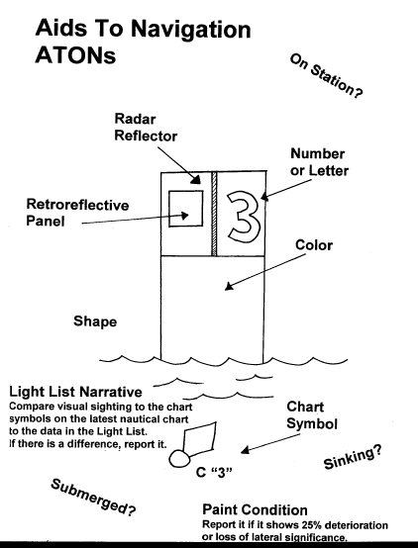 |  |  |  |  |  |  | 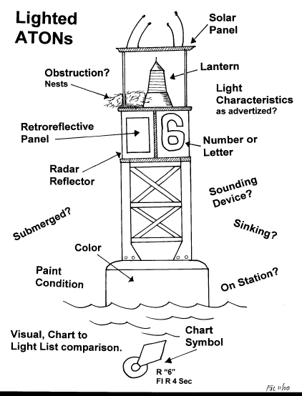

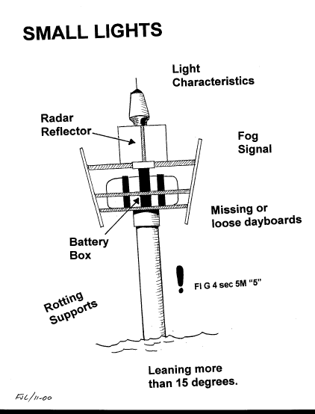 | 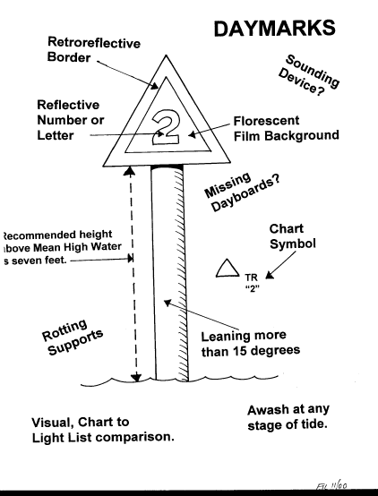

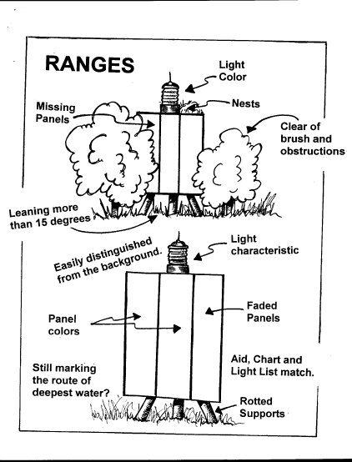 | 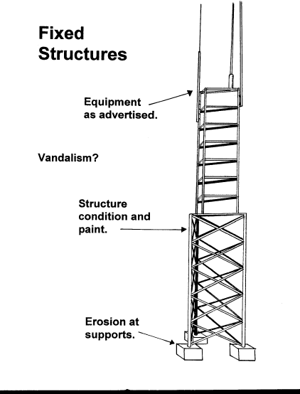

These new LED Lanterns are being deployed throughout the District.

Model 701 – LED Lantern  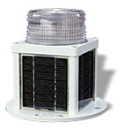 | 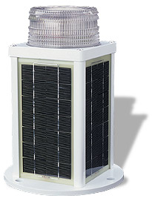  Model 702 – LED Lantern

Reporting ATON Patrols and AN Activity to AUXDATA

Three separate reports may be required. Do not confuse their use or purpose.

- ATON Discrepancies are reported to the local C.G.Unit on an ANSC 7054 Aid to Navigation report.

  - This report alerts the Coast Guard about the problem on the aid. Urgent and Critical discrepancies are phoned or e-mailed directly to the C.G Unit.

  - When no discrepancies are observed on the ATON – Federal Aid (i.e., aid is watching properly), it is not necessary to make a report to the C.G. Unit or agency unless they specifically request it.

  - Note that the ANSC 7054 report alerts the Coast Guard but does not interface with the AUXDATA system. If you only make this report, you do not get any credit for underway hours in the Boat Crew program and do not receive any credit for your AN Mission activity.

- ATON Patrols hours are reported to AUXDATA on an ANSC 7030 Activity Report – Mission – Boat, manually or via POMS, through the IS Staff Officer.

  - The “ANSC Activity Report – Mission – Boat” report is submitted by the coxswain or owner of the OPFAC.

  - This report accounts for the hours underway for the Boat Crew program in AUXDATA. This includes everyone on the OPFAC except a Q.E.

  - When the AN Patrol is performed by private vehicle or on foot, this report is not required.

  - Note that the “ANSC 7030 Activity Report – Mission – Boat” form that is submitted through POMS or as a standalone report to the IS Staff Officer provides you credit for underway hours in the Boat Crew program but does do not provide any credit for your Individual AN Mission activity in AUXDATA. Also, the 7030 report does not provide the local C.G. Unit or agency with any discrepancy information.

- All individual AN mission activity is reported to AUXDATA on an “ANSC 7030 Activity Report – Mission – Unit/Individual,” through the IS Staff Officer.

  - Report all your AN activity, including the aids observed as “watching properly” and those observed as “discrepant.”

  - Note that the “ANSC 7030 Activity Report – Mission – Individual” report that is submitted to AUXDATA through the IS Staff Officer accounts for your individual AN activity in AUXDATA but does not provide you credit for underway hours in the Boat Crew Program, nor does it interface with the local C.G. Unit or agency.

  - Only one member may submit an ANSC 7030 Activity Report Mission – Individual report for each aid verified. Only one member should be listed on this report. Credit for activity at a single aid cannot be split among many members. The only program option available for distributing credit is to allocate credit among the crew members on the patrol. However, the total ATONs, PATONs, and Bridges checked on the patrol should equal the total ATONs, PATONs, and Bridges reported to AUXDATA. Multiple crewmembers cannot take credit for the same aid. This is considered double dipping.

Submitting one report without the other two takes care of only one-third of the reporting job and leaves two important aspects of the AN job undone.

All Auxiliary Aid to Navigation hourly statistics in support of the Coast Guard are retrieved from AUXDATA. In order to provide evidence of the support hours that the Auxiliary provides to the Coast Guard, reporting AN patrol time to AUXDATA is extremely important. Hours reported while underway on an authorized patrol are credited toward your annual underway hours requirements for the Boat Crew program. But, only AN Mission activity is used to calculate the statistics for annual AN awards, not hours.

In summary, to successfully report AN patrol hours and AN Mission activity, you must understand the difference between:

- AN Patrols,

- Individual Aid to Navigation Missions, and

- Individual AN Activity Reports.

They are distinguished as follows:

- AN Patrols

- Are only performed aboard a properly equipped and crewed operational facility under orders. Reference the Operations Policy Manual for proper procedures.

- Should be of at least four hours duration. Time is not the primary issue. More important is the AN activity that is accomplished during the Patrol.

- Are recorded in AUXDATA by the coxswain or owner of the OPFAC as a Type 03 patrol using an “ANSC 7030, Activity Report-Mission – Boat” form that can be generated through POMS. Much AN activity is also conducted as part of multi-mission patrols under other patrol type codes.

- Individual Aid to Navigation Missions

- AN mission activity is reported on an “ANSC 7030 Activity Report – Mission – Individual”, as follows:
Mission 30 – Federal Aid Activity
Mission 31 – Private Aid Activity.
Mission 32 – Bridge Activity.

- Individual AN Activity Reporting

- Is a method for reporting the totals of your particular AN activity on an “ANSC 7030 Activity Report – Mission – Individual form.” Only one member should be listed on this report.

- Should never be confused with reporting underway patrol hours on an “ANSC 7030 – Activity Report – Mission – Boat,” form generated manually or via POMS.

- Arranges and reports observed totals of your particular AN activity as either discrepant and as watching properly.

- Includes all AN activity performed by a particular Auxiliary member aboard a boat on any type of patrol, or individually while in a privately owned vehicle, boat, on foot, or other conveyance.

- In order to get credit in AUXDATA, each member must submit their own individual “ANSC 7030 Activity Report – Mission – Individual” report to their IS Staff Officer reflecting the total number of ATONs, PATONs, and/or Bridges that were observed as “watching properly” and as “discrepant.”

- When AN activity is performed while acting as an authorized coxswain or crewmember on an authorized operational patrol, limit the time reported on the “ANSC 7030 Activity Report – Mission – Individual” submissions to 15 minutes and report time outside of the time-window reported for the patrol.

- When performing AN activity on an OPFAC on an authorized patrol but not boat-crew qualified and not participating as a Boat Crew Trainee, you will be listed as being on the patrol on POMS and on the “ANSC 7030 Activity Report - Mission –Boat” that is submitted to AUXDATA by the coxswain or OPFAC owner. You will receive credit in AUXDATA for your underway times. When submitting your “ANSC 7030 Activity Report – Mission – Individual” form to report your AN activity, limit the time reported to 15 minutes and report time outside of the time-window reported for the patrol.

- Remember, there can be no splitting of AN activity credit for checking an aid. Only one member can report one aid to AUXDATA at a time. The member who submits the ANSC 7030 report gets the AUXDATA credit for the activity. While there may be other crew members aboard the boat, multiple members can not take individual AN activity credit for the same aid.

Check out the new USCGAUX Federal Short Range Aid to Navigation Study Guide that can be found on the D1NR AN Web Site at www.uscgann.com/ for more details on the AN Program and official guidelines for planning AN patrols, for taking Fixes, taking depths, etc. Use this guide to fill in the details of your Aid to Navigations education.

Prepared by the First Northern Aids to Navigation Team as a reference guide for checking ATONs—Federal Short Range Aids to Navigation throughout the District.
Forward all comments to: Frank Larkin, DSO-AN, 107 Concord Road, Acton, MA 01720 – 978-263-3023 – FrankJLarkin@verizon.net. [April, 2007]

