ATON KIT
(Federal Short Range Aids to Navigation)

Every member while underway on an authorized patrol should check every ATON—Federal Short Range Aid to Navigation—that they pass and report any observed discrepancies to the local C.G. Unit – ANT—Aid to Navigation Team.

Port Side Marks indicate the left side of channels when proceeding in the Conventional Directions of Buoyage. They normally show as a square or can in shape, are green in color, and have odd numbering. Beacons have green square daymarks while buoys are green cans or pillar buoys. Green lights of various rhythms are used on port hand marks. Note that the numbers on daymarks are the color of the aid while the numbers on buoys are white.

Port Side Odd Numbered Aids

 | Green Light Only
 | Flashing (2)
 | Flashing
 | Occulting
 | Quick Flashing
 | ISO
 |   Light | 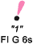 |   Lighted Buoy | 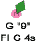
 |   Can |  |   Daybeacon

Preferred Channel to Starboard - have no numbers but may be lettered. Used as port side aids in the primary channel; used as starboard side aids in the secondary channel. The topmost band is colored green.
 |  | Green Light Only
Composite Group Flashing (2+1)
 |  | 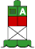 | 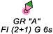
 |   Daybeacon |  | 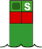  Can
Preferred Channel to Port - have no numbers but may be lettered.
Used as a starboard side aids in the primary channel; used as a port side aids in the secondary channel. The topmost band is colored red.
 |  | Red Light Only
Composite Group Flashing (2+1)
 |  | 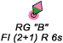 | 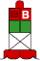
 | 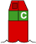  Nun | 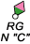 | 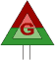  Daybeacon

Starboard Side Marks indicate the right side of channels when proceeding in the conventional directions of buoyage. They normally show as a conical or nun shape, are red in color, and have even numbering. Beacons have triangular red daymarks while buoys are red nuns or pillar buoys. Red lights of various rhythms are used on starboard side marks. Note that the numbers on daymarks are the color of the aid while the numbers on buoys are white.

Starboard Side Even Numbered Aids
 | Red Light Only
 | Flashing (2)
 | Flashing
 | Occulting
 | Quick Flashing
 | ISO
 |   Light | "2"  FI R 6s |   Lighted Buoy | 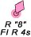
 | Note that daymarks have colored numbers. |  | Note that buoys have white numbers.
 | 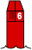  Nun | R  N"6" | 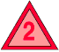  Daybeacon | 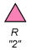

Safe Water Marks indicate that there is navigable water all around the mark. They usually mark fairways, midchannels, and offshore approach points. Safe watermarks have red and white vertical stripes, are spherical in shape and are never numbered. When a Safe Water mark is lighted or fitted with a sound signal, its buoy displays a red spherical top mark. Lighted safe water marks show a white light with a Morse Code “A” rhythm.

Safe Water Marks
Have no numbers but may be lettered.
White light only, shows a Morse code rhythm.
Mo(A)
 | RW N"  Mo(A) |  | RW  "A" | 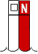  Can |  |  | RW "N"

Isolated Danger marks are erected on, moored over, or placed immediately adjacent to an isolated danger that may be passed on all sides by mariners. They are black with one or more broad horizontal red band and are fitted with a top mark of two black spheres, one above the other. When lighted, they display a white light, group flashing (two) with a period of five seconds. These aids should not be approached closely without special caution.

Isolated Danger Marks
Have no numbers but may be lettered.
White Light Only
FI(2) 5s
 |  | BR"A"  FI(2) 5s | Lighted |  | Unlighted | BR "C"

Special Marks are not primarily intended to assist safe navigation, but more to indicate a special area or a feature referenced on charts or in another nautical publication. They may be used, for example, to mark anchorages, cable or pipeline areas, traffic separation schemes, military exercise zones, ocean data acquisitions systems, etc. Special marks are colored a solid yellow and, when lighted, show yellow lights with a slow-flashing rhythm preferred. Special marks may not show a quick-flashing rhythm. Many special marks are often private aids.

Special Marks — May Be Lettered.
Yellow Light Only
 |  |  |  | Fixed
 |  |  |  | Flashing
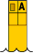 |  |  |  |  |  |  |  | 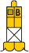
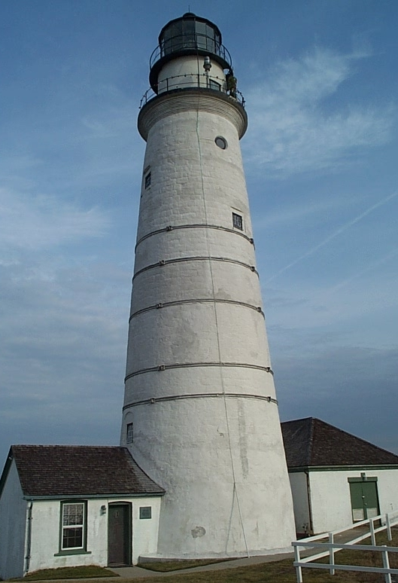 |  |  | Major Lights are lights of moderate to high candlepower and reliability that are exhibited from a fixed structure. They do not fall under the IALA agreement. While their signal characteristics are largely discretionary, they will be marked to provide maximum information while avoiding conflicts with nearby aids displaying IALA markings. The coloration and/or characteristic of a light is often distinctive in order to avoid confusion with any nearby lights. The color of the structure is intended to allow the light tower to clearly stand out from its background. Report any lights that are merging into the background and are becoming difficult to recognize from the sea.  A major light may or may not have colored sectors with higher intensities. Major lights have an availability standard of 90%.

Light Characteristics

An aid's light characteristic consists of its color and rhythm. Authorized colors are red, green, white, and yellow. A light’s characteristic is determined by the aid’s function. The quick rhythm is the most conspicuous and is used on important lateral aids, such as aids on turns or marking shoals and wrecks. Authorized rhythms are:

Fixed (F) – shows a continuous, unblinking light. Not authorized for lateral aids.

Flashing (Fl) – the duration of light is clearly shorter than the duration of darkness. Frequency not greater than 30 flashes per minute.

Quick Flashing (Q) – the light duration is shorter than the duration of darkness. Frequency is at least 60 or more per minute.

Very Quick Flashing (VQ) – the light duration is shorter than the duration of darkness. Frequency is at least 100 per minute.

Interrupted Quick Flashing (IQ) – is similar to quick flashing but has a brief, extended darkness period.

Group Flashing (Gp Fl (x+x)) – Combination of two patterns in one period, i.e. 2 flashes followed by three flashes would appear as Gp Fl (2 + 3). The darkness in between the groups is clearly longer than the darkness between flashes.

Long Flashing (LFL) – One long flash in a lighted period of at least 2 seconds.

Slow Flashing – less than 30 flashes per minute. The adjective ‘slow” is usually omitted.

Isophase (Iso) – Light has equal duration between light and darkness. Period consists of both light and dark interval. Also called Equal Interval (E Int).

Occulting (Occ) – is the opposite of flashing – the light is on more than it is off.

Alternating (AL) – an alternating light changes color. It is used as a special purpose light for situations requiring significant caution.

Morse (Mo) – groups flashes (long and short) to form Morse code characters. Example: Morse code “U” shows two short flashes followed by one prolonged flash then a period of darkness.

Federal Aid Discrepancies

A discrepancy to an aid to navigation is defined as a defect on the unit, which, therefore, is not watching properly. Always refer to the latest LNM to check whether the discrepancy on the aid has already been reported. Discrepancies to Federal Aids are divided into three categories. The purpose of these categorizations is to establish a defect hierarchy for reporting the discrepancy to the Coast Guard. The three discrepancy categories for Aids to Navigation are CRITICAL, URGENT and ROUTINE.

CRITICAL identifies those discrepancies, where failure to report by the most expeditious means, may result in loss of life or damage to a vessel.

URGENT identifies those discrepancies, where failure to report will result in no danger or loss of life or vessel damage, but may contribute to grounding or stranding of a vessel.

ROUTINE identifies those discrepancies, where failure to report will result in very low likelihood of grounding or stranding, but where corrective maintenance to the aid may be necessary.

CRITICAL Discrepancies

Report Critical Discrepancies by the most expeditious means available to the local CG Unit or agency. Depending on your District NS procedures, this could be a phone call, an E-mail, or a written report. Follow up with a hard-copy report within 24 hours to the designated function or NS Staff Officer in your District, who is assigned as liaison with the local C.G. Agency responsible for Federal Aids in your District. Hard copy follow up reports may not be required in some Districts. Restrict CRITICAL reports to lateral aids and lights. The discrepancy number corresponds to the discrepancy numbering on the Aid to Navigation Discrepancy Report and the AN10 Aid Observation Worksheet.

1. The aid is totally covered or shrouded with ice.

2. The light signal is showing improper characteristics or rhythm. Normally determined at night.

3. The light is obscured. Explain the circumstances in the comment section of your report. What is obscuring the light?

4. The light is extinguished. Normally determined at night.

5. The lantern is damaged. This is a great photo opportunity that adds credibility to your discrepancy report. Has the damage caused a light failure?

6. The buoy is sinking. Double check before reporting. Return to the scene after an elapse of time to check whether the buoy is actually sinking or is just an aid that floats low in the water.

7. The buoy is submerged. The assumption is that you can still see the aid and, possibly, it has become a hazard to navigation. When you can’t see the buoy, report it as missing.

8. The buoy has capsized. This is a great photo opportunity.

9. The aid is off station. Be sure you are right before making this report. Check the guidelines in this study guide before making an “off station” report.

10. The aid is missing. Enter the LAT/LON of the buoy as a waypoint on your GPS and use the “GO TO” command to try to locate the aid. Be sure to stay in the navigable channel during this procedure.

11. The buoy is adrift. Radio or call for instructions from your OPFAC. You may be instructed to take it under tow or tie it off to another aid. Try to read the buoy’s ID Number that is welded on the buoy’s hull. This code pinpoints where the adrift buoy originated to the Coast Guard.

12. The buoy is stranded. Use extra caution when operating your OPFAC near a stranded buoy. Report the buoy’s characteristics and, if possible, report the serial numbers welded into the hull of the buoy. This data indicates where the buoy originated to the Coast Guard. Stranded buoys would be still attached to their anchor system.

13. The aid’s RACON is off the air. You need a RADAR set to activate the RACON in order to make this determination.

14. The aid’s RACON is emitting improper characteristics per the Light List. You need a RADAR set and must be able to read Morse code to make this determination.

15. The aid’s Radio Beacon is off the air. You need a RDF-Radio Direction Finder
to make this determination.

16. The aids Radio Beacon has a timing error. You need a RDF-Radio Direction Finder to make this determination.

17. The aid was vandalized. (either in progress or the result of such action). If the vandalism is in process, do not approach the vandals. Notify the Coast Guard and request instructions. This is a good photo opportunity.

18. A dayboard or bird’s nest is obstructing the aid’s light. The object could be a dayboard, s bird’s nest, etc. This is a good photo opportunity.

19. The aid’s structure has collapsed. This is a good photo opportunity.

URGENT Discrepancies

Report by telephone to your local C.G. Unit. Depending on your District NS policy, this could be a phone call, an e-mail, or a written report. Follow up with a hard copy report within 24 hours to the designated function or NS Staff Officer in your District, who is assigned as liaison with the local CG Unit or agency responsible for Federal Aids in your District. Hard copy follow up reports may not be required in some districts. Restrict URGENT reporting to lateral aids to navigation and lights.

1. The light is burning dim or showing reduced intensity. Verify by close examination that the "burning dim" or "reduced intensity" condition is not being caused by smoke, other atmospheric conditions, or viewing angle.

2. The aid’s light is partially obscured by dayboards. This is a good photo opportunity.

3. Dayboard(s) is missing. This is a good photo opportunity.

4. Dayboard(s) is damaged. This is a good photo opportunity.

5. The sound signal, either a bell, a gong, a horn, or a whistle, is inoperative. Sound signals may be electrically operated or manual--wave actuated. Manual signals can be actuated by generating a wave near the aid with the OPFAC and listening. Some sound signals may be remotely activated or triggered by a Fog Detector.

6. The battery box is missing. Note that many lighted aids are being equipped with Solar LED lanterns which do not need a battery box. The LED lights are self contained—LED light, battery and solar panel.

7. The battery box is damaged. This is a good photo opportunity.

8. The fog signal is inoperative. Be sure to check that the fog signal is not “VHF-FM radio actuated” before reporting it is as not working properly.

ROUTINE Discrepancies

Submit details by hard-copy report within 24 hours to the designated function or NS Staff Officer in your District, who is assigned as liaison with the local C.G. Agency responsible for Federal Aids in your District. The numbers referenced for these routine discrepancies correspond to the numbers on the ANSC 7054 Aid to Navigation Report and AN Aid Observation Worksheet.

1. The aid is obscured by foliage or other objects that needs to be removed. This could be classified as CRITICAL if the aid is completely obscured.

2. Dayboard(s) is faded so that the color of the aid is compromised. The aid could be located in the water or onshore. Fading is a very subjective call. This is a good photo opportunity to show the problem.

3. There is extensive bird fowling on the aid so that the color of the aid is compromised. This is a good photo opportunity.

4. Aid is damaged by collision. Explain the extent of the damage as part of your report. Submit photos and the registration numbers or name of the boat, if known. This is a good photo opportunity.

5. Paint deterioration is interfering with ability to identify the lateral color of aid. This could involve peeling paint, fading, retro-material deterioration or missing, or rusting of the buoy. Normal annual maintenance usually corrects these problems. Report when lateral significance is compromised. This is a good photo opportunity.

6. Dayboard(s) is delaminating. This is a good photo opportunity. Explain in Comments.

7. The numbers on the aid are obliterated and not easily read or identifiable. When all the numbers on the aid are missing, this becomes the CRITICAL discrepancy – “The aid is showing improper characteristics.” This is a good photo opportunity. Explain in Comments.

8. Wood supporting structure(s) have extensive deterioration and/or is rotting. This is a good photo opportunity.

9. The aid’s structure is leaning - more than 15 degrees from the vertical. This is a good photo opportunity.

10. The vent valve on a lighted buoy is missing. Not applicable to new LED lanterns. Explain in Comments.

11. The vent tube(s) on a lighted buoy is broken. Not applicable to new LED lanterns. Explain in Comments.

12. RADAR reflector is missing or severely damaged. Explain in Comments. This is a good photo opportunity.
13. The tapper(s) on a sound signal is missing. Explain in Comments.
The following panels illustrate the typical discrepancies that you may encounter on an ATON—Federal Aid to Navigation.
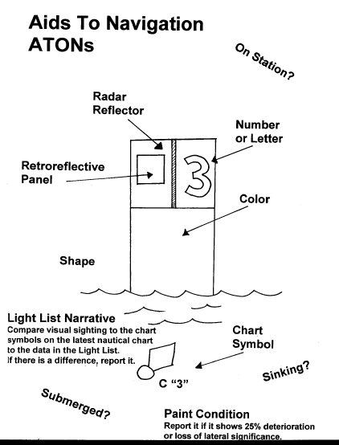 |  |  |  |  |  |  | 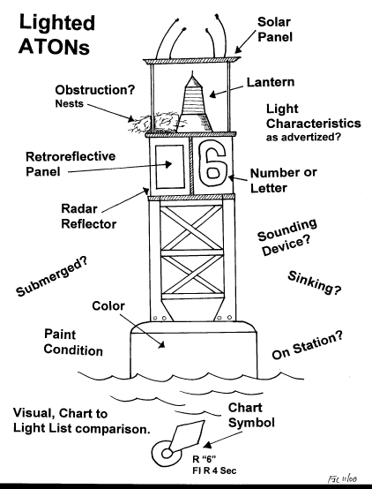

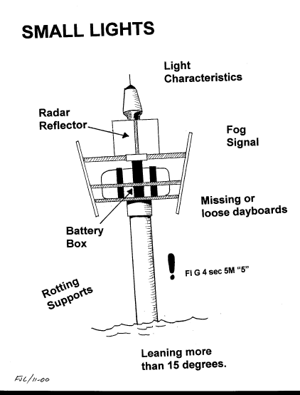 | 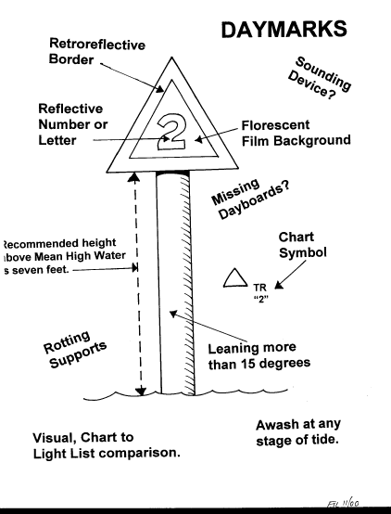

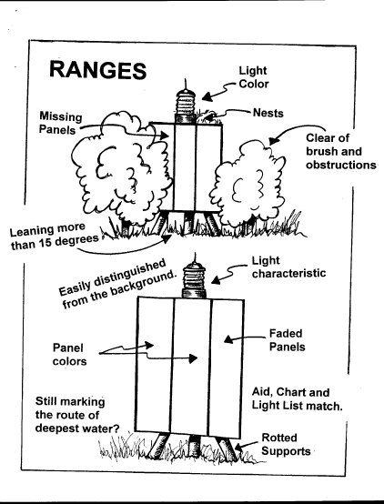 | 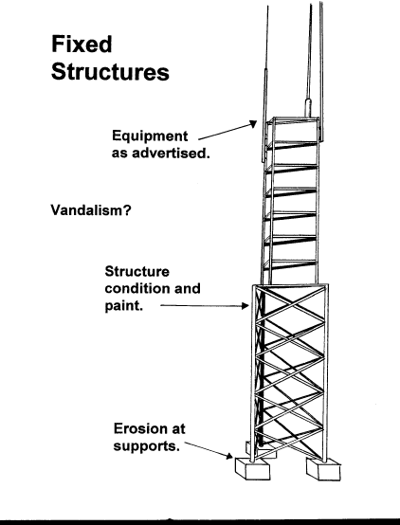

These new LED Lanterns are currently being deployed.

Model 701 – LED Lantern  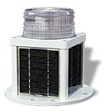 | 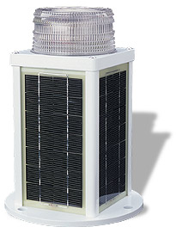  Model 702 – LED Lantern

What to report about Beacons, Daymarks and Small Lights.

Shapes, Numbers, and Colors of the Daymarks.

- Square-shaped daymarks, colored green, with odd green numbers mark the left side of channel when returning from the sea.
- Triangle-shaped daymarks, colored red, with even red numbers mark the right side of the channel when returning from the sea.
- Octagonal-shaped daymarks, vertically striped red and white with white letters in the red panel mark the outer limit of a channel toward the sea.
- Always verify that the aid conforms to the IALA-B System, the Light List, the abbreviations and symbols on the NOAA chart. Also review any comments in the Coast Pilot about the daymark.

Number or Letter on Daymark. [Per Light List and latest NOAA Chart]

- Usually, each daymark has a number or occasionally has a letter.
- The color of the retro reflective material used for numbers and letters on daymarks will reflect the color of the aid. Triangular-shaped daymarks will have red characters and square-shaped daymarks will have green characters.
- Always verify that the charted number or letter is correct per the Light List and the NOAA chart.

Is Daymark awash at any time?

- Check and report the depth of water at charted datum on the navigable channel side of the aid only. Follow the guidelines for taking and reporting a depth as shown in the Federal Short Range Aid to Navigation Study Guide.
- “Depths at datum” that are less than the “range of tide” indicate that an aid can be awash or stranded at low water.
- “Range of tide” can be found on the almanac screen on your GPS.

Light colors and characteristics of Small Lights.

- When lighted, a daymark is considered a minor aid or small light, not a daybeacons.
- Light characteristics on small lights are the same as for lighted buoys. Verify the light characteristic that you observe against the light characteristics published in the Light List and on the latest NOAA chart.
- The height of a small light is measured from MHW to the focal-plane of the lantern...
- Check the small light’s range of visibility as shown on your NOAA chart and in the Light List.
- Always check for lantern, battery, and solar panel damage and/or vandalism on small lights.
- Check that the solar panel is oriented toward the sun—normally a southern direction.

Structural condition of Daymarks.

- Report all fixed aids to navigation that are leaning more than 15°.
- Report any aids that are knocked over.
- Check aid’s supports for rot either from the top down or the bottom up. This problem is more visible at lower tides. Always observe with your binoculars if you suspect shoaling near a fixed aid to navigation.
- Confirm that support and/or structural pieces on the daymark are not missing or broken.
- Confirm that the material around the base of the structure has not washed away or eroded?
- Verify whether any dayboards are missing?

Purpose of the Daymark.

- When a dayboard is used as part of a range, check whether the panels are obstructed in any way?
- Verify whether the range panels mark the center of the navigable channel?
- Are the dayboard colors correct as advertised in the Light List and on your NOAA chart?
- Has the color of the daymark faded? This is very subjective. Report fading only when obvious color changes have occurred—green to yellow; red to light pink or white, etc.

Growth of brush or structures near the Daymark.

- Overgrowth of brush is usually corrected during annual Coast Guard maintenance.
- Check with the CG ANT/Unit and volunteer to remove the brush for the Coast Guard.
- Has the aid’s effectiveness been lessened by brush growth height, tree growth, or any new construction?

Reporting ATON Patrols and AN Activity to AUXDATA

Three separate reports may be required. Do not confuse their use or purpose.

- ATON Discrepancies are reported to the local C.G. Unit on an “ANSC 7054 Aid to Navigation Discrepancy Report.”

  - This report alerts the Coast Guard about the problem on the aid.

  - When no discrepancies are observed on the ATON – Federal Aid (i.e., aid is watching properly), it is not necessary to make a report to the C.G. Unit or agency unless they specifically request it.

  - Note that the “ANSC 7054 Aid to Navigation report” alerts the Coast Guard but does not interface with the AUXDATA system. If you only prepare this report, you will not get any credit for underway hours in the Boat Crew program and do not receive any credit for your NS Mission activity in AUXDATA

- ATON Patrols hours are reported to AUXDATA on an “ANSC 7030 Activity Report – Mission – Boat,” manually prepared or submitted via POMS, through the IS Staff Officer.

  - An “ANSC 7030 Activity Report – Mission – Boat” report is submitted by the coxswain or owner of the OPFAC to IS.

    - Use Mission Code 03 – ATON Patrol, on multi-mission patrols, be sure that the time spent performing ATON activity is split out and reported on the ANSC 7030 report.
    - This ANSC 7030 report accounts for your hours underway for the Boat Crew and ATON program in AUXDATA.

    - When the AN Patrol is performed by private vehicle or on foot, this report is not required.

  - Note: The “ANSC 7030 Activity Report – Mission – Boat” form that is submitted through POMS or as a standalone report to the IS Staff Officer initiates credit for your underway hours in the Boat Crew program, but does do not provide any credit for your individual NS Mission activity in AUXDATA. Also, this report does not inform the local C.G. Unit or agency of the discrepancy.

- All individual NS mission activity is reported to AUXDATA on an “ANSC 7030 Activity Report – Mission – Unit/Individual,” through the IS Staff Officer.

  - Report all your NS activity, including the aids observed as “watching properly” and those observed and reported as “discrepant.”

  - Note: The “ANSC 7030 Activity Report – Mission – Individual” report that is submitted to AUXDATA through the IS Staff Officer accounts for your individual AN activity in AUXDATA but does not provide you credit for underway hours in the Boat Crew Program, nor does it report discrepancies to the local C.G. Unit or agency.

  - Only one member may submit an “ANSC 7030 Activity Report Mission – Individual” report for each aid verified. Only one member should be listed on this report. Credit for activity at a single aid cannot be split among many members. The only option available for distributing credit is to allocate credit among the crew members on the patrol. However, the total ATONs, PATONs, and Bridges checked on the patrol should equal the total ATONs, PATONs, and Bridges reported to AUXDATA. Multiple crewmembers cannot take NS activity credit for the same aid.

Submitting one report without the other two takes care of only one-third of the reporting job and leaves two important aspects of the ATON job undone.

All Auxiliary Aid to Navigation hourly statistics in support of the Coast Guard are retrieved from AUXDATA. In order to provide evidence of the support hours that the Auxiliary provides to the Coast Guard, reporting NS patrol time to AUXDATA is extremely important. Hours reported while underway on an authorized patrol are credited toward your annual underway hour requirements for the Boat Crew program. But, only NS Mission activity is used to calculate the statistics for annual NS awards, not hours.

In summary, to successfully report NS patrol hours and AN Mission activity, you must understand the difference between:

- NS Patrols,

- Individual Aid to Navigation Missions, and

- Individual AN Activity Reports.

They are distinguished as follows:

- NS Patrols:

- Are only performed aboard a properly equipped and crewed operational facility under orders. Reference the Operations Policy Manual for proper procedures.

- Should be of at least four hours duration. Time is not the primary issue. More important is the NS activity that is accomplished during the Patrol.

- Are recorded in AUXDATA by the coxswain or owner of the OPFAC as a Type 03 patrol using an “ANSC 7030, Activity Report-Mission – Boat” report that can be generated through POMS. Much AN activity is also conducted as part of multi-mission patrols under other patrol type codes.

- Individual Aid to Navigation Missions

- NS mission activity is reported on an “ANSC 7030 Activity Report – Mission – Individual”, as follows:
Mission 30 – Federal Aid Activity
Mission 31 – Private Aid Activity.
Mission 32 – Bridge Activity.

- Individual AN Activity Reporting

- Is a method for reporting the totals of your particular NS activity on an “ANSC 7030 Activity Report – Mission – Individual form.” Only one member should be listed on this report.

- Should never be confused with reporting underway patrol hours on an “ANSC 7030 – Activity Report – Mission – Boat,” form generated manually or reported via POMS by the Coxswain.

- Arranges and reports observed totals of your particular AN activity as either discrepant and as watching properly.

- Includes all NS activity performed by a particular Auxiliary member aboard a boat on any type of patrol, or individually while in a privately owned vehicle, boat, on foot, or other conveyance.

- In order to get credit in AUXDATA, each member must submit their own individual “ANSC 7030 Activity Report – Mission – Individual” report to their IS Staff Officer reflecting the total number of ATONs, PATONs, and/or Bridges that were observed as “watching properly” and as “discrepant.”

- When NS activity is performed while acting as an authorized coxswain or crewmember on an authorized operational patrol, limit the time reported on the “ANSC 7030 Activity Report – Mission – Individual” submissions to 15 minutes and report time outside of the time-window that was used to report for the patrol.

- Remember, there can be no splitting of NS activity credit for checking an aid. Only one member can report one aid to AUXDATA at a time. The member who submits the ANSC 7030 report gets the AUXDATA credit for the activity. While there may be other crew members aboard the boat, multiple members can not take individual AN activity credit for the same aid.

Recognition of the Navigation Systems Division and the Aids to Navigation / Chart Updating program by the Coast Guard and the Auxiliary depends on annual and periodic reports of the ATON support activity that is performed by Auxiliarists in support of the Coast Guard. The success and funding of the Aids to Navigation Program relies on your AUXDATA input data. When you fail to report ATON patrol and activity missions, you are actually hurting the Aid to Navigation program.

