SECTION XIX – ATON Verifier Qualification Guide

United States Coast Guard Auxiliary

“We verify the ATONs and PATONs, check the Bridges, and update the Charts of First Northern”

AUXILIARY AID TO NAVIGATION VERIFIER
QUALIFICATIONS GUIDE

INTRODUCTION
This Auxiliary Aid to Navigation Verifier Qualification Guide is designed to manage the training of AVC—Aid Verifier Candidates to become AV-Aid Verifiers. Each section contains a listing of tasks that are necessary for the AV Candidate to demonstrate proficiency in order to complete the AV mission.

This guide can function as a syllabus for a workshop or as a self-study guide. Each listing allows the AVC-ATON Verifier Candidate, as well as the AVQ-ATON Verifier Qualifier, to know what is expected of them.

If an AVC-ATON Verifier Candidate has difficulty finding qualified examiners, he or she is encouraged to contact:
  - Their Flotilla FSO-AN.
  - Their local CG ANT-Aid to Navigation Team.
  - Their Auxiliary ADSO-AN or DSO-AN.

As each task is completed, it is signed off by the AVQ-ATON Verifier Qualifier or authorized personnel, on the task page and on the “ATON Verifier Qualification Check Off List.”

When all of the tasks are completed, the AVC will contact the local Coast Guard Group ATON Officer or the Officer in Charge of the local CG ANT-Aid to Navigation Team. Using the “Letter of AV Certification” as a sample, the qualifications of the AVC will be locally endorsed after all AVC training and check offs have been completed. It is the responsibility of the AVC to forward the endorsed “Letter of AV Certification” and a copy of the ”ATON Verifier Check Off List” to the DSO-AN 1NR.

The DSO-AN forwards the AVC’s endorsed “Letter of AV Certification” with a copy of the “ATON Verifier Qualification Check Off List” to:

Director of Auxiliary (oax)
First Coast Guard District
408 Atlantic Avenue
Boston, MA 02110-3350

This guide is the only listing of your completed tasks. Take all appropriate steps to see that it is not lost.

Certification is complete only when endorsed by the District Director of Auxiliary.

ATON Verifier Qualification Check Off List
Member Name Member ID Number

1 | KNOWLEDGE OF CHARTS AND NAUTICAL PUBLICATIONS
1 | No. | Description of Task | Complete | Qualifier | Date
1 | 1 | Demonstrated the use of Chart Number 1
1 | 2 | Demonstrated the basic parts, symbols and abbreviations found on a NOS chart.
1 | 3 | Demonstrated making corrections to a NOS chart using the LNM—Local Notice To Mariners.
1 | 4 | Demonstrated knowledge of the Coast Pilot.
2 | KNOWLEDGE OF PATON REGULATIONS
2 | No. | Description of Task | Complete | Qualifier | Date
2 | 1 | Discussed to whom the PATON Regulations apply.
2 | 2 | Discussed the penalty for failure to comply with the PATON regulations.
2 | 3 | Discussed the difference between Class I, II, and III PATONS.
2 | 4 | Discussed the maintenance and discontinuance of PATONs.
2 | 5 | Completed an application for a Private Aid to Navigation.
3 | KNOWLEDGE OF PATON DISCREPANCIES
3 | No. | Description of Task | Complete | Qualifier | Date
3 | 1 | Demonstrated the use of the Light List.
3 | 2 | Demonstrated familiarity with the PATON Verification Report.
3 | 3 | Described the conditions that cause a PATON to be discrepant.
3 | 4 | Prepared a report for an unauthorized PATON.
3 | 5 | Completed the necessary reports for AUXDATA
4 | KNOWLEDGE OF THE IALA-B AID TO NAVIGATION SYSTEM
4 | No. | Description of Task | Complete | Qualifier | Date
4 | 1 | Explained the characteristics and purpose of the major aids to navigation that comprise the IALA-B Aid To Navigation System.
4 | 2 | Described the characteristics of lighted ATONs.
5 | KNOWLEDGE OF POSITIONING PRIVATE AIDS BY SOUNDINGS
5 | No | Description of Task | Complete | Qualifier | Date
5 | 1 | Explained how to calibrate an electronic echo sounder.
5 | 2 | Explained the effect of the wind and current on the position of a floating aid to navigation.
5 | 3 | Explained how to correct the height of tide using a GPS.
5 | 4 | Described the procedure for taking soundings alongside an aid.
6 | KNOWLEDGE OF POSITIONING PRIVATE AIDS BY ELECTRONIC MEANS
6 | No | Description of Task | Complete | Qualifier | Date
6 | 1 | Explained the difference of position accuracy provided by GPS, DGPS, and WAAS.
6 | 2 | Explained the critical units of measurement that must be pre-set into a GPS set in order to maximize the accuracy of its positioning capability.
6 | 3 | Explained how to interpret the various quality / accuracy readouts provided by a GPS.
6 | 4 | Explained the use of waypoints and how they are established, verified and used by a GPS set.
6 | 5 | Explained the use of routes and how they are established, verified and used by a GPS set.
7 | KNOWLEDGE OF AV ANNUAL MAINTENANCE AND REQUALIFICATION PROCESS.
7 | No | Description of Task | Complete | Qualifier | Date
7 | 1 | Describe the Annual Maintenance requirement for an AV.
7 | 2 | Describe the Five-Year Re-qualifications requirements for an AV.

SECTION 1 - The tasks of this section examine the AV’s knowledge of Charts and Nautical Publications.

Task 1-1 Demonstrate the use of Chart No. 1.

REFERENCES | a. | NOS Chart No. 1 – to be provided by the AVC.
REFERENCES | b. | On line at http://pollux.nss.nima.mil.pubs
CONDITIONS | Task may be performed at any location, at any time.
STANDARDS | AVC should perform tasks in a reasonable time without prompting. Referral to NOS Chart No. 1 publication is permitted.
PERFORMANCE CRITERIA
Check Off Tasks
a. | AVC provided the information requested by the AVQ from a copy of NOS Chart No. 1.
Date | AVQ signature

Task 1-2 Demonstrate the basic parts, symbols, and abbreviations found on a chart.

REFERENCES | a. | NOS Chart No. 1 – to be provided by the AVC.
REFERENCES | b. | NOS Chart of the AOR – to provided by the AVC.
REFERENCES | c. | ATON/CU Study Guide – Read Section VII – Nautical Charts and Chart No. 1 on page 66.
CONDITIONS | Task can be performed at any location, at any time. It is often helpful when the task is performed within the location covered by the NOS Chart and that the charted items are identified with the actual objects.
STANDARDS | AVC should perform tasks in a reasonable time without prompting but with reference to a NOS Chart of the AOR.
PERFORMANCE CRITERIA
Check Off Tasks
a. | AVC identified the longitude scale on a NOS Chart.
b. | AVC identified the nautical mile scale on the NOS Chart.
c. | AVC identified the latitude scale on the NOS Chart.
d. | AVC identified and interpreted depths on the NOS Chart.
e. | AVC identified depth curves on the NOS Chart.
f. | AVC identified the “Identification Block” on the NOS Chart.
g. | AVC identified the “Horizontal Datum” and “Vertical Datum” on a NOS Chart.
h. | AVC identified the symbols for buoys and their configuration on the NOS Chart.
i. | AVC identified the symbols for prominent local landmarks and stated whether they were accurate positions versus approximate positions.
j. | AVC identified the Compass Rose and indicated the purpose of each of its parts.  Outer Scale - True  Inner Scale – Magnetic  Variation Error – Geographical.  Location of True North.
k. | AVC identified the symbols for a Wreck, Rock, and a Rock visible at various levels.
Date | AVQ signature

Task 1-3 Using the LNM—Local Notice to Mariners, make corrections to a chart.

REFERENCES | a. | NOS Chart of the AOR – provided by the AVC.
REFERENCES | b. | LNM – Local Notice to Mariners - latest hard-copy LNM to be provided by the AVC from the Internet. Available at www.uscg.mil/d1/navinfo.htm
REFERENCES | c. | ATON/C/U Study Guide – Read Section XII – ATON/CU Reports and Publications on page 93.
CONDITIONS | Task may be performed at any location, at any time.
STANDARDS | AVC should perform tasks in a reasonable time without prompting or referral to any reference other than a NOS Chart of the AOR and a copy of the LNM-Local Notice to Mariners – provided by the AVC from the Internet.
PERFORMANCE CRITERIA
Check Off Tasks
a. | AVC stated the sources of correction data is found on the Internet as the Local Notice to Mariners and is also available as a link on the First Northern District Web Site.
b. | AVC stated that when correcting a chart, the proper procedure is to start with the most recent LNM and work backward. This avoids redundant errors.
c. | AVC stated that permanent corrections are made in ink. The use of red ink should be avoided, as it is difficult to read under the red lights commonly used during night operations.
d. | AVC stated that temporary corrections are always made in pencil.
e. | AVQ provided the AVC with a LNM with two corrections to be made to the NOS Chart for the local AOR.
f. | AVC made the correct margin notes to indicate the two corrections have been made to the NOS Chart.
Date | AVQ signature

Task 1-4 Demonstrate knowledge of the Coast Pilot.

REFERENCE: | a. | U.S. Coast Pilot - latest hard-copy for the AOR to be provided by the AVC from the Internet. Available at www.uscg.mil/d1/navinfo.htm
REFERENCE: | b. | ATON/CU Study Guide – Read Section X – Coast Pilot Updating on page 85.
CONDITIONS | Task may be performed at any location, at any time.
STANDARDS: | AVC should perform tasks in a reasonable time without prompting but with reference to a U.S. Coast Pilot – provided by the AVC from the Internet.
PERFORMANCE CRITERIA
Check Off Task
a. | Referencing the Coast Pilot, AVC will provide information requested by the AVQ.
Date | AVQ signature

SECTION 2 – The tasks in this section examine the AVCs understanding of Private Aid
to Navigation regulations. These tasks include:

90
TASK 2-1 Discuss to whom the PATON regulations apply.

REFERENCES | a. | 14 USC 83
REFERENCES | b. | 33 CFR 66.01 – 1 - Available at www.uscg.mil/d1/navinfo.htm
REFERENCES | c. | 33 CFR 66.01 – 3 - Available at www.uscg.mil/d1/navinfo.htm
REFERENCES | d. | ATON/CU Study Guide – Read Section III – Private Aids to Navigation on page 13.
REFERENCES | e. | ATON/CU Study Guide – Read Section XVIII – Private Aids to Navigation Application on page 109.
CONDITIONS | Task may be performed at any location, at any time.
STANDARDS | AVC should discuss the points below from memory, in a reasonable time, without prompting or referral to a reference document.
PERFORMANCE CRITERIA
Check Off Task
a. | AVC stated that no one, other than the Armed Forces, may place private aids (PATONs) anywhere in the navigable waters of the United States without permission from the Coast Guard.
b. | AVC stated that permission to deploy a PATON must come from the Commandant of the Coast Guard or the District Commander of the local Coast Guard District.
c. | AVC described “Navigable Waters” as:
c. | a. | Coastal waters below MHW—Mean High Water.
c. | b. | Waters subject to tidal ebb and flow.
c. | c. | Inland waters that are used for interstate or foreign commerce.
c. | d. | Inland waters that with “reasonable cost improvements” could, in the near future, be used for interstate or foreign commerce.
Date | AVQ signature

TASK 2-2 Discuss the penalty for failure to comply with PATON regulations.

REFERENCE | a. | 14 USC 83
REFERENCE | b. | ATON/CU Study Guide – Read Section III – Private Aids to Navigation on page 13.
REFERENCE | c. | ATON/CU Study Guide – Read Section XVIII – Private Aids to Navigation Application on page 109.
CONDITIONS | Task can be performed at any location, at any time.
STANDARDS | AVC will discuss the points from memory, in a reasonable time, without prompting or referral to a reference document.
PERFORMANCE CRITERIA
Check Off Task
a. | AVC stated that any person or agency that operates a PATON without authorization may be subject to a fine of up to $100 for each offense.
b. | AVC stated that the Coast Guard considers each day an unauthorized aid is in operation as a separate offense.
c. | AVC stated that when more than one aid is used to mark a waterway, each aid is considered a separate offense.
Date | AVQ signature

TASK 2-3 Discuss the difference between Class I, II, and III PATONS.

REFERENCES | a. | 33 CFR 64 - Available at www.uscg.mil/d1/navinfo.htm
REFERENCES | b. | 33 CFR 67 - Available at www.uscg.mil/d1/navinfo.htm
REFERENCES | c. | 33 CFR – 01-16 - Available at www.uscg.mil/d1/navinfo.htm
REFERENCES | d. | ATON/CU Study Guide – Read Section III – Private Aids to Navigation on page 13.
REFERENCES | e. | ATON/CU Study Guide – Read Section XVIII – Private Aids to Navigation Application on page 109.
CONDITIONS | This task may be performed any time, at any location.
STANDARDS | AVC will discuss the points from memory, in a reasonable time, without prompting or referral to a reference document.
PERFORMANCE CRITERIA
Check Off Task
a. | AVC stated that a Class I PATON is a mark on wrecks, marine structure or other works that owners are legally obligated to maintain.
b. | AVC stated that a Class II PATON is a mark, exclusive of Class I aids, located in waters used for general navigation.
c. | AVC stated that a Class III PATON is a mark, exclusive of Class I and II aids, located in waters not ordinarily used for general navigation.
Date | AVQ signature

TASK 2-4 – Discuss maintenance and discontinuance of PATONs.
REFERENCES | a. |  | 33 CFR 66.01 – 25 - Available at www.uscg.mil/d1/navinfo.htm
REFERENCES | b. |  | ATON/CU Study Guide – Read Section III Private Aids to Navigation on page 13.
REFERENCES | c. |  | ATON/CU Study Guide - Read Section XVIII Private Aids to Navigation Application on page 109.
CONDITIONS | This task may be performed any time, at any location.
STANDARDS | AVC will discuss the points from memory, in a reasonable time, without prompting or referral to a reference document.

PERFORMANCE CRITERIA

Check Off Task
a. |  | AVC stated that a Class I PATON is to be maintained without expense to the Coast Guard.
b. |  | AVC stated that a Class I PATON may not be removed until:
 |  | a | The obstruction it marks has been completely removed.
 |  | b | The owner(s) have permission of the District Commander for removal.
c. |  | AVC stated that a Class II and Class III PATON may be removed by notifying the appropriate Coast Guard District Commander, at least 30 days in advance of removal.
d. |  | AVC stated that the District Commander has the authority to order the discontinuance and removal of a previously approved PATON whenever it is determined that the PATON is no longer being operated in the public interest.
e. |  | AVC stated that Class II and III PATONS are usually charted on NOS Charts and advertised in the Coast Guard Light List.
f. |  | AVC stated that PATONs are subject to inspection by the Coast Guard without prior notice and at any time.
g. |  | AVC stated that discrepancies must be reported to the District Commander by the most expeditious means. The correction of the discrepancy must be reported by the same means.
h. |  | AVC stated that discrepancies must be corrected as soon as is practicable.
Date |  | Signature

TASK 2-5 Complete an application for a Private Aid to Navigation.
REFERENCES | a. | 33 CFR 66.01 – 25 - Available at www.uscg.mil/d1/navinfo.htm
REFERENCES | b. | ATON/CU Study Guide - Read Section XVIII Private Aids to Navigation Application on page 109.
REFERENCES | c. | CG-2554 Private Aid Application Form. See the copy on page 122.
CONDITIONS | This task may be performed at any time, at any location.
STANDARDS | AVC will complete this report in a reasonable time with referral to a reference document.

PERFORMANCE CRITERIA
Check Off Task
a. | AVC completed a CG-2554 Form on page 123 without error and in a legible fashion using the data input provided in (b.) below.
b. | Acme Corporation, 135 Main Street, Warwick, RI is requesting to establish and maintain a private aid to navigation that will be deployed between May 15th and October 15th each year to mark a hazard (Rock) on the Weymouth Back River in Weymouth MA at 042-25-16.800N / 072-56-10.500W in a depth of 14 feet at MLW. The aid is a white can with orange bands and diamond with the word “Rock” in black letters in the center of the orange diamond on both side of the aid. James Doe, 12 Beach Street, Weymouth MA at 781-772-4220 is in charge of maintaining this aid.
Date | Signature

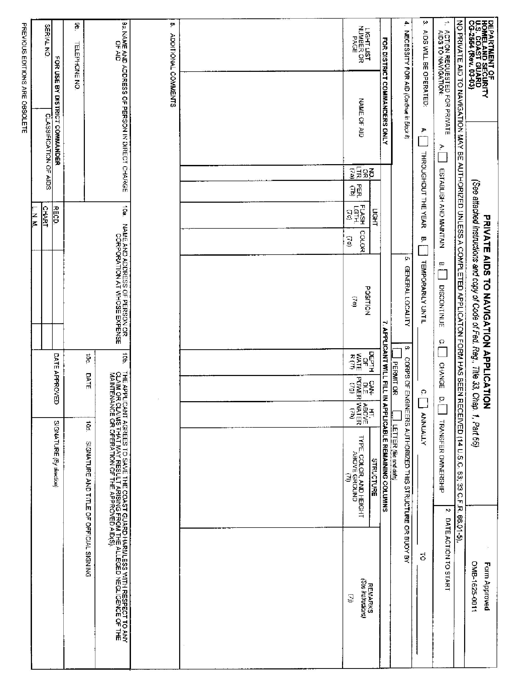
CG-2554 Private Aid Application Form

SECTION 3 – The tasks in this section examine the AVC’s knowledge of PATON discrepancies, how to report discrepancies, and when a PATON is authorized.
TASK 3-1 Demonstrate how to use the Light List.

REFERENCE | a | Light List Volume 1 – Atlantic Coast COMDTPUB P16502.1 – See page 111. Available at www.uscg.mil/d1/navinfo.htm
REFERENCE | b. | ATON/CU Study Guide – Read Section IV – ATON Discrepancies on page 21.
CONDITIONS | This task may be performed any time, at any location.
STANDARDS | AVC will be provided with data to identify three aids, by LLNR, by general location and name, and by Latitude and Longitude. Task should be completed in a reasonable time using the Light List – provided by the AVC.
PERFORMANCE CRITERIA
Check off Task
a. | AVC fills in the data for three Private Aids from the Light List sample on page 124 below on the forms provided below. LLNRs 10830, 10840, and 10841.

AID ONE

Aid Name
LLNR | Latitude |  | Longitude
Height | Range | Structure |  | Color
Chart Number | Remarks
AID TWO

Aid Name
LLNR | Latitude |  | Longitude
Height | Range | Structure |  | Color
Chart Number | Remarks
AID THREE

Aid Name
LLNR | Latitude |  | Longitude
Height | Range | Structure |  | Color
Chart Number | Remarks

Date | AVQ signature

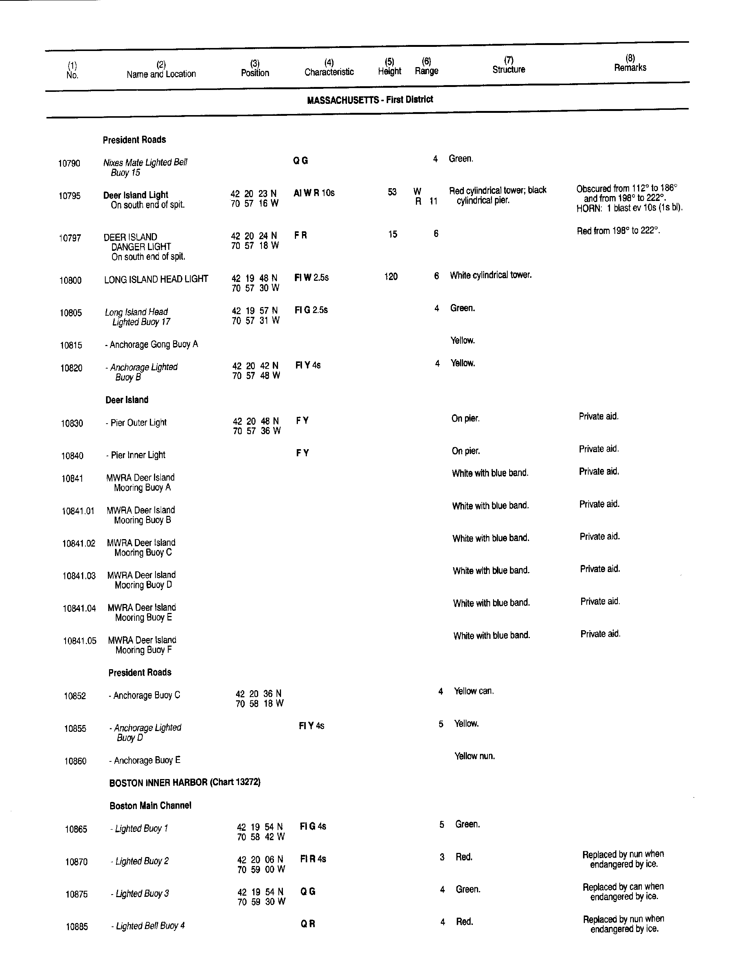
Page from the Light List

Task 3-2 Demonstrate familiarity with the D1 Private Aid Verification Report.

REFERENCE | a. | D1 Private Aid Verification Form ( ATONIS ) See page 17.
REFERENCE | b. | ATON C/U Study Guide – Section III – Private Aids to Navigation
CONDITIONS | This task may be performed at any time, at any location.
STANDARDS | AVC will refer to the two copies of the Private Aid Verifications forms on pages 126 and 127 and will fill in the data requested below.
PERFORMANCE CRITERIA
Check Off Task
a. | AVC fills in the data on the forms supplied below from the Private Aid Verification Forms on pages 126 and 127.

PATON One from page 126.
Class | Depth | Owner’s Name
Owner’s Address |  |  | Last verified | Light color
Name of Aid |  |  | Latitude | Longitude
Light color and characteristic |  |  |  | LLNR

PATON Two from page 127.
Class | Depth | Owner’s Name
Owner’s Address |  |  | Last verified | Light color
Name of Aid |  |  | Latitude | Longitude
Light color and characteristic |  |  |  | LLNR

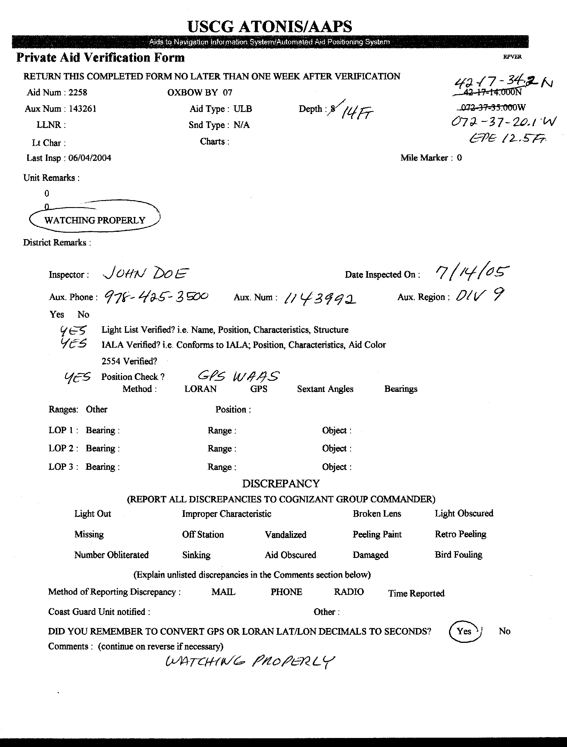
Private Aid Verification Form – 2258 – Oxbow Buoy 07

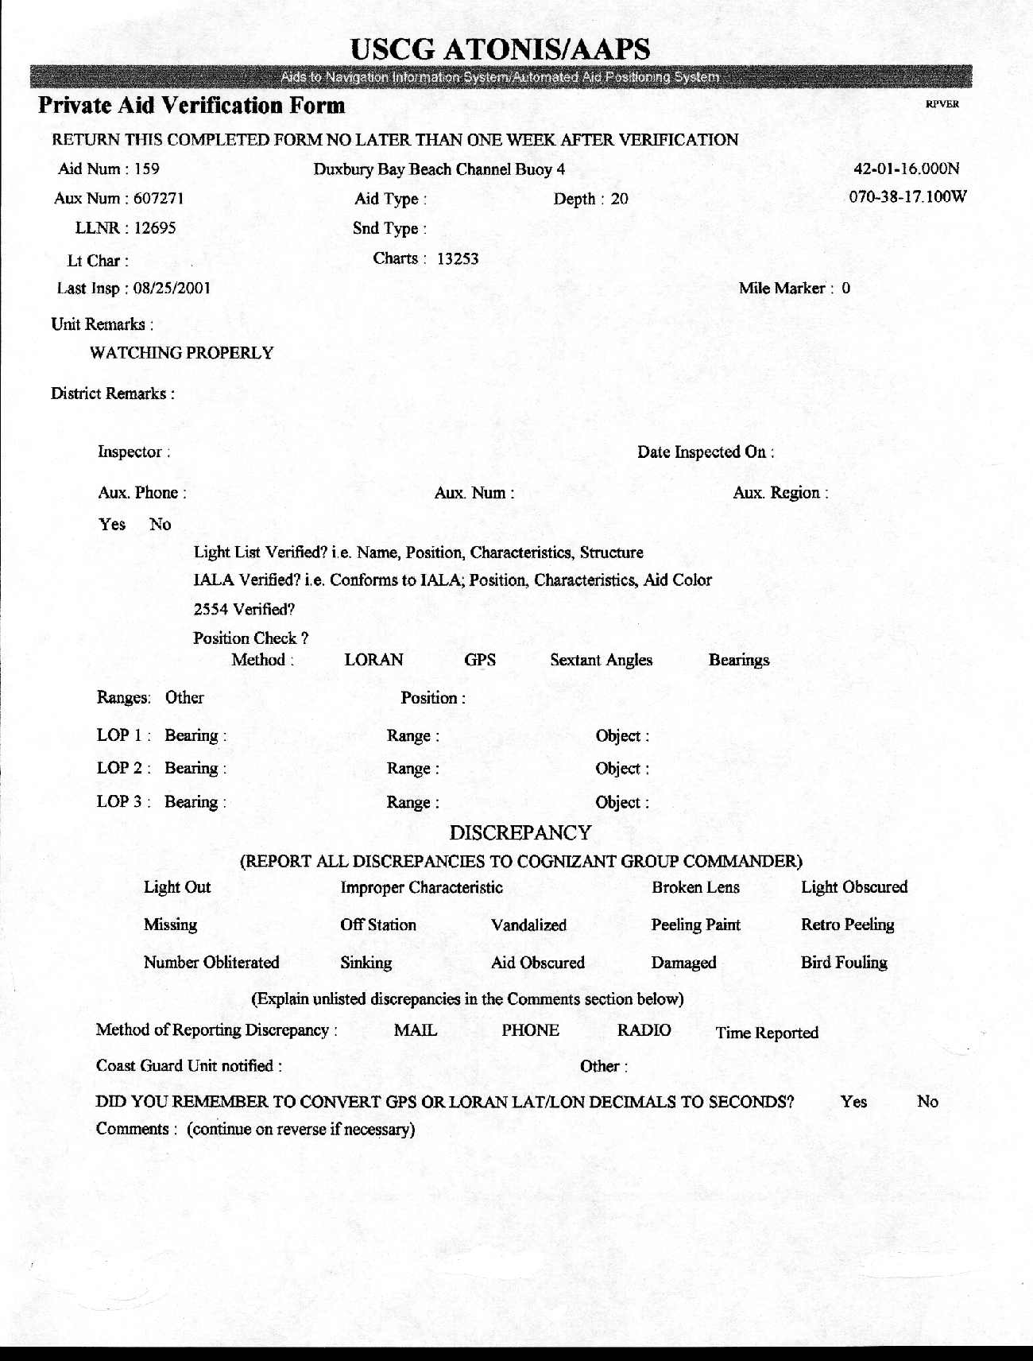
Private Aid Verification Form – Duxbury Bay Beach Channel Buoy #4
TASK 3-3 Describe conditions that cause a PATON to be discrepant.

REFERENCES | a. | ATON/CU Study Guide – Read Section IV – ATON Discrepancies on page 21.
REFERENCES | b. | Private Aid Verification Form from ATONIS – See page 17 for a sample form.
CONDITIONS | This task may be performed at any time, at any location.
STANDARDS | AVC will discuss the pertinent points from memory, in a reasonable time, and without prompting or referral to a reference document.
PERFORMANCE CRITERIA
Check off Check Off Task
a. | AVC stated that an aid is discrepant when it does not conform as described in ATONIS.
b. | AVC stated that aid discrepancies include:
b. | a. |  | Aid is missing.
b. | b. |  | Lack of prescribed signal.
b. | c. |  | Incorrect light characteristic if so affixed.
b. | d. |  | Improper color.
b. | e. |  | Improper shape.
b. | f. |  | Aid is off station and does not mark the best water.
b. | g. |  | Damaged or sinking.
c. | Using the Private Aid Verification Form from ATONIS on page 127 as a reference, complete this report showing that the PATON is missing.
Date  April 16.2005 | AVQ signature  Frank Larkin

TASK 3-4 Describe how to report an unauthorized PATON.

REFERENCES | a. | CG-5474 – (P)ATON Discrepancy Report – see page 130 for an example..
REFERENCES | b. | D1 – Private Aid Verification Form ( EXCEL ) – see page 131 for an example.
REFERENCES | c. | ATON/CU Study Guide – Read Section IV – ATON Discrepancies on page 21.
CONDITIONS | This task may be performed at any time, at any location.
STANDARDS | AVC will demonstrate their ability to complete a Private Aid Verification Report to report an unauthorized aid.
PERFORMANCE CRITERIA
Check Off Task
a. | The AVC reported unauthorized PATON activity on the CG-5474 Discrepancy Report on page 130. AVC explained how to forward this report.  Aid is a red barrel, laying on its side, with the number 3 painted on it nearby the HHYC at 042-34-56.600N / 069-54-25.800W in 20 feet of water. Aid was observed last Sunday at 1450 on the Swift River in Columbus, MA
b. | The AVC completed the D1 – Private Aid Verification Form ( EXCEL ) on page 131 to report an unauthorized aid.  Aid is a white can with the words “No Wake” in black letters in 20 feet of water off the Merry Days Marina at 040-34-44.500N / 058-22-05.400W. Aid was observed last Sunday at 1400 on Crabby Bay in Finton, RI.
c. | AVC explained the importance of determining the owner of the unauthorized aid. AVC stated that the Auxiliary is not authorized to contact an unauthorized aid owner unless specifically directed to by the Coast Guard.
Date | AVC signature

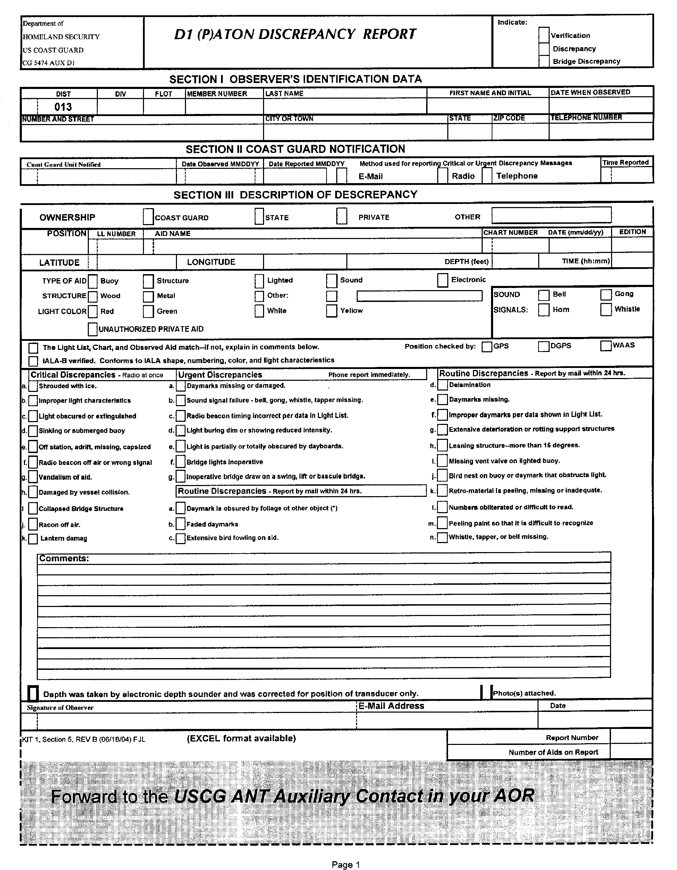
CG-5474 – D1 (P)ATON DISCREPANCY REPORT

D1 Private Aid Verification Form (EXCEL)

TASK 3-5 Complete the necessary reports for AUXDATA.

REFERENCES | a. | ANSC 7030 Activity Report Mission – for Patrol use – see the sample on page 133..
REFERENCES | b. | ANSC 7030 Activity Report Mission – for Mission Activity – see pages 134 and 135.
CONDITIONS | Task can be performed at any location, at any time
STANDARDS | AVC must complete an ANSC 7030 – Activity Report Mission form for a patrol, for AN activity while on the patrol, and for AN activity when not on a patrol. Task should be completed in a reasonable time.
PERFORMANCE CRITERIA
Check off Tasks
a. | AVC stated that the purpose of reporting PATON activity in a timely manner is to provide support statistics regarding the performance of the PATON program concerning: PATON Missions; PATON Verifications; and PATON Discrepancies.
b. | AVC stated that Mission 31 is used for reporting PATON activity.
c. | AVC stated that each person performing PATON verifications are responsible for preparing their own ANSC 7030 ACTIVITY REPORT – MISSION, referencing UNIT/INDIVIDUAL as the Type of Resource.
d. | AVC explained the importance of entering a correct OPCON reference.
e. | AVC accurately completed an ANSC 7030 – ACTIVITY REPORT – MISSION. AVC limited one Mission type to a single report.
f. | AVC indicated that when PATON verification is performed as part of an authorized Patrol, the total time allowed for Individual ATON activity is limited to 15 minutes.
g. | AVC indicated that his or her name is entered as LEAD on the ANSC 7030 ACTIVITY REPORT – MISSION.
h. | Complete an ANSC 7030 Activity Report Mission for the following ATON Patrol.  You completed a 5.25 hour ATON Patrol today under orders in your AOR. You were underway at 1055 with two crew: John Doe, 1145678, and John Smith, 1148765.
i. | Complete an ANSC 7030 Activity Report Mission for the following ATON activity performed while on the above ATON Patrol  While on the patrol, you verified 8 PATONs. 5 of these PATONs were discrepant.
j. | Complete an ANSC 7030 Activity Report Mission for the following ATON.  While on a pleasure trip on your boat last Sunday, you verified 4 PATONS. It took 1.5 hours to complete the verifications.
Date | AVQ Signature

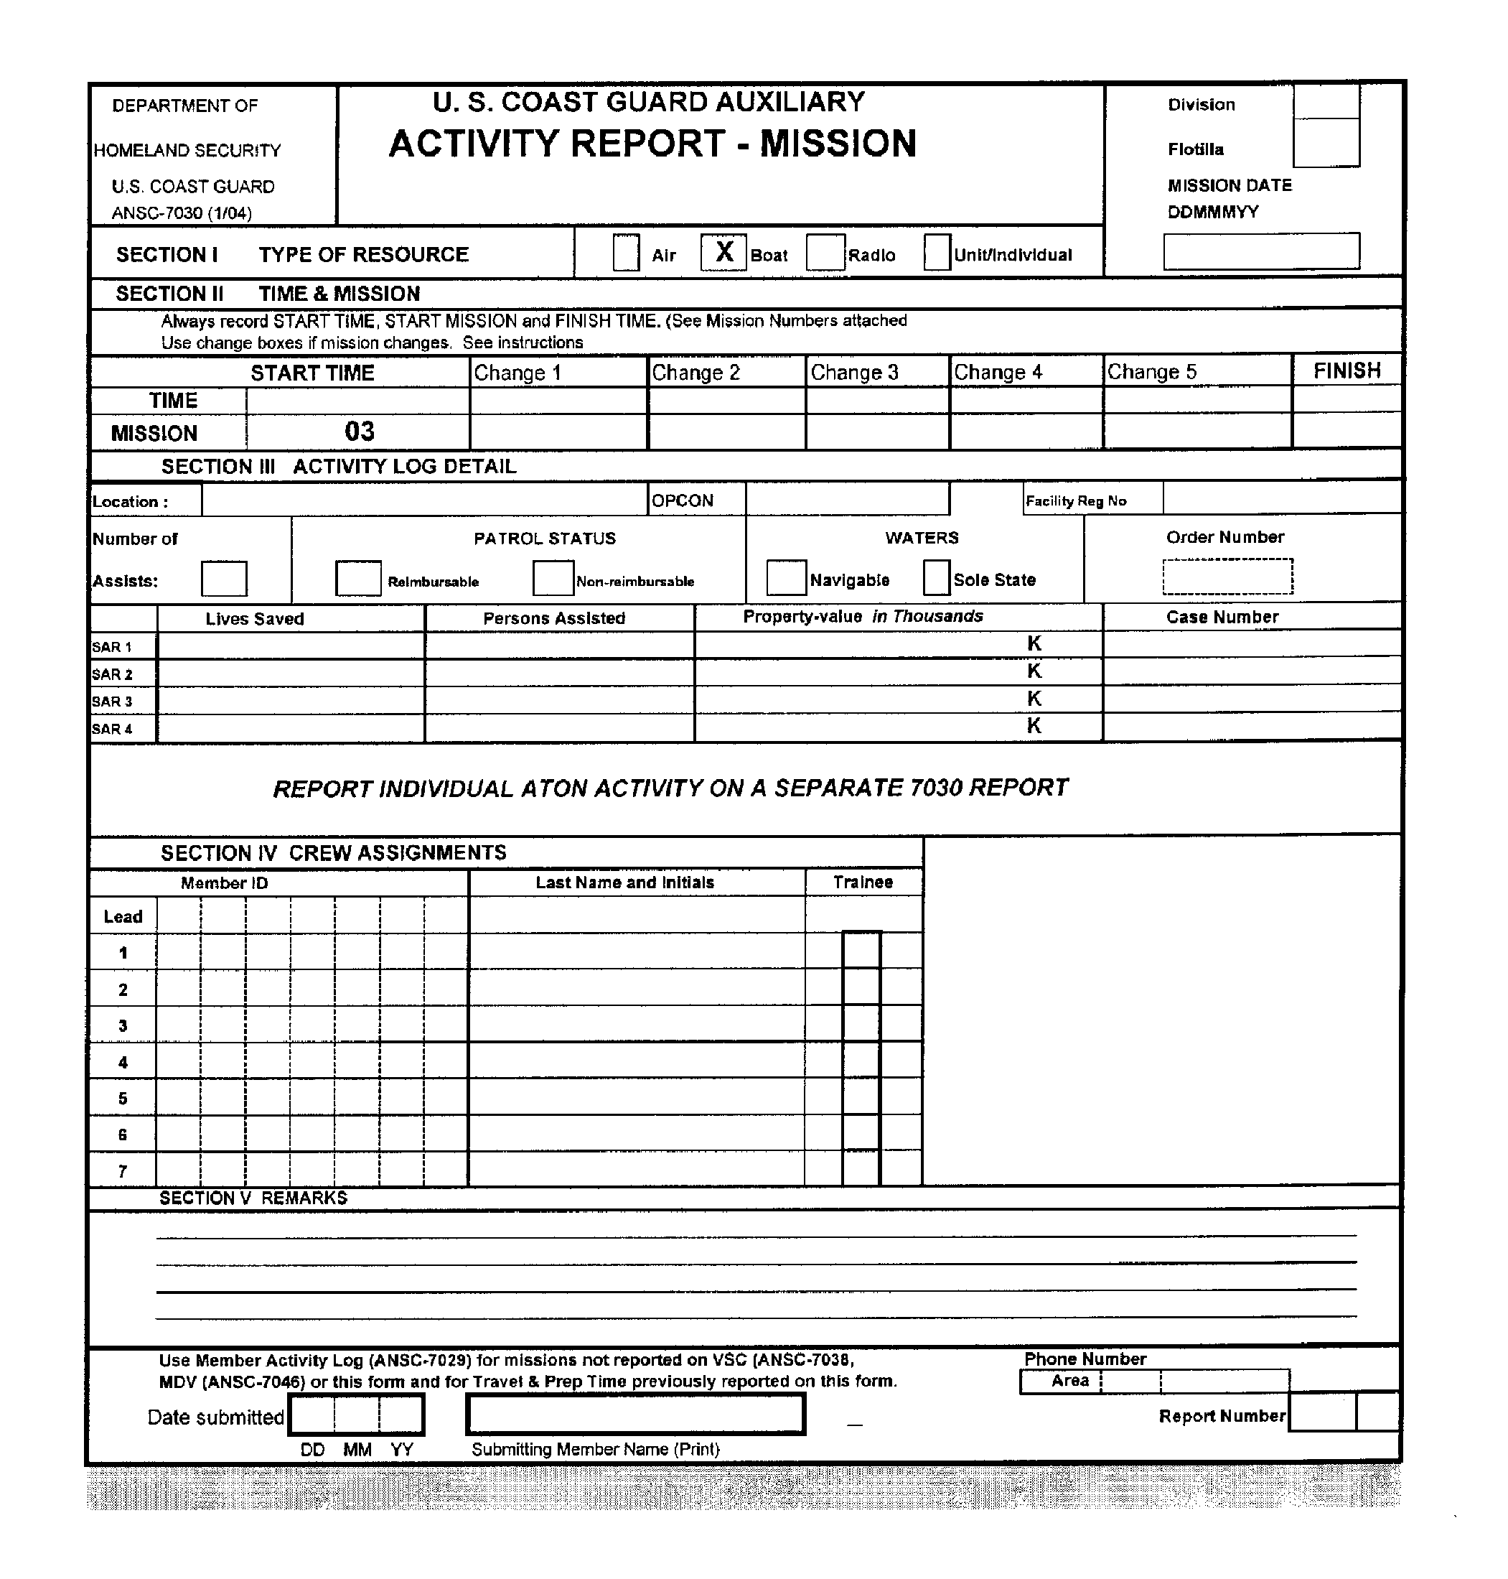
ANSC 7030 Activity Report Mission – for Patrol use

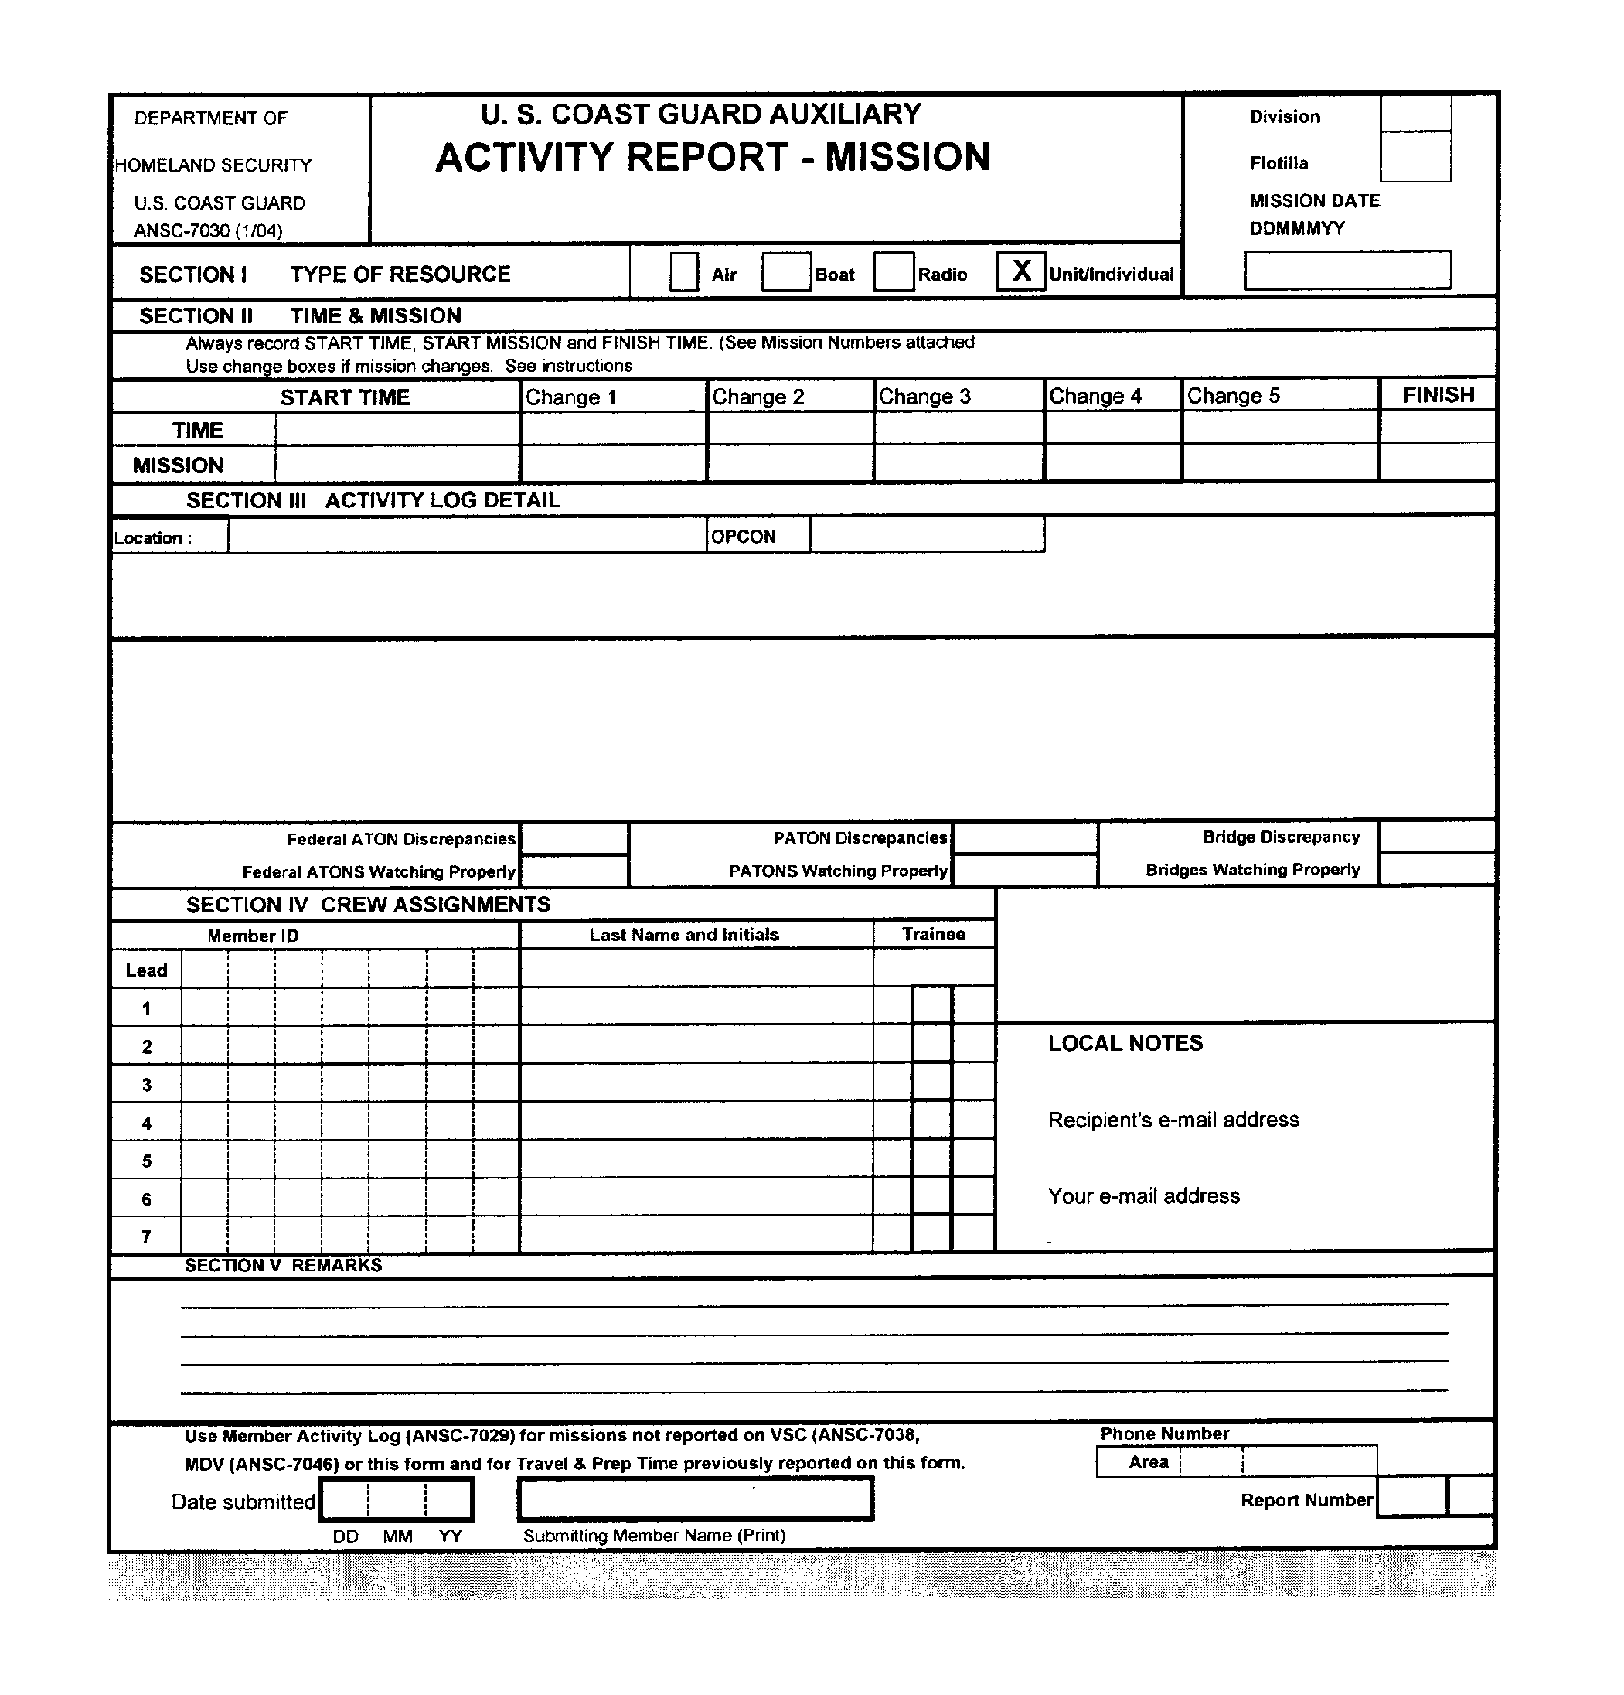
ANSC 7030 Activity Report Mission – for AN Activity while on a patrol.

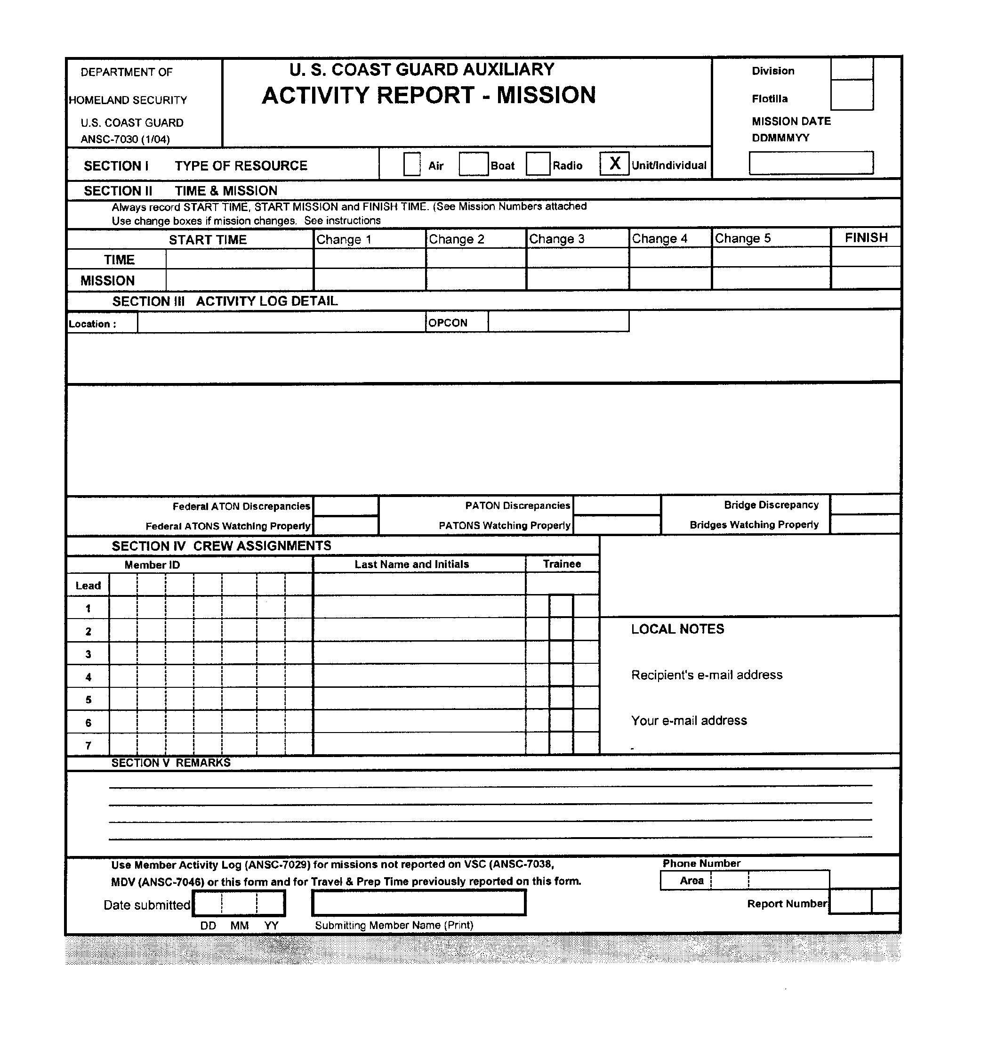
ANSC 7030 Activity Report Mission – for AN Activity when not on a patrol

SECTION 4 - The tasks in this section examine the AV’s knowledge of the IALA-B
Aid to Navigation System.

TASK 4-1 - Explain the characteristics and purpose of the major aids to navigation that comprise the IALA-B Aid to Navigation System.

REFERENCES | a. |  | NOS Chart No. 1 – to be provided by the AVC.  On line at http://pollux.nss.nima.mil.pubs
REFERENCES | b. |  | U.S. Coast Guard Aid to Navigation Booklet. ANSC 3022. Blocks of 100.
REFERENCES | c. |  | ATON/CU Study Guide – Read Section II – Federal Short Range Aids to Navigation on page 7.
CONDITIONS | Task can be performed at any location, at any time.
STANDARDS | AVC will, in response to the AVQ, identify on the NOS Chart and explain the function of a selected quantity of Aids to Navigation. This will be performed from memory, in a reasonable time, without prompting or referral to a reference document.
PERFORMANCE CRITERIA
Check Off Tasks
a. | AVC stated that red, conical (Nun), even numbered, lateral buoys mark the starboard side of the channel when returning from sea. When lighted, light will be red.
b. | AVC stated that green, cylindrical (Can), odd numbered, lateral buoys mark the port side of a channel when returning from sea. When lighted, the light will be green.
c. | AVC stated that red and white vertically striped Safe Water Marks are used to mark the center of the channel or fairway. This buoy is lettered and will display a red ball at the top. When lighted, it will display a flash of Morse Code “A” with a white light. If fitted with a radio beacon, it will broadcast Morse Code “A.”
d. | AVC stated that a buoy with red and green horizontal bands marks a junction in a channel. The top band designates the buoy’s use in the main channel (returning from the sea) and the secondary band designates the buoy’s use in the secondary channel (returning from the sea). When lighted, it will show the light color indicated by the top horizontal band with a light characteristic if Composite Group Flashing of 2+2+1. When not lighted, the buoy will reflect the shape for its use in the main channel.
e. | AVC stated that Isolated Danger Marks were positioned over hazards to navigation, are black buoys with a red horizontal stripe and a black ball on top, and when lighted, will show a white light displaying Group Flashing (2).
f. | AVC stated that Special Purpose buoys are used to mark with no lateral significance, such as: Anchorage areas; Fish net areas; Spoil grounds; ODAS Buoys and Traffic Separation Schemes. When lighted, these aids will show yellow lights. Buoys will be lettered, not numbered.
g. | AVC stated that Regulatory Marks may be white buoys or daymarks with orange horizontal bands above and below any of the following symbols:
g. | a | Orange diamond with a cross inside indicates a Boat Exclusion Area where boats are not allowed to enter. Called an “Exclusion Buoy.” The reason for the exclusion may be shown outside the diamond in black letters.
g. | b | Orange diamond indicates danger. The nature of the danger may be printed on the inside of the diamond in black block letters. This is called a “Danger Buoy.”
g. | c | Orange circle indicated a controlled area. The nature of the restriction is printed inside the circle in black block letters. When it restricts speed, it is called a “Speed Buoy.” When it controls wakes, it is called a “No Wake Buoy.” When it marks a swimming area, it is called a “Swim Buoy.”
Date | AVQ signature

TASK 4-2 Describe the characteristics of lighted ATONs.

REFERENCE | a. | NOS Chart Number 1 – to be provided by AVC.
REFERENCE | b. | Light List Volume 1 – Atlantic Coast COMDTPUB P16502.1  Available at www.uscg.mil/d1/navinfo.htm
CONDITIONS | Task can be performed at any location, at any time.
STANDARDS | AVC will discuss the pertinent points from memory, in a reasonable time, and without prompting or referral to a reference document.
PERFORMANCE CRITERIA
Check Off Tasks
a. | FIXED |  | Light is on all of the time from sunset to sunrise.
b. | OCCULTING |  | The total duration of the lighted period is longer than the total period of darkness.
c. | ISOPHASE |  | The duration of light and darkness is equal.
d. | FLASHING |  | The light duration is shorter than darkness period. The frequency of the flashes is not greater than 30 flashes per minute.
e. | QUICK FLASHING |  | The light duration is shorter than the darkness period. The repetition rate is 50 to 70 times per minute.
f. | VERY QUICK FLASHING |  | The light duration is shorter than the darkness period. Repetition rate is 80 to 159 times per minute.
g. | ULTRA QUICK FLASHING |  | The light duration is shorter that the darkness period. Frequency rate is not greater than 120 flashed per minute.
h. | MORSE CODE |  | The light flashes in a pattern of short and long durations to signal in International Morse Code. For example, a light listed as Mo (A) will have a short flash, followed by a prolonged flash, followed by a period of darkness equal to the duration of the previous flash.
i. | FIXED and FLASHING |  | The light has the same characteristic as a FIXED light, but with flashes of higher intensity at the published repetition rate.
j. | ALTERNATING |  | The light has same characteristics as a FIXED light but the color will change (alternate) at the published repetition rate.
k. | Measuring a light cycle. |  | AVC explained the proper procedure for time the light characteristics for a LB—Lighted Buoy.
Date | AVQ signature

SECTION 5 - The tasks of this section examines the AV’s knowledge of positioning private aids by sounding.

Task 5-1 - Explain how to calibrate an electronic Echo Sounder.

REFERENCE: | a. | Owner’s Manual for the Fathometer – provided by the AVC if necessary.
 | b. | Preliminary instructions for the type of Fathometer in use on the vessel.
CONDITIONS | This task may be performed any time when underway or at the dock when the weather and seas are calm on a vessel equipped with a Fathometer.
STANDARDS | AVC should perform the listed tasks without error. The task must be completed in a reasonable time, without prompting or referral to a reference document.
PERFORMANCE CRITERIA
Check Off Task
a. | AVC turned on and adjusted the Fathometer as necessary. The AVC performed a quality check to insure the Fathometer was reading accurately.
b. | AVC determined the correct depth unit of measure by referencing the current NOS Chart of the area.
c. | AVC set up the correct depth unit of measure on the Fathomer—feet, meters, or fathoms.
d. | AVC explained the correction required for the position of the Fathomer’s transponder and how it is computed.
Date | AVQ signature

Task 5-2 - Explain the effect of wind and current on the position of a floating aid to navigation.

REFERENCE: | a. | Current Table – to be provided by the AVC.
CONDITIONS: | Task can be performed at any time, at any location.
STANDARDS: | AVQ will provide location and date. Task should be performed in a reasonable time and without prompting.
PERFORMANCE CRITERIA
Check Off Task
a. | AVC will explain the effects on a floating aid from the influence of Set and Drift of the current—Wind and other elements. AVC will explain the meaning of the term, “Watch Circle.”
b. | Upon receipt of a location and a date, AVC will look up the current predictions from the Current Tables or on a GPS set.
Date | AVQ signature

Task 5-4 - Describe the procedure for taking soundings at a PATON.

REFERENCE | a. | AV lecture.
CONDITIONS | Task can be performed at any time, at any location. While underway in calm seas and weather.
STANDARDS | AVC will perform the tasks listed below in a reasonable time without prompting or referral to a reference guide.
PERFORMANCE CRITERIA
Check Off Tasks
a. | AVC will explain that while taking soundings near any aid to navigation that the boat should never transit outside of the navigable channel at any time for any reason.
b. | AVC will explain that the boat should be maneuvered close aboard the private aid using extra precautions that the aid could be positioned over shoals and/or obstructions. Depths will be recorded from an electronic Fathometer that is corrected for the position of the Fathometer’s transducer.
c. | AVC will explain that special precautions must be taken near fixed aids to navigation due to the possibility of shoaling or obstructions near the aid’s position. AVC will explain the term “riprap” and how it should be handled when positioning a private aid.
d. | AVC will explain the importance of recording the time when the depth is taken.
e | AVC will indicate that reported depths are not corrected for the height of tide.
Date | AVQ signature

SECTION SIX - The tasks of this section examines the AV’s knowledge of positioning private aids by electronic means.

Task 6-1 - Compare the position accuracy between GPS, DGPS, and WAAS.

REFERENCES | a. | ATON/CU Study Guide – Read Section XI – The Use of GPS on page 90.
CONDITIONS | This task may be performed at any time and place.
STANDARDS | AVC will perform the tasks listed below in a reasonable time without prompting or referral to a reference guide.
PERFORMANCE CRITERIA
Check Off Tasks
a. | AVC explained that the accuracy of GPS readings was approximately 100 meters before Selective Availability Error was shut off.
a. | AVC also explained that SA error is controlled by the Air Force from Boulder, CO and can be reset whenever necessary to distort the accuracy of GPS position output.
b. | AVC explained that the accuracy of GPS readings is approximately 10 meters after SA error was removed.
c. | AVC explained that the accuracy of DGPS readings is approximately 10 feet, 95%of the time.
c. | AVC explained that DGPS corrections are from local ground stations.
d. | AVC explained that the accuracy of WAAS readings is approximately 8 to 10 feet, 99% of the time.
d. | AVC explained that WAAS corrections are satellite generated in conjunction with ground stations.
Date | AVQ signature
Task 6-2 - Demonstrate knowledge of the critical unit of measurements that must be pre-set into a GPS in order to maximize the accuracy of its positioning capability.

REFERENCES | a. | ATON/CU Study Guide – Read Section XI – The Use of GPS on page 90.
REFERENCES | b. | GPS Operating Manual – to be provided by the AVC.
REFERENCES | c. | GPS – to be provided by the AVC.
REFERENCES | d. | NOS Nautical Chart – to be provided by the AVC.
CONDITIONS | This task may be performed at any time and place.
STANDARDS | AVC should perform the tasks listed below in a reasonable time without prompting. Reference to the GPS Operating Manual is permitted.
PERFORMANCE CRITERIA
Check Off Tasks
1. | HORIZONTAL DATUM - AVC explained the definition of a Horizontal Datum in GPS and  how it related to a nautical chart and the accuracy to a GPS position reading.
1. | a. | AVC explained where to find the correct Horizontal to use.
2. | SPEED UNIT OF MEASURE – AVC indicated that while operating on the water, the Speed  Unit of Measure must be set to Knots – Nautical Miles per Hour.
2. | a. | AVC explained the difference between MPH and KNOTS.
3. | HEADING – AVC explained that the Heading was related to the type of Compass used on  the boat.
3. | a. | An Analog Compass uses Magnetic Headings.
3. | b. | Electronic Compasses can be offset to reflect True Headings. (and be compensated and  corrected for Deviation Error.)
4. | VARIATION – AVC explained that some GPS sets have automatic Variation correction  capability while others must be corrected for Variation manually.
4. | a. | AVC indicated that Variation can be obtained from the Compass Rose on a nautical chart that is nearest to your position.
5. | DATE and TIME – AVC explained that most sets obtain date and time data from the satellites. It  is usually more accurate that a watch or clock on your boat and should be used when reporting  position data of private aids.
6. | LATITUDE and LONGITUDE – AVC explained that the Coast Guard uses Deg—Min—Sec  readings. Most GPS sets are pre-set to show decimal seconds (Deg—Min or “00  00.000.”) AVC indicated that a GPS set should Be adjusted to reflect the Coast Guard  standard in order to avoid reporting errors—000-00-00.000.
7. | GPS ALARMS – AVC explained the following available Alarms:
7. | WAYPOINT ALARM – AVC described as a pre-set diameter in miles that triggers an alarm whenever a boat penetrates the protective circle around the waypoint.
7. | OFF COURSE ALARM – AVC indicated that establishing a XTE—Cross Track Error parameter in the GPS, creates this alarm. The alarm sounds whenever the boat crosses the error limit on either side of the track line.
7. | ANCHOR ALARM – AVC indicated that an alarm is created by establishing a diameter (nautical miles) that triggers the alarm whenever a boat drifts outside of the limits of the circle’s circumference.
8. | VERTICAL DATUM – DEPTH – AVC indicated that when the Fathometer is integrated or bundled into the GPS, a depth datum must be established in the GPS. AVC indicated that the Vertical Datum established in a GPS must match the Vertical Datum used on the nautical chart of the AOR.
Date | AVQ signature
Task 6-3 - Explain how to interpret the various accuracy readings provided by a GPS set.

REFERENCES | a. | ATON/CU Study Guide – Read Section XI – The use of GPS on page 90.
REFERENCES | b. | GPS Set Operating Manual – to be provided by the AVC.
REFERENCES | c. | GPS Set – to be provided by the AVC.
CONDITIONS | This task may be performed at any time.
STANDARDS | AVC will perform the tasks listed below in a reasonable time without prompting or referral to a reference guide.
PERFORMANCE STANDARDS
Check Off Tasks
1. | THREE DIMENSION POSITIONS – AVC explained that a three-dimension is obtained by the GPS after acquiring data from four satellites.
1. | a. | AVC also explained that a three-dimension position must be obtained when positioning private aids and bridges.
2. | HDOP – Dissolution of Position Error – AVC explained that this error indicated the geometry of the satellites in relation to your position on the earth’s surface. Lower readings indicate readings that are more accurate.
2. | a. | AVC reviewed the HDOP scale in the GPS Operating Manual for the GPS set being used and expressed the accuracy of the current satellites position readings being generated by the GPS set.
3. | EPE – Estimated Position Error (in feet) – AVC explained this error is an expression of the accuracy of the position being generated by the GPS. The expression, in feet, represents the diameter of a circle in which the position exists.
4. | AVC expressed the benefit for recording position error on PATON documents into order to enhance the professionalism of reporting Auxiliary PATON positions.
Date | AVQ signature

Task 6-4 - Explain Waypoints and how they are established, verified and used by GPS.

REFERENCES |  | a. |  |  |  | ATON / CU Study Guide – Read Section IX – The Use of GPS on page 90.
 |  | b. |  |  |  | GPS Operating Manual – to be provided by the AVC.
 |  | c |  |  |  | GPS Set – to be provided by the AVC.
 |  | d. |  |  |  | NOS Nautical Chart for the AOR – to be provided by the AVC.
CONDITIONS |  | This task may be performed at any time and place.
STANDARDS |  | AVC will perform the tasks listed below in a reasonable time without  prompting or referral to a reference guide.
PERFORMANCE CRITERIA
Check Off Tasks
 | 1. |  | AVC explained the composition of a Waypoint as used by GPS, including  Latitude and Longitude, a number, and a symbol.
 | 2. |  | AVC explained the need to keep Waypoint definitions simple in order to avoid  clutter on an electronic nautical chart.
 | 3. |  | AVC explained the need to keep Waypoint definitions simple in order to avoid  clutter on an electronic nautical chart.
 | 4. |  |  | AVC indicated five methods for loading waypoints into a GPS.
 |  |  |  | 1. Manual entry of Latitude and Longitude.
\
2. Cursor entry using an electronic nautical chart screen.

 |  |  |  | 3. Bearing and range entry from an underway position.
 |  |  |  | 4. Entry of waypoints from a remote computer.
 |  |  |  | 5. Actually visiting the site and updating the LAT/LON position to the GPS.
 | 5. |  |  |  | WAYPOINT VALIDATION – AVC explained that every new waypoint should be considered suspect until verified by actually visiting the waypoint site and by correcting any LAT-LON position error in the GPS at the site.
 | 6. |  |  |  | AVC indicated the importance of creating an Excel spread sheet list of waypoints in order to reference additional information about the waypoint.
 | Date |  |  |  | AVQ signature

Task 6-5 - Explain Routes and how they are created and used by GPS.

REFERENCES: | a. | ATON/CU Study Guide – Read Section IX – The Use of GPS on page 90.
REFERENCES: | b. | GPS Operating Manual – to be provided by the AVC.
REFERENCES: | c. | GPS Set – to be provided by the AVC.
REFERENCES: | d. | NOS Nautical Chart – to be provided by the AVC.
CONDITIONS | This task may be performed at any time and place.
STANDARDS | AVC should perform the tasks listed below in a reasonable time. Reference to the AVC’s GPS Operating Manual is allowed.
PERFORMANCE CRITERIA
Check Off Tasks
1. | AVC explained the composition of a Route as used by GPS to be a series of verified Waypoints linked together in the order that you plan to use them.
2. | AVC explained the need to plot the Waypoints used in a Route on a nautical chart to validate that there are no obstructions present along the proposed track line.
3. | AVC indicated that benefits of using Waypoints that reference Aids to Navigation in order to provide the addition validation of sight to objects and to increase the safety aspect of the Route.
4. | AVC indicated three methods for loading Routes into a GPS.
4. | a. | Manual entry of Waypoints from the GPS Waypoint Library.
4. | b. | Cursor entry using an electronic nautical chart screen.
4. | c. | Conversion of Track data to a Route.
Date | AVQ signature

SECTION SEVEN - The tasks of this section explain the AV’s knowledge of annual maintenance and requalification requirements.

Task 7-1 - Describe the annual maintenance requirement for an AV.

Task 7-2 - Describe the five-year re-qualification requirements.

