*United States Coast Guard Auxiliary*

TRAINING CHECKLIST FOR THE

AV - AID TO NAVIGATION VERIFIER

Version 1

Revised 5/17/2010

## AVC Name __________________________________________________

## Auxiliary Member Number __ __ __ __ __ __ __ __

**District/Division/Flotilla ___ ___ ___ - __ __ - __ __**

INTRODUCTION

1. The Auxiliary Aid to Navigation Verifier Training Guide has been designed to help Auxiliarists become AV-Aid Verifiers. Each section of this guide contains a listing of training tasks that allow Auxiliarists to demonstrate their proficiency in the skills needed to complete the AV mission.
2. This guide can function as the agenda for a workshop or may be used as a self-study tool.
3. If an AVC – Aid Verifier Candidate has difficulty finding qualified examiners, they are encouraged to contact:
   * 1. Their Flotilla NS Staff Officer - FSO-NS.
     2. Their local CG ANT-Aid to Navigation Team.
     3. Their Assistant District Staff Officer - ADSO-NS or District Staff Officer - DSO-NS.
4. The AVQ can be any qualified, current and active Aid Verifier that has been approved by the DSO-NS.
5. Check off each task as you complete it so you don’t lose track of each training element.
6. When the final tasks are completed, the AVC will contact their AVQ who will validate the required PATON verifications and AUXdata entries and will notify their ADSO-NS.
7. AV Certification is complete only when endorsed by the District Director of Auxiliary and posted to the member’s Auxiliary record.

**List of assisting AVQ – Aid Verifier Qualifiers:**

Each participating AVQ should be listed in this section.

**Name of AVQ CG ANT Date.**

**______________________________________ ___________ ___________**

**______________________________________ ___________ ___________**

1. **PATON Policy Statement.**
   1. ____ Review the District PATON Policy Statement available on the Navigation Systems Web Site.
2. **Boat Crew Qualification.**
   1. Members pursuing AV qualification should be currently or formerly boat crew or coxswain qualified. If not, they must complete the following sections of the Boat Crew Qualification Guide:
      1. BCM-02-08-AUX Type III PFD, Anti-Exposure Coverall Or Dry Suit Swim
      2. BCM-02-09-AUX Identify Boat Crew Survival Equipment
      3. BCM-02-10-AUX Use The Emergency Signaling Mirror
      4. BCM-02-11-AUX Describe The Use Of Hand Held Distress Flares
      5. BCM-02-12-AUX Describe The Use Of Aerial Flares
      6. BCM-02-13-AUX Operate The Personal Marker Light (PML) or Strobe Light
      7. BCM-02-14-AUX State Survival Procedures In Event The Boat Capsizes Or Swamps
      8. BCM-06-01-AUX Identify The Basic Parts, Symbols And Abbreviations Found On A Nautical Chart
      9. BCM-06-02-AUX Identify Common Aids To Navigation Used In Small Boat Piloting
      10. BCM-06-03-AUX Identify Local Landmarks Used In Piloting On A Nautical Chart
      11. BCM-06-04-AUX Plot A Position Using Latitude And Longitude
      12. BCM-06-05-AUX Plot A Magnetic Course On A Nautical Chart
      13. BCM-06-06-AUX Measure Distance On A Nautical Chart
      14. BCM-06-07-AUX Compute Time, Speed And Distance
      15. BCM-06-08-AUX Determine The Depth Of Water Using A Fathometer And/Or A Sounding Pole
3. **Required Pre-workshop readings and downloads:**
   1. NOS Chart No. 1.
      1. ____ Purchase or download a copy of the NOS Chart for your PATON Navigation Kit.
      2. ____ Browse through this publication and become familiar with the parts symbols and abbreviations used on NOAA nautical charts.
   2. **NOAA Nautical Chart**.
      1. ____ Acquire the latest NOAA nautical chart for the patrol area where you plan to verify PATONs.
      2. ____ Scan this chart and become familiar with the charted features in your AOR.
   3. **NS-PN03-03 Chart Orientation**.
      1. ____ Review this PowerPoint presentation.
   4. **NS-CU02 Chart Update Training Guide**.
      1. ____ Read pages 2 thru 8.This guide is available at the Navigation Systems Web Site.
4. **Other Navigational-related documents and publications.**
   1. **LNM – Local Notice to Mariners**.
      1. ____ Sign up and review a copy of ***LNM-Local Notice to Mariners***.
      2. ____ Familiarize yourself with the section of the ***LNM*** where information regarding discrepancies and corrections to Private Aids to Navigation is presented n the LNM.
   2. **U.S. Coast Pilot**
      1. ____ Download and read the pages of the local ***Coast Pilot*** edition that reflects the AOR where you normally operate and include these pages in your PATON Navigation Kit for on-scene reference.
   3. **Light List – Volume 1** **– Atlantic Coast COMDTPUB P16502.1.**
      1. ____ Download and review the pages of the local ***Light List*** edition that reflects the AOR where you normally operate and include it in your PATON Navigation Kit.
      2. ____ Familiarize yourself with the pages of the ***Light List*** for the AOR where you normally operate. Understand that some Private Aids may not be listed in the Light List and, also, may or may not be charted on a NOAA chart.
      3. ____ Understand that changes in the Light List are directly related to the Coast Guard additions, deletions and updates to the Coast Guard’s I-ATONIS System.
5. **NS-AN02 Auxiliary Short Range Aids to Navigation Training Guide**
   1. ____ Download and read the Auxiliary Short Range Aids to Navigation Training Guide.
6. **33 CFR, PART 66--Private Aids To Navigation**
   1. ____ Read the *33CFR, Part 66-Private Aids to Navigation* section in this training guide**.**
7. **Preparing a manual Aid to Navigation Report.**
   1. ____ Download and review the ***NS-PN04 Private Aid to Navigation Report*** on www.uscgaan.com. Enter your static data (data that normally doesn’t change) on the form and save this form to your home computer.
8. **Understanding the I-ALA Aid to Navigation System.**
   1. ____ Acquire, read and place a copy of the USCG Aids to Navigation System Booklet in your Navigation Kit for use as a reference document.
   2. ____ Read pages 9 through 24 of the *Auxiliary Short Range Aid to Navigation Training Guide.*
9. **Reviewing lights and lanterns used on Aids to Navigation.**
   1. ____ Read pages 25 and 26 of the NS-AN02 Auxiliary Short Range Aid to Navigation Training Guide.
   2. ____ Review the PowerPoint Presentation, “*Basic ATON System*”
   3. ____ Simulate a lighted aid report by entering the information relating to the lighting system specified for the aid in *Section 5 – AID TO NAVIGATION Characteristics* on a 7054 *Aid to Navigation Report.*
   4. ____ Become aware that the guideline for checking the light characteristic and period of a light is performed by using a stop watch to time five successive period light cycles and by dividing the total time by five. This activity must be performed at night.
10. **Understanding the sources of information about a Private Aid to Navigation.**
    1. ____ Understand that **not** all of the permitted PATONs are available from the downloaded pages of the local ***Light List*** or reflected on the NOAA chart of the area. Realize that all permitted PATONs are listed in the Web-Based PATON System.
    2. ____ Locate the Allerton Harbor Buoy No. 6 on the Light List and the NOAA Chart shown below.

Copy of Light List showing Allerton Harbor

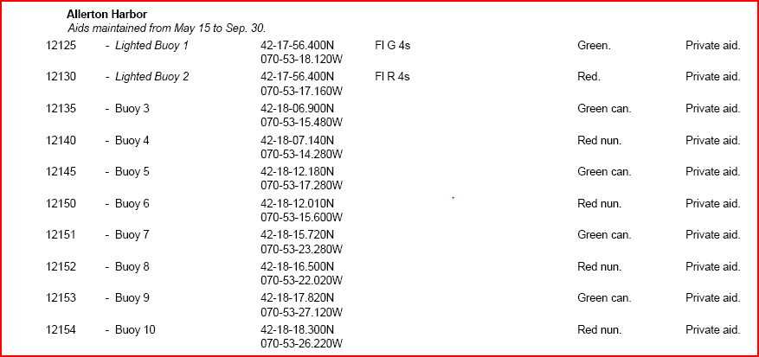

Chart of Allerton Harbor is available on page 5.

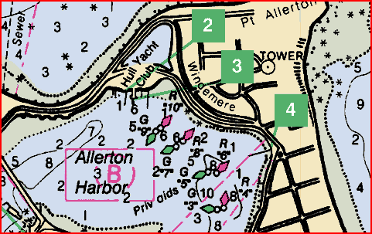

1. **Becoming familiar with the typical conditions that can cause a PATON to be discrepant.**
   1. ____ Understand that a private aid is discrepant when it does not conform to descriptions of the PATON described in ***I-ATONIS,*** in the ***Light List***, listed in the ***Web-Based PATON System*** and displayed on the NOAA chart.
   2. **PATON DISCREPANCY REVIEW** 
      1. ____ Review this PowerPoint presentation.
      2. ____ Review the typical discrepancies found on a private aid and corrolate them to the discrepancy listings shown on a “7054  *Aid to Navigation Report.****”***
2. **Reporting Non-Permitted Aids to the Coast Guard.**
   1. ____ Understand the importance of providing clear data, the name and address of the owner, and a photo of the aid. Basically, nothing can happen to resolve this issue until the aid’s owner applies for a permit to the DPW.
   2. ____ Simulate and complete the additional information required for a non-permitted PATON report using the ***7054 Aid to Navigation Report.***
3. **Guidelines for reporting the depth of water to a Federal Agency.**
   1. **Echo Sounder Set Up**:
      1. ____ Read your echo sounder’s operating manual to fully understand the operation of your unit. Echo sounders used to measure depth should have a digital reading for partial feet.
      2. ____ Understand how to set up an echo sounder in order to insure it is operating accurately before getting underway.
      3. ____ Understand how to determine the correct depth unit of measure by referencing the current *General Information Block* of NOAA Chart.
      4. ____ Pre-check that the correct depth unit of measure is set up in your echo sounder--feet, meters, or fathoms.
      5. ____ Understand the correction required for the location of the echo sounder’s transponder on an OPFAC’s hull and how it was determined.
      6. ____ Understand how to use of depth alarms on an echo sounder.
      7. ____ Understand how to pre-calibrate your echo sounder before getting underway to insure that it is operating accurately and how to report this information.
   2. **Compensating for Current and Wind.**
      1. **____** Understand the effects on a floating aid from the influence of Set and Drift of the current, wind and other elements and the meaning of the term, “*Watch Circle*.”
      2. ____ Understand that more accurate depth readings are possible by taking the reading up wind and/or up current from the aid.
   3. **Correcting the depth of water for the height of tide.**
      1. ____ Understand the concept of “Height of Tide at any time.”
      2. ____ Understand how to use a GPS set to look up and state the tide predictions for a specific date and time.
      3. ____ Understand how to read a charted depth on a *NOAA Chart* and how it compares to the reading from an electronic echo sounder.
      4. ____ Understand that the depth reading from an echo sounder is corrected by adding the correction for the position of the echo sounder’s transducer to the echo sounder’s depth read out.
      5. ____ Understand and actually correct the “***Substation***” reference on the Almanac screen of the GPS. Also, understand that Substations change as you transit from one area to another.
      6. ____ Understand how to correct a depth reading to charted datum by subtracting the *HOT-Height of Tide* taken from the Almanac screen on their GPS that is referenced to the correct “*Substation*.”
   4. **On-scene precautions and processes**:
      1. ____Be aware that while taking soundings near any aid to navigation that the boat should never transit outside of the navigable channel at any time for any reason while verifying PATONs.
      2. ____ Understand that the boat should be maneuvered close aboard the private aid taking extra precautions that the aid could be positioned over shoals and/or obstructions. Depths, recorded from an electronic echo sounder, are always corrected for the position of the echo sounder’s transducer.
      3. ____Be aware that special precautions must be taken near fixed aids to navigation due to the possibility of shoaling or obstructions near the aid’s position. Understand the term “*riprap*” and how it should be handled when positioning a private aid and how to recognize the symbols used to identify riprap on a nautical chart.
      4. ____Be aware that floating aids are anchored to the seabed with a harness and, often, will not be directly over the anchor due to wind and tide. Depths should be taken upwind and up current on these aids to insure a more accurate depth reading for the aid.
      5. ____ Understand the importance of recording and reporting the exact time when each depth is taken.

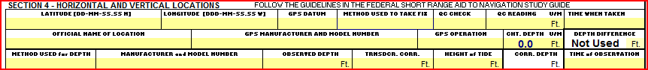

1. **Understanding the use of GPS.**
   1. **Background Information**:
      1. ___ View the PowerPoint presentation “*GPS Orientation*”.
      2. ____Be aware that the accuracy of a WAAS reading is approximately 10 feet, 95% of the time. State that “*WAAS*” corrections are satellite generated in conjunction with ground stations and additional satellites.
   2. **GPS Set Ups**
      1. ____ **Horizontal Datum** - Be aware that only charts showing NAD83 or WGS84 datum may be used for verifying PATONs.
      2. ____ **Heading** – Understand that the term “Heading” is related to the type of Compass used on the vessel and that an analog compass generates magnetic headings that must be compensated and corrected for Deviation Error.
      3. ____ **Speed Unit of Measure** – Understand that while operating on the water, the Speed Unit of Measure in a GPS set must be set to Knots – Nautical Miles per Hour. Most sets come preset to MPH—Statute Miles.
      4. ____ **Deviation** – Understand that certain magnetic influences aboard an OPFAC can affect the direction of your compass and that a Deviation Table is necessary for accurate navigation.
      5. ____ **Variation** – Understand that new GPS sets have automatic variation correction capability while older sets may have to be corrected manually. Variation can be obtained from the nearest compass rose on your chart.
      6. ____ **Date and Time –** Understand that most GPS sets obtain date and time data from the satellites which is more accurate that any watch or clock.
      7. ____ **Latitude and Longitude** – Understand that the Coast Guard uses *Deg—Min—Sec* readings and that GPS sets must be adjusted to reflect the Coast Guard standard.
   3. **GPS Alarms** – Be aware of the following available alarms:
      1. *____* **Waypoint Alarm** – Defines a pre-set diameter in miles that triggers an alarm whenever a boat penetrates the protective circle around the waypoint entered on a GPS Set.
      2. *____* **Off Course Alarm** – Establishes a XTE—Cross Track Error parameter in the GPS, creates this alarm which sounds whenever the boat crosses the error limit on either side of a track line.
      3. *____* **Anchor Alarm** – Indicates that an alarm is created by establishing a diameter (nautical miles) that triggers an alarm whenever a boat drifts outside the limits of the circumference.
   4. **Quality readouts:**
      1. ____ THREE DIMENSION POSITIONS– Understand that a three-dimension position is obtained by the GPS after acquiring data from *four* or more satellites and that a three-dimension fix must be attained at a minimum when locating (fixing) private aids. This condition must also be included on your PATON Report. 3D Differential fixes are highly desirable.
      2. ____HDOP – Dilution of Presision Error – Understand that this statistic is a measure of the accuracy of the geometry of the satellites in relation to your position on the earth’s surface. Lower readings indicate possible lower accuracy. If DGPS is being used, review the HDOP scale in the GPS’ Operating Manual and express the accuracy of the current satellites position readings being generated by the GPS set – Optional. This condition must also be included as part of your PATON Report.
      3. ____ EPE – Estimated Position Error (in feet) – Know that this error is an expression of the accuracy of the fix being generated by your GPS and that the expression, in feet, represents the diameter of a circle in which the fix exists. This quality measurement must also be included as part of your PATON Report.
2. **Guidelines for taking and reporting a fix to a Federal Agency.**
   1. **Background Information**:
      1. ____ Record the manufacturer’s name and model number for the GPS(s) being used on the ***“7054 Private Aid to Navigation Report.”***
   2. **Pre-underway activity:**
      1. ____ Understand how your GPS set should be checked for accuracy before getting underway.
         1. Verified that units of measure are correct.
         2. Horizontal DATUM is set correctly.
         3. LAT/LON is formatted correctly.
         4. WAAS is enabled.
         5. GPS readout is compared to a known location or other GPS.
   3. **On Scene Activity:**
      1. ____ Understand that a coxswain must be able to hold the OPFAC alongside the aid while remaining in the navigable channel when a fix and depth is being recorded so that the AV can record all of the required information.
      2. ____ Understand the need to record the accuracy of the GPS readings as the Fix is taken:
         1. EPE or HDOP reading.
         2. 3D or 3D Differential indications.
      3. ____ Know that all fix data must be recorded in degrees, minutes and seconds when reporting data to the Coast Guard.
      4. ____ Simulate a FIX and enter the information on a ***7054 Aid to Navigation Report.***
3. **Activity reports to AuxData:**
   1. ____ Understand that the purpose of reporting PATON activity in a timely manner is to provide support statistics regarding the performance of the PATON program concerning PATON Missions, PATON Verifications and PATON Discrepancies that Mission 31 is used for reporting PATON activity.
   2. ____ Be aware that each person performing PATON verifications is responsible for preparing their own “*ANSC 7030 ACTIVITY REPORT – MISSION*,” referencing *UNIT/INDIVIDUAL* as Type of Resource.
   3. ____ Accurately complete an “*ANSC 7030 – ACTIVITY REPORT – MISSION - INDIVIDUAL*.”
   4. ____ Understand that when the PATON verification is performed as part of an authorized Patrol, the total time allowed for Individual ATON activity is limited to 15 minutes since the time underway is recorded in POMS by the coxswain.

|  |
| --- |
|  |

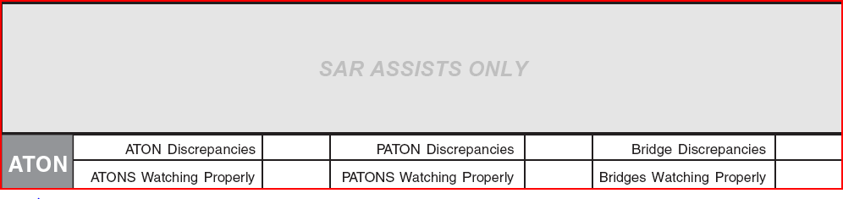

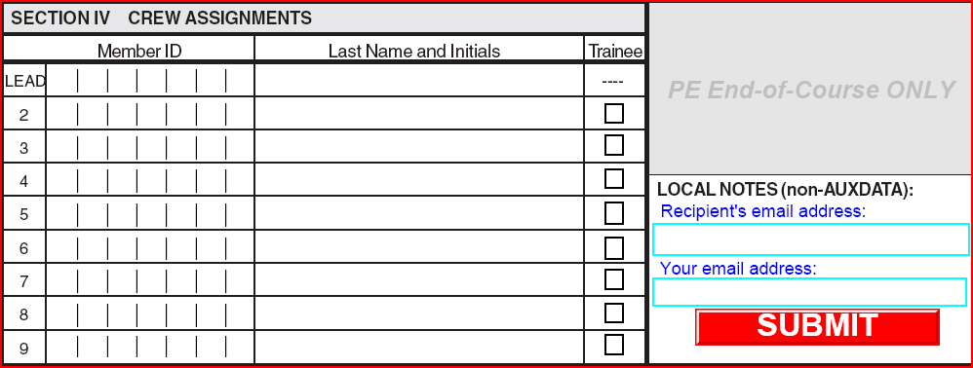

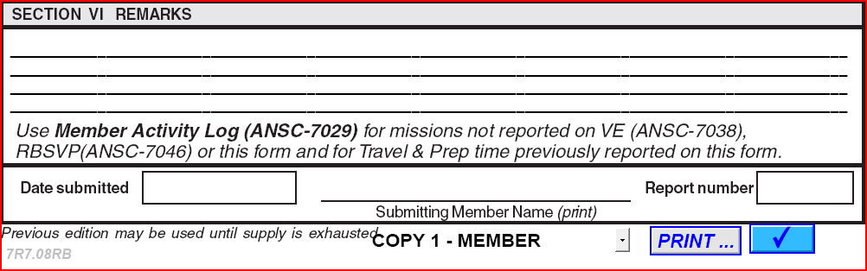

1. Planning, observing, and transmitting three (3) ATON/PATON 7054 Verification Reports to the CG.
   1. ____ Contact an AVQ to monitor your three ATON/PATON Verifications.
      1. Note that PATON verifications must be performed between April 15 and November 15 each year.
      2. Use the AVQ’s log on to make your reports on line.
2. ISC Training Requirements:
   1. ____ Complete ICS 100 Training.
   2. ____ Complete ICS 700 Training.
3. Review of the Federal Regulations for Bridges.
   1. ____ Download and read the “*Auxiliary Bridge Program Training Manual.*”
   2. ____ Download and read “ *How to Conduct a Bridge Survey*.”
   3. ____ Download and read “ *33CFR 117 Bridges*.”
   4. ____ Review the procedure for reporting a bridge using the Bridge Database System.
4. Complete the Open-Book AV Exam.
   1. ____ Request a copy of the final AV Exam from your AVQ. A passing grade of 96% is required (24 out of 25). 20 questions are on the PATON System and 5 questions refer to the Bridge Program.

GLOSSARY OF AV TERMINOLOGY

ADSO Assistant District Staff Officer.

ANT ATON Team. This name is followed by a location:

Boston, Bristol, Portland, Woods Hole and SWH.

AOR Area of Responsibility.

ATON Aid to Navigation.

AV ATON Verifier

AVC ATON Verifier Candidate.

AVQ ATON Verifier Qualifier.

BM( # ) Boson Mate. The number suffix indicates the class of Petty Officer. BMs are the Coast Guard’s operational personnel for vessels.

CFR Code of Federal Regulations.

CGD1 Coast Guard District 1—properly written as “First Coast Guard District.”

Coxswain Coast Guard person in charge of a small boat.

DGPS Differential Global Positioning System.

DSO-NS Auxiliary, District Staff Officer - Navigation Systems

EPE Estimated Position Error.

FSO-NS Flotilla Staff Officer – Navigation Systems.

GPS Global Positioning System.

HDOP Horizontal Dissolution of Precision.

IALA International Association of Lighthouse Authorities.

KNOTS Nautical Miles per Hour.

LNM Local Notice to Mariners.

MPH Miles per Hour—normally refers to statute miles.

NOS National Ocean Service

OINC or OIC Officer in Charge.

OTO Assistant Director of Auxiliary, Operations and Training Officer.

PATON Private Aid to Navigation.

QM ( # ) Quarter Master. The number suffix indicates the class of Petty Officer. QMs are the Coast Guard’s navigation and signaling personnel.

SO-NS Division Staff Officer – Navigation Systems.

USACE United States Army – Corps of Engineers.

USC United Stated Code.

WAAS Wide Angle Augmentation System

XPO Executive Petty Officer.

XTE Cross Track Error.